**ANNUAL REPORT 2021**

**The**

**Norwegian Renal Registry**

**(Norsk Nyreregister)**

________________________________________________________________________

This report will also be available on:

http://www.nephro.no/registry.html

Registry Chairperson: Anna V. Reisæter (areisate@ous-hf.no)

Director of Registry: Anders Åsberg (aaasbe@ous-hf.no)

Address: Norsk Nyreregister, ATX-Nyreseksjonen, OUS Rikshospitalet, Pb. 4950 Nydalen,  
0424 Oslo, Norway.

# Table of Contents

Table of Contents 2

History and Organization of Norwegian Renal Registry (NRR) 3

National organization and policy 3

Incidence data 2021 5

Biopsy 5

Serious complications 9

Percentage of kidney biopsies with 10 or more glomeruli 11

Number of primary kidney biopsies with moderate to severe chronic changes 13

Missing/incomplete data 14

Turnaround time in pathology departments 15

Electron microscopic investigation of kidney biopsies 16

Oxford classification of IgA nephropathy 17

CKD5 not in RRT 20

CKD5 in RRT (Dialysis or Transplantation) 21

Prevalence data CKD5 without RRT by December 31st 2021. 24

Prevalence data RRT by December 31st 2021. 25

New annual variables in the registry: 26

Transplantations and patients listed for transplantation: 26

Fun-facts Transplantation (by 31.12.2021): 26

Patient and graft survival: 30

Death in CKD5: 41

Quality indicators: 41

Quality projects 55

Reasons for not starting HD with AV-fistula as blood access: 55

Phosphate level as quality indicator? 56

Blood pressure in kidney transplant recipients: 56

COVID-19 in patients on renal replacement therapy 57

Concluding remarks: 58

Appendix: 59

# History and Organization of Norwegian Renal Registry (NRR)

The Norwegian Renal Registry is an epidemiology quality registry for patients with severe renal disease. Inclusion in the registry is based on written informed consent and patients are followed for their entire life course. Patients in whom a diagnostic kidney biopsy is obtained or who have developed chronic kidney disease stadium 5 (CKD5) are included in the registry. Acute kidney failure patients are not included in the registry unless they develop chronic kidney failure (dialysis > 3 months).

The current version of NRR is a merge in 2016 of the Norwegian Nephrology Registry and the Norwegian Renal Biopsy Registry and consists of two sections; Section for dialysis and transplantation (at Oslo University Hospital) and Section of kidney biopsy (at Haukeland University Hospital). In the merge all historic data from the Norwegian Nephrology Registry was continued, while historic data from the Norwegian Renal Biopsy Registry was not eligible for transfer into the new registry. The historic biopsy data is however still available for analyses.

The Norwegian Nephrology Registry was formally constituted in 1994 as a collaboration between The Norwegian Renal Association (Norsk Nyremedisinsk Forening) and Oslo University Hospital-Rikshospitalet, with the latter as the formal owner. National data on renal replacement therapy (RRT) had been collected within The Renal Association since 1980 in a less formalized manner, and the transplant center had stored data on transplanted patients since the late sixties. Further, Norwegian renal units had reported to the ERA-EDTA-registry since the late sixties. Since the mid -90ies, a process of transition from a pure epidemiological registry into a quality-oriented registry has progressed.

Norwegian Renal Biopsy Registry was established in 1988. It has been run by the Renal unit at Haukeland University Hospital. Both, nephrologists and pathologists contributed with data related to non-neoplastic kidney biopsies. The aim of the registry was, first of all, to provide a platform for development of expertise and improvement of quality, second to have a material available for research. In 2012, the registry was acknowledged as one of the national quality registries. From 2012, the registry has been building a digital slide archive of kidney biopsies. In 2015, the registry had collected clinical and pathological data of about 13,000 non-neoplastic kidney biopsies. Together with the 4,000 non-neoplastic kidney biopsies collected in the new registry the total amount of biopsies is about 17,000.

### National organization and policy

Norway had 5.456 mill. inhabitants (July 2020) and 11 counties with populations ranging from 240,715 to 1,280,810 inhabitants. Each county has at least one central renal unit and some central units have satellite units run in close collaboration. There is only one transplant center (two during 1963-82). Pre-transplant work-up, as well as post-transplant follow-up beyond 2 months, is handled by the county-centers. County boarders does not always coincide with the area that the different renal units cover, and this report present data based on county boarders as well as divided in RHF and HF levels, whenever appropriate.

During 2017 Finnmark was separated from Tromsø, so now there are 26 centers responsible for reporting data to NRR, and they all do. Each center is responsible to report all patients from whom a diagnostic kidney biopsy is taken, and all patients established in CKD5 on a continuous basis (eGFR <15 mL/min/1.73 m2 that is verified after three months. The verification eGFR date is then the CKD5 start date). Progression to need of renal replacement therapy (dialysis, transplantation), changes between dialysis modality (PD, “center HD”, “home HD”), transfer between centers or immigration/emigration, graft loss and deaths is reported on a continuously basis. During 2021, data from the last visit before December 31st 2021 was to be reported for all CKD5 patients, either if they were not treated with renal replacement therapy or if they received dialysis or had a functioning renal graft. The overall report rate by the finalization of this report was 96.3%.

Transplantation has always been considered the renal replacement treatment of choice, if possible, with a living related donor. Since 1984, also unrelated donors have been used. Acceptance criteria for transplantation have been wide, strict age limits have not been applied. Over time, an increasing number of non-transplantable patients have also been offered life-long dialysis.

Individual coverage of the registry for the entire cohort is estimated to be at least 90%. Transplanted patients are crosschecked continuously against the transplantation lists at OUS-Rikshospitalet and annual crosschecks against each of the 26 centers lists of dialysis patients are performed per December 31st each year. For patients in renal replacement therapy the individual coverage is close to 100% (currently 32 patients (0.58%) alive without consent). CKD5 patients not treated with renal replacement therapy have only been included in the registry since 2016 and the coverage is improving for each year. Based on prevalence data from the literature it is expected that there is between 550-600 prevalent CKD5 patients not on RRT in Norway. For 2021 this results in an estimated coverage of about 85%. However, considering that some Norwegian centers have reported many patients and some none, this coverage estimate is probably too high. Scaling the prevalence for the top five reporting centers give an anticipated national coverage of about 60%. A coverage analysis of non-neoplastic kidney biopsies is performed 3 to 4 times per year since 2020. The last coverage was 77%. At regular intervals, reporting of deaths to the registry is checked against the Norwegian National Registry (NO: *Folkeregisteret*).

NRR is one of the national medicine quality registries (https://www.kvalitetsregistre.no/registeroversikt). NNR has identified 22 quality indicators in order to cover all relevant subgroups of patients in the registry. The quality indicators are reported annually (https://www.kvalitetsregistre.no/registers/norsk-nyreregister). These data are in addition included in the present report. A list of all quality indicators can be found here: https://www.nephro.no/nnr.html.

# Incidence data 2021

During 2021, a diagnostic kidney biopsy, and relevant clinical data, was available from 595 patients (Table 1). Of these were 587 biopsies registered with complete pathology data (Table 8). Also, 288 new patients with CKD5, not previously established in renal replacement therapy, were reported and 527 patients started renal replacement therapy (i.e. 96.6 per mill. inhabitants).

# Biopsy

**Table 1. Number of kidney biopsies per regional health authority**

|  |  |  |  |  |  |  |
| --- | --- | --- | --- | --- | --- | --- |
|  | **2016** | **2017** | **2018** | **2019** | **2020** | **2021** |
| Helse Sør-Øst | 297 | 305 | 353 | 346 | 372 | 369 |
| Helse Vest | 126 | 134 | 137 | 113 | 115 | 101 |
| Helse Midt | 62 | 54 | 78 | 60 | 77 | 76 |
| Helse Nord | 47 | 52 | 54 | 54 | 48 | 49 |
| **Total** | **532** | **545** | **622** | **573** | **612** | **595** |

*Helse Sør-Øst: South-Eastern Norway Regional Health Authority   
Helse Vest: Western Norway Regional Health Authority   
Helse Midt: Central Norway Regional Health Authority   
Helse Nord: Northern Norway Regional Health Authority*

*Neoplastic and transplant biopsies are not included*

**Figure 1. Number of native kidney biopsies per hospital in 2021**



*Seven hospitals were excluded from the figure, as they reported less than ten native kidney biopsies in 2021.*

**Table 2. Mean age at kidney biopsy, per Regional Health Authority in 2021**

|  |  |  |  |  |  |
| --- | --- | --- | --- | --- | --- |
|  | **Helse Sør-Øst** | **Helse Vest** | **Helse Midt** | **Helse Nord** | **Total** |
|  | N = 369 | N = 101 | N = 76 | N = 49 | N = 595 |
| **Mean age in years (±SD)** | 53.1 (19.2) | 52.1 (24.8) | 54.7 (18.2) | 59.8 (18.8) | 53.7 (20.1) |

Mean age at kidney biopsy in 2021 was 53.7 (±20.1) years (table 2), which is about a year higher compared to mean age at kidney biopsy the last two years. The highest mean age at kidney biopsy was reported in Northern Norway (Helse Nord) (59.8 years), while the lowest mean age at biopsy was reported in Western Norway (Helse Vest) (52.1 years).

The percentage of kidney biopsies performed in the pediatric range is slightly smaller than previous years; 3.2 % of all kidney biopsies reported to the registry were performed in patients under the age of 18 (compared to 5.6 % in 2020). The majority of pediatric biopsies were performed at OUS Rikshospitalet (73.7 %) in South-Eastern Norway (Helse Sør-Øst). Off all kidney biopsies, 5.5 % were performed in patients above 80 years of age, which is similar to previous year (5.1 % in 2020). The majority of the octogenerians were biopsied in South-Eastern Norway (Helse Sør-Øst) (57.6 %).

**Figure 2. Mean age in years at kidney biopsy, per hospital and total in 2021**

*Seven hospitals were excluded from the figure, as they reported less than ten native kidney biopsies in 2021.*

**Figure 3. Number of clinical forms and vintage, per hospital in 2021**



*Seven hospitals were excluded from the figure, as they reported less than ten native kidney biopsies in 2021.*

Of the 595 clinical forms reporting kidney biopsies for 2021 received by June 2022, 16 % were older vintage. Updated forms can be downloaded or printed from [www.nephro.no](http://www.nephro.no).

**Table 3. Number (%) of reported clinical indications for kidney biopsies, total and per Regional Health Authority in 2021**

|  |  |  |  |  |  |  |  |  |  |  |
| --- | --- | --- | --- | --- | --- | --- | --- | --- | --- | --- |
|  | **Helse Sør-Øst N=369** | | **Helse Vest N=101** | | **Helse Midt**  **N=76** | | **Helse Nord**  **N=49** | | **Total**  **N=595** | |
|  | **n** | **(%)** | **n** | (%) | **n** | **(%)** | **n** | **(%)** | **n** | **(%)** |
| **Nephrotic syndrome** | 65 | 17,6 % | 30 | 29,7 % | 11 | 14,5 % | 13 | 26,5 % | 119 | 20,0 % |
| **Nephritic syndrome** | 47 | 12,7 % | 14 | 13,9 % | 12 | 15,8 % | 5 | 10,2 % | 78 | 13,1 % |
| **Acute kidney failure** | 106 | 28,7 % | 27 | 26,7 % | 17 | 22,4 % | 15 | 30,6 % | 165 | 27,7 % |
| **Chronic kidney failure** | 130 | 35,2 % | 18 | 17,8 % | 29 | 38,2 % | 13 | 26,5 % | 190 | 31,9 % |
| **Proteinuria** | 187 | 50,7 % | 46 | 45,5 % | 38 | 50,0 % | 17 | 34,7 % | 288 | 48,4 % |
| **Hematuria** | 126 | 34,1 % | 32 | 31,7 % | 33 | 43,4 % | 12 | 24,5 % | 203 | 34,1 % |
| **Other** | 3 | 0,8 % | 5 | 5,0 % | 0 | 0,0 % | 0 | 0,0 % | 8 | 1,3 % |

It is possible to report more than one clinical indication for a biopsy. As a result, the total number of clinical indications exceeds the total number of reported kidney biopsies for 2021. Some regional differences are apparent. Nephrotic syndrome was more frequently reported in Western and Northern Norway when compared to the rest of the country, and the difference is more pronounced than in 2020. Chronic kidney failure as an indication is less frequently reported in Western Norway when compared to the rest of the country. This is similar as in previous years.

**Figure 4. Proteinuria (mg/mmol creatinine) at the time of kidney biopsy in different Regional Health Authorities in 2021**



**Figure 5. Albuminuria (mg/mmol creatinine) at the time of kidney biopsy in different Regional Health Authorities in 2021**



**Figure 6. Serum creatinine (µmol/liter) at the time of kidney biopsy in different Regional Health Authority in 2021**



**Figure 7. Mean serum creatinine at the time of kidney biopsy, per hospital in 2021**

*Seven hospitals were excluded from the figure, as they reported less than ten native kidney biopsies in 2021.*

**Table 4. Quality indicators for division of kidney biopsy**

|  |  |  |
| --- | --- | --- |
| **Quality indicator** | **Target** | **What does it indicate?** |
| Percentage of serious complications | <2 % | Procedure related safety |
| Percentage of kidney biopsies with 10 or more glomeruli | 90 % | Procedure related quality |
| Percentage of kidney biopsies with a final diagnosis within 1 month | 80 % | Indicates how well routines and structure in the examination procedure by the pathology departments work |
| Number of primary kidney biopsies with moderate to severe chronic changes | <30 % | Indicates whether patients are being examined early by the specialist health service in the course of their kidney disease |

### Serious complications

A serious complication is defined as the need for blood transfusion, and/or the need for interventions. Minor, self-limiting bleeding is not considered a serious complication.

**Table 5. Percentage of procedure related complications**

|  |  |  |  |  |  |  |
| --- | --- | --- | --- | --- | --- | --- |
|  | **2016** | **2017** | **2018** | **2019** | **2020** | **2021** |
| Serious complications | 0,6 % | 2,0 % | 0,6 % | 2,1 % | 2,8 % | 0,8 % |
| No complications | 82,9 % | 78,3 % | 81,0 % | 79,9 % | 83,0 % | 86,1 % |
| Not reported | 9,1 % | 13,0 % | 9,8 % | 11,8 % | 7,7 % | 6,2 % |

Most kidney biopsies are reported without procedure related complications (table 5 and 6). In 2021 five serious complications were reported in five biopsies from four different hospitals.

In total, 6.2 % of all biopsies were reported with missing data regarding this very important quality indicator. This is an improvement compared to the last five years. It is important to strive for more complete reporting of serious procedure related complications, as changes in the number of serious complications may impact local and/or national guidelines for kidney biopsies and patient care. Complications can be reported to the registry after the initial clinical data report has been submitted, if necessary.

**Table 6. Reported complications per Regional Health Authority, in 2021**

|  |  |  |  |  |  |  |  |  |  |  |
| --- | --- | --- | --- | --- | --- | --- | --- | --- | --- | --- |
|  | **Helse Sør-Øst**  **(N=369)** | | **Helse Vest**  **(N=101)** | | **Helse Midt**  **(N=76)** | | **Helse Nord**  **(N=49)** | | **Total**  **(N=595)** | |
|  | **n** | **(%)** | **n** | **(%)** | **n** | **(%)** | **n** | **(%)** | **n** | **(%)** |
| None | 315 | (85,4 %) | 90 | (89,1 %) | 71 | (93,4 %) | 36 | (73,5 %) | 512 | (86,1 %) |
| Transfusion | 4 | (1,1 %) | 0 | (0,0 %) | 1 | (1,3 %) | 0 | (0,0 %) | 5 | (0,8 %) |
| Intervention | 0 | (0,0 %) | 0 | (0,0 %) | 0 | (0,0 %) | 0 | (0,0 %) | 0 | (0,0 %) |
| Other | 29 | (7,9 %) | 0 | (0,0 %) | 2 | (2,6 %) | 3 | (6,1 %) | 34 | (5,7 %) |
| Hematuria | 9 | (2,4 %) | 1 | (1,0 %) | 1 | (1,3 %) | 1 | (2,0 %) | 12 | (2,0 %) |
| Missing data | 17 | (4,6 %) | 10 | (9,9 %) | 1 | (1,3 %) | 9 | (18,4 %) | 37 | (6,2 %) |

It is possible to report more than one complication per procedure. Clinical data were reported for 595 kidney biopsies in 2021, and 86.1% were reported without complications. Five (0.8%) serious complications from five different patients were reported to the registry in 2021, all of which were blood transfusions. There is great variation in the patient’s age. Three out of five patients had systolic blood pressure below 150 mmHg at the time of biopsy. Four of the biopsies were performed with biopsy needle 18G, one with biopsy needle 16G. Thirty-four (5.7%) “other” complications were reported, most of which were related to subcapsular hematomas not requiring further action.

**Table 7. Procedure-related parameters in 2021 total and per Regional Health Authority**

|  |  |  |  |  |  |  |  |  |  |  |
| --- | --- | --- | --- | --- | --- | --- | --- | --- | --- | --- |
|  | **Helse Sør-Øst**  **(N=369)** | | **Helse Vest**  **(N=101)** | | **Helse Midt**  **(N=76)** | | **Helse Nord**  **(N=49)** | | **Total**  **(N=595)** | |
|  | **n** | **(%)** | **n** | **(%)** | **n** | **(%)** | **n** | **(%)** | **n** | **(%)** |
| **Biopsy performed by** |  |  |  |  |  |  |  |  |  |  |
| Nephrologist | 3 | (0,8 %) | 70 | (69,3 %) | 1 | (1,3 %) | 0 | (0,0 %) | 74 | (12,4 %) |
| Radiologist | 361 | (97,8 %) | 28 | (27,7 %) | 75 | (98,7 %) | 46 | (93,9 %) | 510 | (85,7 %) |
| Other | 1 | (0,3 %) | 0 | (0,0 %) | 0 | (0,0 %) | 0 | (0,0 %) | 1 | (0,2 %) |
| Not reported | 4 | (1,1 %) | 3 | (3,0 %) | 0 | (0,0 %) | 3 | (6,1 %) | 10 | (1,7 %) |
|  |  |  |  |  |  |  |  |  |  |  |
| **Biopsy needle** |  |  |  |  |  |  |  |  |  |  |
| 14G | 0 | (0,0 %) | 1 | (1,0 %) | 0 | (0,0 %) | 0 | (0,0 %) | 1 | (0,2 %) |
| 16G | 8 | (2,2 %) | 85 | (84,2 %) | 73 | (96,1 %) | 35 | (71,4 %) | 201 | (33,8 %) |
| 18G | 332 | (90,0 %) | 10 | (9,9 %) | 0 | (0,0 %) | 5 | (10,2 %) | 347 | (58,3 %) |
| Unknown | 22 | (6,0 %) | 3 | (3,0 %) | 2 | (2,6 %) | 4 | (8,2 %) | 31 | (5,2 %) |
| Not reported | 7 | (1,9 %) | 2 | (2,0 %) | 1 | (1,3 %) | 4 | (10,2 %) | 15 | (2,5 %) |
|  |  |  |  |  |  |  |  |  |  |  |
| **No. of passes** |  |  |  |  |  |  |  |  |  |  |
| 1 | 39 | (10,6 %) | 28 | (27,7 %) | 0 | (0,0 %) | 1 | (2,0 %) | 68 | (11,4 %) |
| 2 | 155 | (42,0 %) | 51 | (50,5 %) | 52 | (68,4 %) | 18 | (36,7 %) | 276 | (46,4 %) |
| 3 | 110 | (29,8 %) | 15 | (14,9 %) | 21 | (27,6 %) | 19 | (38,8 %) | 165 | (27,7 %) |
| 4 or more | 49 | (13,3 %) | 3 | (3,0 %) | 1 | (1,3 %) | 5 | (10,2 %) | 58 | (9,7 %) |
| Not reported | 16 | (4,3 %) | 4 | (4,0 %) | 2 | (2,6 %) | 6 | (12,2 %) | 28 | (4,7 %) |
|  |  |  |  |  |  |  |  |  |  |  |
| **Level of care** |  |  |  |  |  |  |  |  |  |  |
| Out-patient | 33 | (8,9 %) | 14 | (13,9 %) | 18 | (23,7 %) | 1 | (2,0 %) | 66 | (11,1 %) |
| In-patient | 267 | (72,4 %) | 48 | (47,5 %) | 53 | (69,7 %) | 30 | (61,2 %) | 398 | (66,9 %) |
| Not reported | 69 | (18,7 %) | 39 | (38,6 %) | 5 | (6,6 %) | 18 | (36,7 %) | 131 | (22,0 %) |

### Percentage of kidney biopsies with 10 or more glomeruli

The kidneys consist of three compartments, which may be attacked by disease: the glomeruli, the tubules/interstitial tissue and the vasculature. A kidney biopsy is often necessary in order to investigate which compartment or compartments of the kidney are affected by disease and which kidney disease is responsible for the clinical picture observed. The normal kidney contains about 1 million glomeruli, which continuously filter the blood, producing pre-urine. Numerous diseases can affect the glomeruli. It is important to realize, that a disease may not affect all glomeruli and that the affected glomeruli might only show changes in a part of the glomerulus. In addition, early and late stages of a disease may be observed in different glomeruli at the same time in one biopsy. Therefore, in order to detect changes and to be able to evaluate changes, the kidney biopsy must contain sufficient material. For a reliable diagnosis, at least 10 glomeruli should be present in the biopsy material prepared for light microscopy. This number is the basis for the definition of the national quality indicator “Number of glomeruli per biopsy”: **At least 90% of biopsies taken at one nephrology center should contain 10 or more glomeruli.** The number of glomeruli in a kidney biopsy may be obtained by different methods. The most common approach is to count the number of glomeruli in the paraffin embedded material prepared for light microscopy. Only 3 of 20 hospitals reported 10 or more glomeruli in 90% or more of the kidney biopsies (figure 8), thus fulfilling the national quality indicator.

**Figure 8. Percent biopsies with 10 or more glomeruli, total and per hospital in 2021**



*The number behind the hospital name is the number of non-neoplastic kidney biopsies per year. The calculation is based on the number of glomeruli in the paraffin embedded biopsy tissue. Only hospitals with 10 or more non-neoplastic kidney biopsies are shown. Red line indicates quality indicator goal*

**Figure 9. Percent biopsies with 10 or more glomeruli based on all material from a kidney biopsy, total and per hospital in 2021**



The number behind the hospital name is the number of non-neoplastic kidney biopsies per year. The calculation is based on the number of glomeruli both in the paraffin embedded biopsy tissue, the frozen tissue for immunofluorescence (only few departments) and the tissue processed to electron microscopy. Only hospitals with 10 or more non-neoplastic kidney biopsies are shown. Red line indicates quality indicator goal.

The national average number of glomeruli in 2021 is 17.5 per kidney biopsy. Here we observe a tendency for a slight and steady increase of the mean number of glomeruli (figure 10).

**Figure 10. Mean number of glomeruli from 2016 – 2021**

  
*Blue lines represent the hospitals and the red line represent the mean number of glomeruli of all biopsies taken.*

### Number of primary kidney biopsies with moderate to severe chronic changes

Chronic changes in the kidney are persistent and irreversible. A high proportion of chronic changes in the biopsy indicates a high risk of loss of kidney function. A high proportion of chronic changes may also indicate that treatment cannot achieve stabilization or improvement in kidney function. It is therefore important to diagnose kidney disease early on in the disease process, before the disease manifestations result in chronic, irreversible changes.

Tubular atrophy is a hallmark of chronic kidney changes. Moderate to pronounced tubular atrophy can indicate that the biopsy was taken late in the course of the disease implying that the patient was late in seeing a doctor or that the investigation process was not optimal.

The proportion of biopsies with moderate or severe tubular atrophy is calculated by dividing the number of biopsies showing moderate or severe tubular atrophy by the total number of biopsies at the center. Some patients have multiple kidney biopsies. For the calculation, only the first biopsy taken from a patient is used.

The national quality indicator “Grade of chronic changes” expects that less than 30% of biopsies from one center should have moderate of severe tubular atrophy.

Figure 11 shows two issues:

First, there are some nephrology units with a high number of cases with moderate to severe tubular atrophy. To explain this finding, we would suppose either that more patients actually came late in the course of the disease or that these nephrology units had different biopsy indications.

Second, the numbers indicated for some nephrology units (e.g. Levanger and St. Olavs Hospital) can only be interpreted with a certain amount of reservation because reports from the associated pathology department showed many missing/incomplete data for this indicator in question.

**Figure 11. Percent biopsies with moderate or severe tubular atrophy and biopsies without proper registration of tubular atrophy by hospital in 2021**



Light blue bars represents percent biopsies with moderate or severe tubular atrophy by hospital. Dark blue bars represent percent biopsies without proper registration of tubular atrophy by hospital. The number behind the hospital name is the number of primary non-neoplastic kidney biopsies per year. Only hospitals with 10 or more non-neoplastic kidney biopsies are shown. Red line indicates quality indicator goal.

### Missing/incomplete data

Because of the results for the quality indicator “Number of primary kidney biopsies with moderate to severe chronic changes” we looked at missing/incomplete data related to chronic tubulointerstitial changes and vascular changes. The registry records data based on the pathology report for the specific kidney biopsy.

International guidelines are in place on what information should be included in a pathology report[1],[2]. “Datasett til Norsk nyreregister – seksjon for nyrebiopsi” is accessible from the homepage of “Den norske patologforening”[3]. This data set shall also be the basis for a standardized pathology report. The data set has recently been expanded through work by the national specialist group for non-neoplastic kidney biopsy.

All guidelines and dataset recommend to record grade of tubular atrophy and interstitial fibrosis. Most guidelines recommend also to grade chronic vascular changes.

Figure 12 and figure 13 show an overview over missing/incomplete data in 2021. Missing data is the absence of any information about the parameter in the pathology report. Incomplete data means, that there is some information, but not all information related to the parameter, for example “areas of tubular atrophy” is mentioned but not graded. One of the reasons that there are most missing/incomplete data in the reports from St. Olavs Hospital might be, that pathologists are using free text descriptions of findings, whereas the other pathology departments use either structured data or preformatted text building blocks for their reports.

**Figure 12. Chronic tubulointerstitial changes: missing/incomplete information**



**Figure 13. Chronic vascular changes: missing/incomplete information**



### Turnaround time in pathology departments

The turnaround time is the time interval from the registration of a kidney biopsy in the pathology department until the nephropathologist has signed the final report including the electron microscopic investigation. This time interval is a quality indicator, as the clinician will base treatment choices on the final pathology diagnosis. Delays in reporting may cause delays in treatment, and consequently impact patient outcomes negatively. The electron microscopy examination in particular is time-consuming, and a kidney biopsy is therefore often reported in stages. Kidney biopsies from severely ill patients are usually communicated orally by the pathologist to the clinician by telephone as soon as the biopsy is read for the first time by light microscopy. This oral report is followed by a preliminary written report, which may or may not include immunopathology findings. The final pathology report is usually signed after electron microscopy.

Only one pathology department met the quality standard of a final diagnostic report in 80 % of the cases within 21 working days (one month) (figure 14).

**Figure 14. Percent kidney biopsies finally reported within 21 working days, total and by pathology department in 2021**



Lines placed in the upper left quadrant indicate that the pathology department has reached the quality criterion of having reported 80% of biopsies within 21 working days. The slope of the individual curves indicates how quickly biopsies are answered: the steeper the faster.

Over a longer period from 2016 to 2021, we see a clear trend of improvement in turnaround time in 3 pathology departments, while the pathology department with the most kidney biopsies shows an equally clear negative trend, which also negatively influences the overall turnaround time (figure 15).

**Figure 15. Percent kidney biopsies finally reported within 21 working days, total and by pathology department from 2014 – 2021**



### Electron microscopic investigation of kidney biopsies

In kidney biopsy diagnostics, an electron microscope is used in addition to the light microscope. Instead of light the electron microscope sends electron beams through a very thin section of tissue. These electron beams light up on a fluorescent screen which results in a black and white image of tissue structures. The examination is also called an ultrastructural examination.

With the help of the electron microscope, we can achieve higher magnification than with the light microscope. In kidney biopsy diagnostics, we need these high magnifications to be able to see tissue changes in some kidney diseases.

To be able to make sections thin enough, a part of the kidney biopsy is specially fixed and embedded in a hard plastic material (EPON).

Table 8 and 9 show an overview over the number of non-neoplastic kidney biopsies per pathology department and the percentage of biopsies, where an electron microscopic investigation has been carried out.

Table 8. Number of kidney biopsies per pathology department 2014 – 2021

|  |  |  |  |  |  |  |  |  |
| --- | --- | --- | --- | --- | --- | --- | --- | --- |
|  | **2014** | **2015** | **2016** | **2017** | **2018** | **2019** | **2020** | **2021** |
| **Rikshospitalet** | 277 | 255 | 243 | 223 | 279 | 252 | 314 | 295 |
| **Haukeland** | 219 | 234 | 186 | 197 | 191 | 186 | 161 | 174 |
| **St. Olavs** | 78 | 53 | 57 | 39 | 53 | 50 | 67 | 70 |
| **Tromsø** | 32 | 27 | 35 | 27 | 36 | 47 | 38 | 33 |
| **Førde** | 12 | 17 | 6 | 17 | 10 | 5 | 14 | 11 |
| **Ålesund** | 9 | 15 | 5 | 8 | 15 | 5 | 7 | 4 |
| **Totalt** | 627 | 601 | 532 | 511 | 584 | 545 | 601 | 587 |

Table 9. Percentage of electron microscopic investigations per pathology department per year.

|  |  |  |  |  |  |  |
| --- | --- | --- | --- | --- | --- | --- |
|  | **2016** | **2017** | **2018** | **2019** | **2020** | **2021** |
| **Rikshospitalet** | 94 % | 95 % | 96 % | 91 % | 95 % | 96 % |
| **Haukeland** | 90 % | 89 % | 83 % | 94 % | 88 % | 90 % |
| **St. Olavs** | 75 % | 68 % | 88 % | 76 % | 73 % | 77 % |
| **Tromsø** | 100 % | 100 % | 97 % | 94 % | 89 % | 97 % |

### Oxford classification of IgA nephropathy

The Oxford classification of IgA nephropathy, the so-called MEST score, was introduced in 2009. Five morphologic features of prognostic and partly predictive value are scored (Figure 16):

* Mesangial hypercellularity (M)
* Endocapillary hypercellularity (E)
* Segmental sclerosis (S)
* Tubular atrophy (T)
* Crescents (C) were added to the model in 2016.

**Figure 16: Morphologic changes included in the MEST score /Oxford classification of IgA nephropathy**

The Oxford classification gives information on how «active» and/or “chronic” an IgA nephropathy is. The higher the M (mesangial hypercellularity), E (endocapillary hypercellularity) and C (crescents) scores are, the more active the disease process is. Segmental sclerosis (S) and tubular atrophy (T) scores give information on chronic, irreversible changes.

The scoring model is of value in the clinical setting, and Norwegian pathologists have therefore started scoring IgA nephropathies according to this model. The registry has investigated to which degree pathology departments have implemented the Oxford classification of IgA nephropathy (Table 10). In 2021, four of six pathology departments have implemented the scoring system to varying degrees. One department did not score IgA nephropathies according to the Oxford classification and one department did not have any cases with IgA nephropathy in 2021. In cases with less than eight glomeruli scoring according to the Oxford classification is not recommended. Thus, a 100% reporting rate is not expected.

**Table 10. Total number of kidney biopsies and number of IgA nephropathies with Oxford classification, per pathology department in 2021.**

|  |  |  |  |  |  |
| --- | --- | --- | --- | --- | --- |
| Pathology department | No. Of kidney biopsies | No. of IgA nephropathies | % IgA nephropathies | No. of reports with Oxford classification | % reports with Oxford classification |
| Rikshospitalet | 295 | 45 | 15 % | 39 | 87 % |
| Haukeland | 174 | 27 | 16 % | 21 | 78 % |
| Førde | 11 | 3 | 27 % | 0 | 0 % |
| Ålesund | 4 | 0 | 0 % | - | - |
| St. Olavs | 70 | 9 | 13 % | 9 | 100 % |
| Tromsø | 33 | 3 | 9 % | 2 | 67 % |
| Total | 587 | 87 | 15 % | 71 | 82 % |

As figure 17 shows, the rate of reports that include the Oxford classification has steadily increased over the years. The rate seems to be stabilizing at a high level.

**Figure 17. Percentages IgA biopsies with Oxford classification per pathology department**



*Only pathology departments with five or more biopsies diagnosed with IgA is included in the table.*

**Table 11. Oxford classification MEST in 2021**

|  |  |  |  |  |  |  |  |  |  |  |  |  |
| --- | --- | --- | --- | --- | --- | --- | --- | --- | --- | --- | --- | --- |
| **Category** | **M** | | **E** | | **S** | | **T** | | | **C** | | |
| **Score** | **0** | **1** | **0** | **1** | **0** | **1** | **0** | **1** | **2** | **0** | **1** | **2** |
| Rikshospitalet | 64 % | 36 % | 90 % | 10 % | 23 % | 77 % | 85 % | 15 % | 0 % | 67 % | 33 % | 0 % |
| Haukeland | 38 % | 62 % | 57 % | 43 % | 14 % | 86 % | 57 % | 29 % | 14 % | 48 % | 48 % | 5 % |

Table 11 shows the MEST scores from the two pathology departments with more than 10 IgA nephropathies per year.

**Table 12. Overview pathology diagnoses in Norway in 2021**

|  |  |  |  |  |  |  |  |
| --- | --- | --- | --- | --- | --- | --- | --- |
|  | **All** | **RH** | **HUS** | **St. Olavs** | **Tromsø** | **Førde** | **Ålesund** |
| Minimal change nephropathy | 29 | 15 | 11 | 1 | 2 | 0 | 0 |
| FSGS[1] primary | 17 | 3 | 10 | 1 | 3 | 0 | 0 |
| FSGS secondary | 14 | 11 | 3 | 0 | 0 | 0 | 0 |
| Membranous GN[2] | 30 | 10 | 9 | 4 | 6 | 0 | 1 |
| IgA nephropathy | 87 | 45 | 27 | 9 | 3 | 3 | 0 |
| Mesangioprol. GN without IgA | 4 | 2 | 2 | 0 | 0 | 0 | 0 |
| Endokapillary prol. GN | 4 | 2 | 2 | 0 | 0 | 0 | 0 |
| Membranoproliferativd GN | 9 | 4 | 4 | 0 | 0 | 1 | 0 |
| ANCA associated GN | 46 | 20 | 16 | 3 | 5 | 2 | 0 |
| Anti-GBM nephritis | 3 | 3 | 0 | 0 | 0 | 0 | 0 |
| GN with crescents not ANCA | 2 | 1 | 1 | 0 | 0 | 0 | 0 |
| HSP[3] | 7 | 1 | 2 | 3 | 0 | 1 | 0 |
| Lupus nephritis - I | 1 | 1 | 0 | 0 | 0 | 0 | 0 |
| Lupus nephritis - II | 4 | 3 | 0 | 1 | 0 | 0 | 0 |
| Lupus nephritis - III | 7 | 6 | 0 | 1 | 0 | 0 | 0 |
| Lupus nephritis - IV | 7 | 3 | 2 | 1 | 0 | 1 | 0 |
| Lupus nephritis - V | 4 | 2 | 2 | 0 | 0 | 0 | 0 |
| Lupus nephritis - VI | 0 | 0 | 0 | 0 | 0 | 0 | 0 |
| Lupus nephritis - not classified | 1 | 1 | 0 | 0 | 0 | 0 | 0 |
| Diffuse proliferative GN | 0 | 0 | 0 | 0 | 0 | 0 | 0 |
| Dense deposit disease | 0 | 0 | 0 | 0 | 0 | 0 | 0 |
| Fibrillary glomerulopathy | 3 | 1 | 1 | 0 | 1 | 0 | 0 |
| Immunotactoid GP[4] | 1 | 1 | 0 | 0 | 0 | 0 | 0 |
| Cryoglobulinemia | 1 | 1 | 0 | 0 | 0 | 0 | 0 |
| Pre-eclampsia-ass. GN | 0 | 0 | 0 | 0 | 0 | 0 | 0 |
| Sclerosing GN | 1 | 1 | 0 | 0 | 0 | 0 | 0 |
| GN unclassified | 11 | 4 | 3 | 3 | 1 | 0 | 0 |
| Alport syndrome | 4 | 2 | 1 | 1 | 0 | 0 | 0 |
| Thin basement membrane GP | 14 | 5 | 2 | 6 | 1 | 0 | 0 |
| Fabry's disease | 9 | 1 | 8 | 0 | 0 | 0 | 0 |
| Other hereditary diseases | 0 | 0 | 0 | 0 | 0 | 0 | 0 |
| Diabetic nephropathy | 47 | 28 | 9 | 7 | 2 | 0 | 1 |
| Benign nephrosclerosis | 27 | 16 | 5 | 4 | 2 | 0 | 0 |
| Malign nephrosclerosis | 2 | 0 | 1 | 0 | 1 | 0 | 0 |
| Cholesterolemboli | 0 | 0 | 0 | 0 | 0 | 0 | 0 |
| Vasculitis other | 0 | 0 | 0 | 0 | 0 | 0 | 0 |
| TMA[5] | 6 | 5 | 1 | 0 | 0 | 0 | 0 |
| TMA - atypical HUS[6] | 0 | 0 | 0 | 0 | 0 | 0 | 0 |
| Scleroderma | 0 | 0 | 0 | 0 | 0 | 0 | 0 |
| Amyloidosis not classified | 2 | 0 | 2 | 0 | 0 | 0 | 0 |
| Amyloidosis - AA | 8 | 4 | 4 | 0 | 0 | 0 | 0 |
| Amyloidosis - AL | 16 | 9 | 5 | 2 | 0 | 0 | 0 |
| Amyloidosis other | 0 | 0 | 0 | 0 | 0 | 0 | 0 |
| Myeloma kidney | 3 | 2 | 0 | 0 | 1 | 0 | 0 |
| Ig[7] deposition disease | 3 | 1 | 0 | 1 | 0 | 1 | 0 |
| ATN[8] | 19 | 13 | 2 | 0 | 3 | 1 | 0 |
| Acute interstitial nephritis | 0 | 0 | 0 | 0 | 0 | 0 | 0 |
| Tubulointerstitial nephritis | 46 | 23 | 14 | 5 | 2 | 1 | 1 |
| Granulomatous TIN[9] / Sarc. | 0 | 0 | 0 | 0 | 0 | 0 | 0 |
| TIN - drug associated | 7 | 4 | 1 | 2 | 0 | 0 | 0 |
| Lithium nephropathy | 2 | 1 | 1 | 0 | 0 | 0 | 0 |
| Phosphate nephropathy | 0 | 0 | 0 | 0 | 0 | 0 | 0 |
| Oxalate nephropathy | 0 | 0 | 0 | 0 | 0 | 0 | 0 |
| TIN with uveitis | 2 | 0 | 0 | 2 | 0 | 0 | 0 |
| TIN aminoglycosides ass. | 0 | 0 | 0 | 0 | 0 | 0 | 0 |
| TIN autoimmune disease ass. | 0 | 0 | 0 | 0 | 0 | 0 | 0 |
| TIN cisplatin ass. | 0 | 0 | 0 | 0 | 0 | 0 | 0 |
| TIN hantavirus infection | 0 | 0 | 0 | 0 | 0 | 0 | 0 |
| Calcineurin inhibitor toxicity | 0 | 0 | 0 | 0 | 0 | 0 | 0 |
| Normal | 14 | 5 | 4 | 5 | 0 | 0 | 0 |
| Uncharacteristic atrophy | 29 | 15 | 7 | 6 | 0 | 0 | 1 |
| End stage kidney | 2 | 1 | 1 | 0 | 0 | 0 | 0 |
| No code - free text | 7 | 4 | 2 | 1 | 0 | 0 | 0 |
| Not representative | 25 | 15 | 9 | 1 | 0 | 0 | 0 |
|  |  |  |  |  |  |  |  |
| All | 587 | 295 | 174 | 70 | 33 | 11 | 4 |

*1: Focal and segmental glomerulosclerosis, 2: Glomerulonephritis, 3: Henoch Schönlein's purpura, 4: Glomerulopathy , 5: Thrombotic microangiopathy, 6: Hemolytic uremic syndrome , 7: Immunoglobin, 8: Acute tubular necrosis, 9: Tubulointerstitial nephritis,   
RH: Rikshospitalet, HUS: Haukeland University Hospital*

Table 12 gives an overview about registered non-neoplastic kidney biopsies and the related

# CKD5 not in RRT

The population of patients with CKD5 not treated with RRT has remained steady over the last five years. The majority of patients remain male (70%), with median (range) age of entering the CKD5 stage being 71 (20-96) years old. Mean BMI has also remained unchanged at 27.6 kg/m2.

Patients were known at the nephrology unit in 89% of the cases, and 84% were candidates for RRT. The percentage of patients who were definitely not candidates for RRT was 8%, down from 11% in 2021, but the main reason for not receiving candidate status was comorbidity.

Select clinical chemistry values and demographic variables are available below, in **Table 13**.

**Table 13. Status at first time reported as CKD5 (without RRT) in 2021**

|  |  |
| --- | --- |
|  | **Total**  **(n = 289)** |
| eGFR (CKD-EPI 2021, mean) [mL/min/1.73m2]) | 13 |
| eGFR (CKD-EPI 2021 - % < 15 mL/min/1.73m2) | 82 % |
| Creatinine (mean) [µmol/L] | 414 |
| Albumin (mean) [g/dL] | 38 |
| Haemoglobin (mean) [g/dL] | 11.5 |
| Haemoglobin - % with < 10 g/dL) | 19 % |
| Proteinuria (ACR>3 and/or PCR>15) | 98 % |
| ESA use | 34 % |
| Active use of vitamin D | 55 % |
| Statin use | 66 % |
| Not on antihypertensive drugs | 5 % |
| Using ACEi or ARB | 52 % |
| Using >=3 antihypertensive drug | 60 % |
| Using bicarbonate | 63 % |

The main cause of renal failure was hypertension, at a rate of 44%, a figure that has remained around 40% for the last five years. When chronic hypertensive nephropathy was the main reason for renal failure, this was proven by histology in 15% of the cases. Diabetes (18%) and glomerulonephritis (14%) remain the next most prevalent reasons for renal failure. The yearly proportion of main cause of renal failure over the last three years is shown in **Table 14**.

**Table 14. Reason for CKD5 over time**

|  |  |  |  |
| --- | --- | --- | --- |
| **Reason for CKD5** | **2019** | **2020** | **2021** |
| Vascular or hypertensive disease | 43 % | 38 % | 44 % |
| Diabetes | 13 % | 17 % | 18 % |
| Glomerulonephritis | 12 % | 16 % | 14 % |
| Polycystic kidney disease | 10 % | 8 % | 8 % |
| Pyelo- or tubulointerstitial nephritis | 8 % | 7 % | 7 % |
| Other | 6 % | 5 % | 3 % |
| Amyloidosis | 1 % | 2 % | 2 % |
| Immunologic/systemic disease | 4 % | 3 % | 2 % |
| Unknown or unspecified reason | 2 % | 3 % | 1 % |
| Cancer (kidney) | 0 % | 0 % | 0 % |
| Myelomatosis | 1 % | 1 % | 0 % |

While the percentage of patients entering CKD5 using three or more hypertensive drugs has remained steady at 60%, the percentage of patients using ACE-inhibitors or ARB increased from 44% in 2020 to 52% in 2021.

For patients starting RRT during 2021, the median (range) time in the CKD5 stage was 12.5 months (0-66.3

# CKD5 in RRT (Dialysis or Transplantation)

The total number of new patients in RRT is showing a downward trend over the last three years, with 603 patients in 2019 decreasing to 548 in 2020 and now 526 in 2021 (**Figure 18**). The greatest decrease was in the number of patients in HD, decreasing from 349 in 2020 to 318 in 2021.

A majority of the patients are male (66.6 %) and median age at start of RRT was 67.3 years mean 64.1 years), ranging from 3.0 to 94.6 years. At time of start of dialysis 37 % were assessed by the treating physician to be a Tx-candidate. Of the patients starting hemodialysis and that had been know at the treating center for at least 4 months 38 % started dialysis using an AV-fistula as blood access, a stable level the last 10 years. A selection of clinical chemistry values and drugs used in patients starting RRT in 2021 are shown in **Table 15**.

**Table 15. Status at start of RRT in 2021**

|  |  |  |  |  |
| --- | --- | --- | --- | --- |
|  | **Total** | **HD** | **PD** | **Preempt.**  **Tx** |
| Number of patients | 527 | 321 | 155 | 51 |
| eGFR (CKD-EPI 2021, mean) [mL/min/1.73m2]) | 9 | 8 | 9 | 13 |
| eGFR (CKD-EPI 2021 - % < 15 mL/min/1.73m2) | 95 % | 97 % | 95 % | 78 % |
| Creatinine (mean) [µmol/L] | 649 | 673 | 646 | 505 |
| Albumin (mean) [g/dL] | 36 | 35 | 37 | 42 |
| Haemoglobin (mean) [g/dL] | 10.0 | 9.7 | 10.4 | 10.8 |
| Haemoglobin - % with < 10 g/dL) | 50 % | 60 % | 36 % | 30 % |
| ESA use | 57 % | 58 % | 67 % | 20 % |
| Active use of vitamin D | 64 % | 61 % | 70 % | 63 % |
| Statin use | 55 % | 53 % | 63 % | 41 % |
| Not on antihypertensive drugs | 9 % | 10 % | 5 % | 12 % |
| Using ACEi or ARB | 34 % | 33 % | 33 % | 43 % |
| Using >=3 antihypertensive drug | 56 % | 57 % | 60 % | 41 % |
| Using bicarbonate | 54 % | 51 % | 60 % | 57 % |

As expected, pre-emptively transplanted patients had a somewhat lower serum creatinine, i.e. better renal function, and a higher hemoglobin than those starting dialysis. Last year, the percentage of preemptively transplanted patients with a level below 10 g/dL increased, from having been stable at about 15% for many years, to 48%. In 2021 the proportion remains elevated but at a lower level (30%). ESA use decreased in the same group, from 25% in 2019 and 31% in 2020 to 20% in 2021.

In **Figure 18 to 21** below the annual incidence of new patients in RRT by first treatment modality, age and if they are considered as Tx-candidates by the local treating physician is presented.

**Figure 18:**

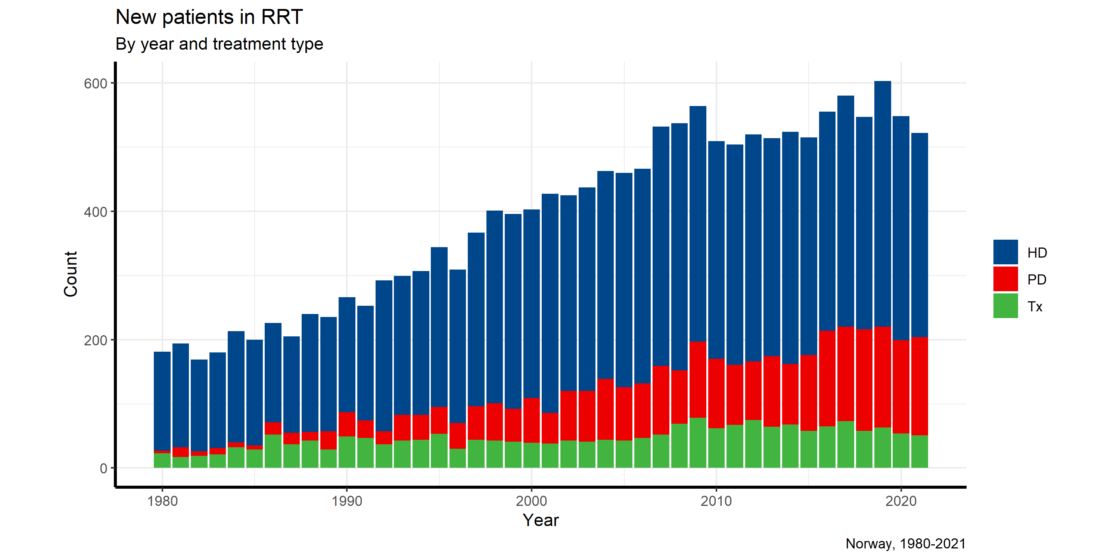

**Figure 19:**

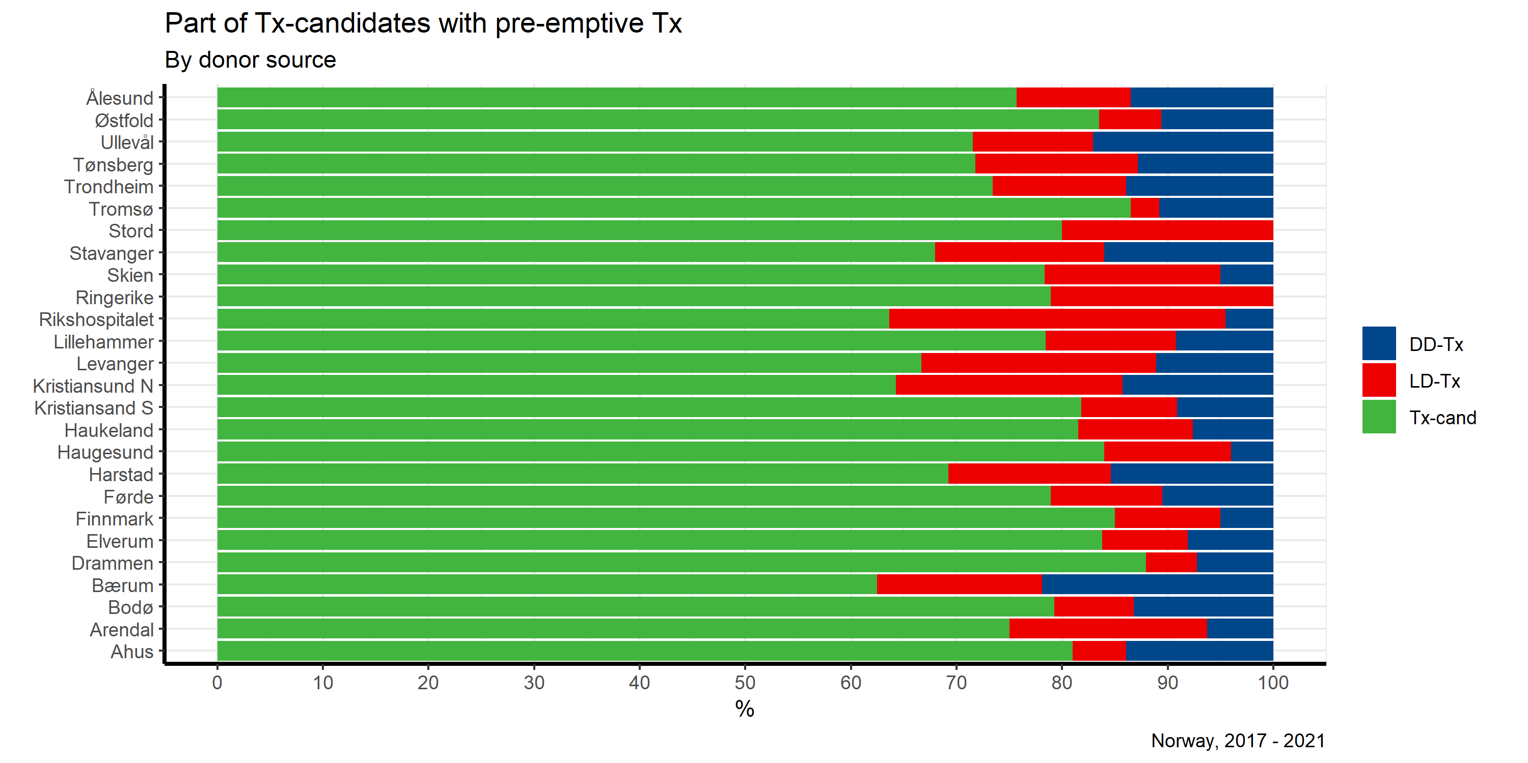

**Figure 20:**

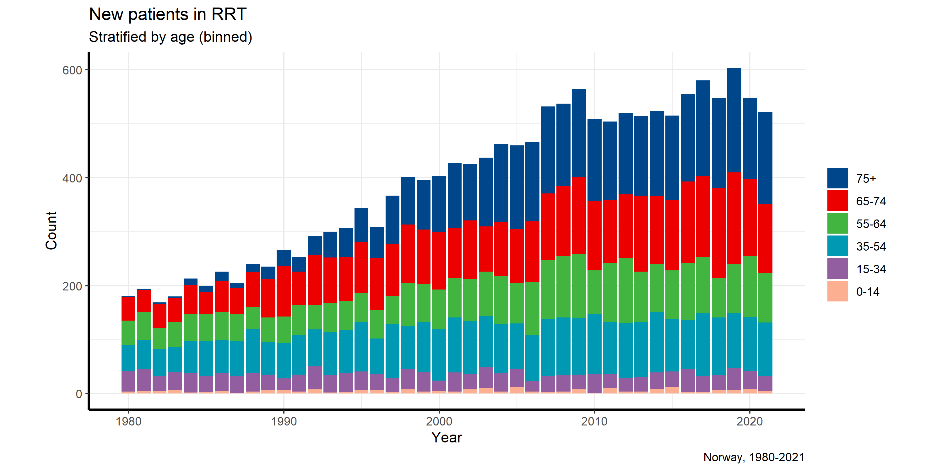

**Figure 21:**

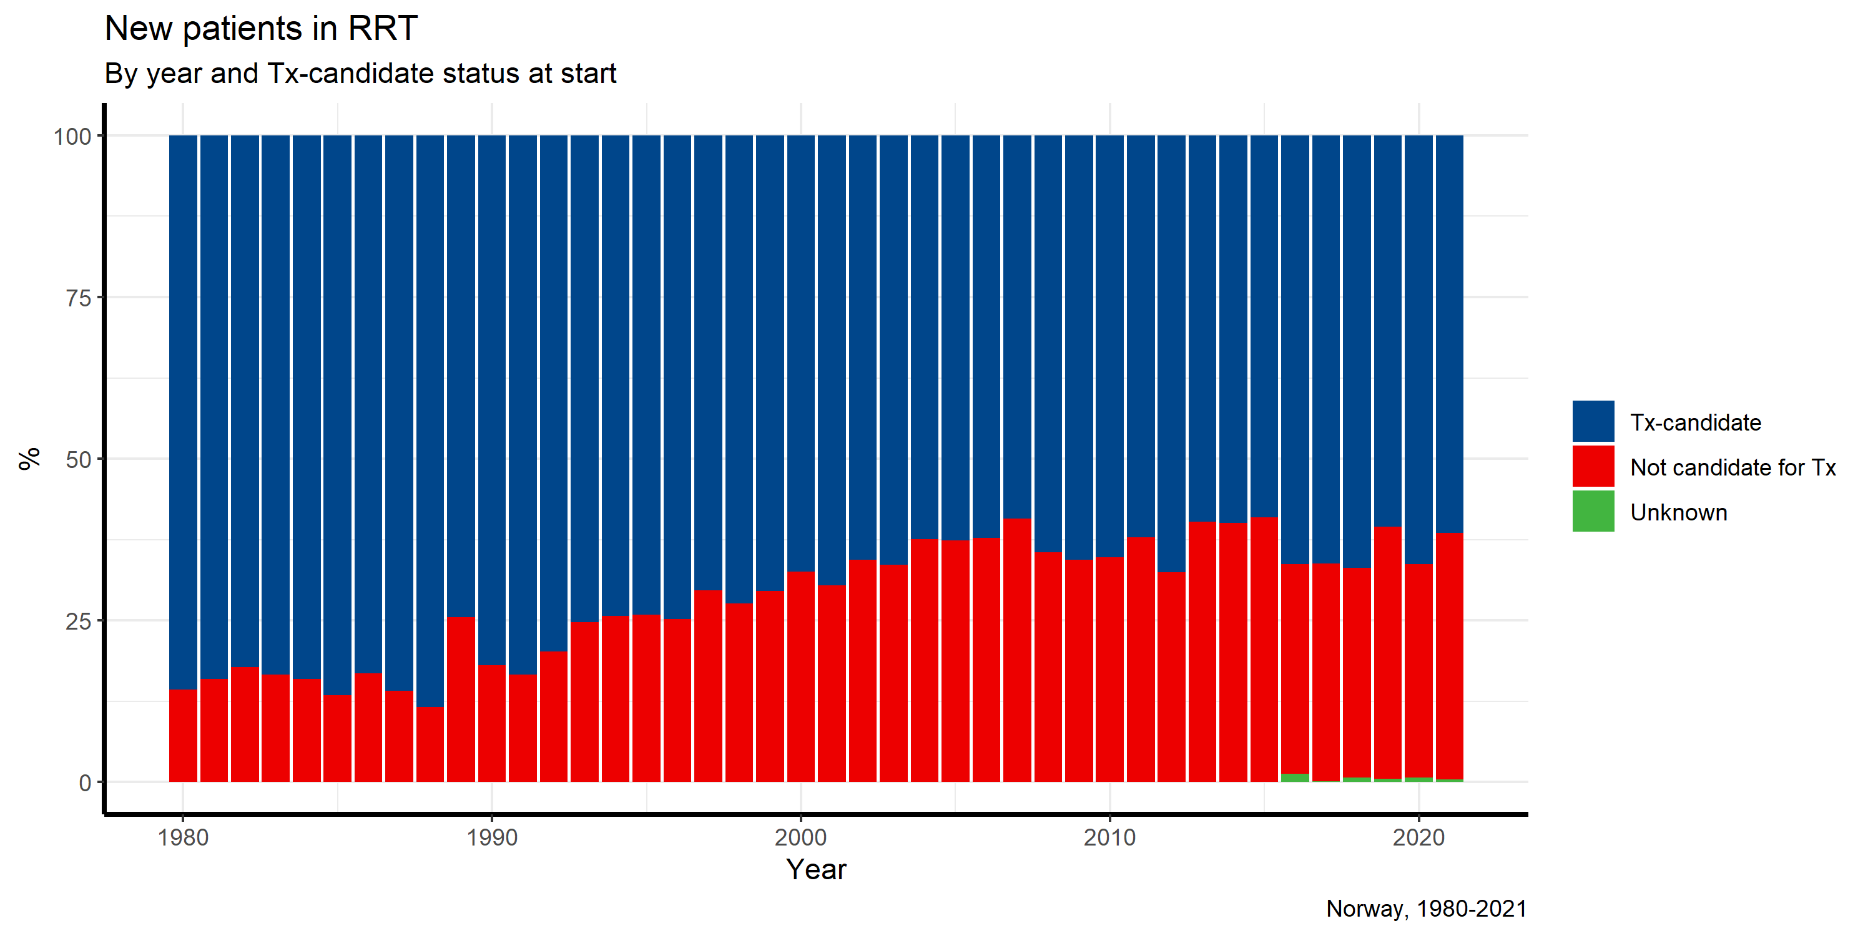

Since registration started in 1980 it has been a continuous shift in patient age. (**Figure 22**) Both the maximum and the median age at start of RRT have increased. Also, the 5-percentile and 95-percentile values (i.e. including the majority of patients) have increased with a similar number of years. But also, younger children have been accepted; the youngest ever started PD in 2011 at age two days. Five children below 16 years started RRT in 2021; transplantation (n=2) and PD (n=3), as compared to 10 in 2020.

**Figure 22:**

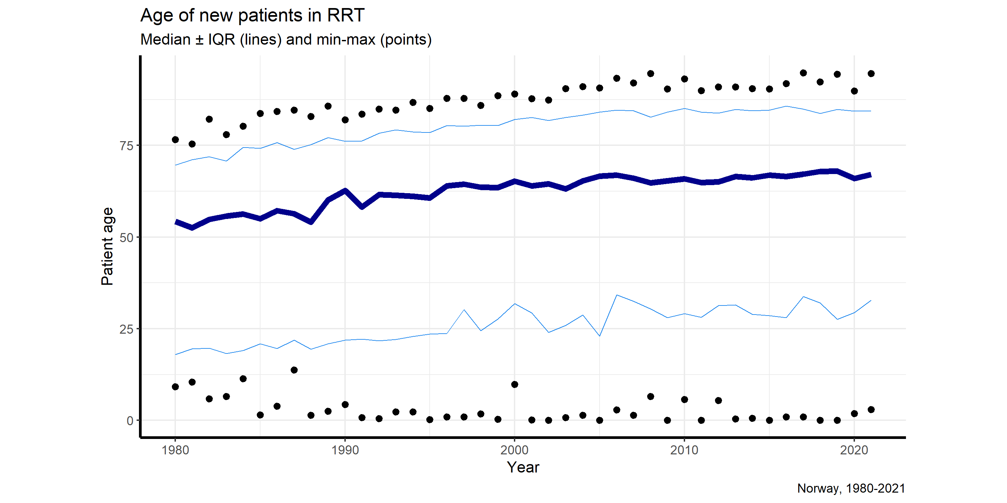

**Table 16. Primary renal disease at start of RRT**

|  |  |  |  |  |  |  |  |
| --- | --- | --- | --- | --- | --- | --- | --- |
|  | 1980-89 | 1990-99 | 2000-04 | 2005-09 | 2010-14 | 2015-19 | 2020-21 |
| Glomerulonephritis | 35% | 27% | 18% | 18% | 16% | 15% | 17% |
| Pyelo/interstitial nephr. | 15% | 11% | 11% | 10% | 9% | 8% | 7% |
| Polycystic diseases | 10% | 9% | 9% | 8% | 7% | 9% | 9% |
| Diabetic nephropathy | 13% | 11% | 15% | 16% | 17% | 17% | 16% |
| Amyloidosis | 6% | 5% | 3% | 2% | 3% | 2% | 2% |
| Vascular/hypertensive | 7% | 21% | 28% | 31% | 32% | 32% | 32% |
| Immune/systemic | 5% | 5% | 4% | 4% | 4% | 4% | 5% |
| Kidney tumor | 1% | 1% | 1% | 2% | 1% | 1% | 1% |
| Myelomatosis | 2% | 2% | 3% | 3% | 2% | 2% | 1% |
| Other defined | 4% | 4% | 3% | 4% | 7% | 7% | 6% |
| Unknown | 3% | 3% | 4% | 4% | 2% | 3% | 3% |
| N: | 2018 | 3234 | 2151 | 2557 | 2570 | 2801 | 1070 |

The main change over time has been an increase of vascular/hypertensive nephropathy and a relative reduction of glomerulonephritis. Whether this only reflects changed coding practice or a true shift is not known.

**Diabetic nephropathy** has stabilized on a higher levels as primary diagnosis cause for renal disease the last decade. In 2021, 17% of these were registered as having Type I diabetes mellitus in relation to 26% in 2020. Including also patients with other primary diagnoses of renal disease a total of 175 patients were recorded as having diabetes mellitus at start of RRT (3% Type I), thus 33 % of new patients in RRT were diabetics. Also here a large decrease in relative contribution of Type I DM from the year before (15%)

The time from onset of diabetes to start of RRT differed considerably. For the patients with Type I diabetes the median time was 33 years, while for the patients with Type II diabetic nephropathy the median time was 18 years.

**Cardiovascular disease** is often present at start of RRT. Coronary heart disease was reported in 23% and 17% had anamnestic heart failure. Echo-verified left ventricular hypertrophy was reported in 22%. Cerebrovascular disease was reported in 14% and peripheral atherosclerotic disease in 15% while 12% had chronic obstructive lung disease.

# Prevalence data CKD5 without RRT by December 31st 2021.

The national coverage of CKD5 patients not in RRT is in the range of 60% to 85%. The registry is currently performing a coverage analysis in cooperation with the Norwegian Patient Registry (NPR). The reported data on CKD5 patients not in RRT should hence be interpreted with caution.

There were 506 CKD5 patients in the registry that did not receive renal replacement therapy by the end of 2021 (515 in 2020). The median length of stay in this category, before being initiated in RRT during 2021 was 13 months, ranging from 0 to 80 months. In total 294 of the 525 (56%) starting RRT during 2021 had not been included in the registry before RRT start; 65% of those starting in HD, 27% of those starting in PD and 8% of those being preemptively transplanted. This underlines that there is a significant underreporting of patients to the registry when they enter in CKD5.

# Prevalence data RRT by December 31st 2021.

By the end of 2021, 5,482 patients in Norway received renal replacement therapy, i.e. 1,004.8 per million inhabitants. This represents an increase of 32 patients or 0.6 % since 2020, similar as the year before.

Median age by the end of the year was 62.3 years, mean 60.4 years and range 2.9 to 95.6 years. Gender: 64.7 % males.

**Table 17. Age distribution in prevalent patients by December 31st 2021**

|  |  |  |  |  |
| --- | --- | --- | --- | --- |
|  | **Total**  **(n:5,482)** | **HD**  **(n:1,395)** | **PD**  **(n:405)** | **Tx**  **(n:3,682)** |
| Age (mean) [years] | 62.3 | 66.3 | 65.5 | 57.7 |
| Age (median) [years] | 60.4 | 68.7 | 79.0 | 59.4 |
| Age (minimum) [years] | 2.9 | 16.3 | 3.2 | 2.9 |
| Age (maximum) [years] | 95.6 | 95.6 | 93.5 | 92.8 |

**Figures 23 and 24** show prevalence per treatment modality, development over time and by center in 2020

**Figure 23:**

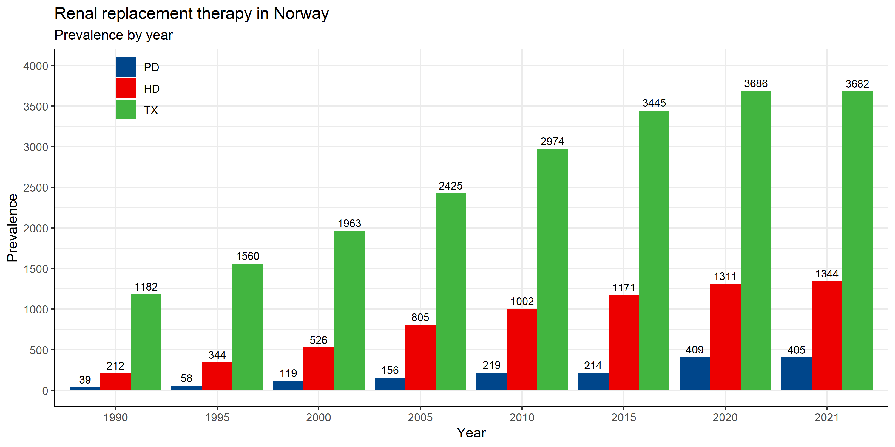

**Figure 24:**

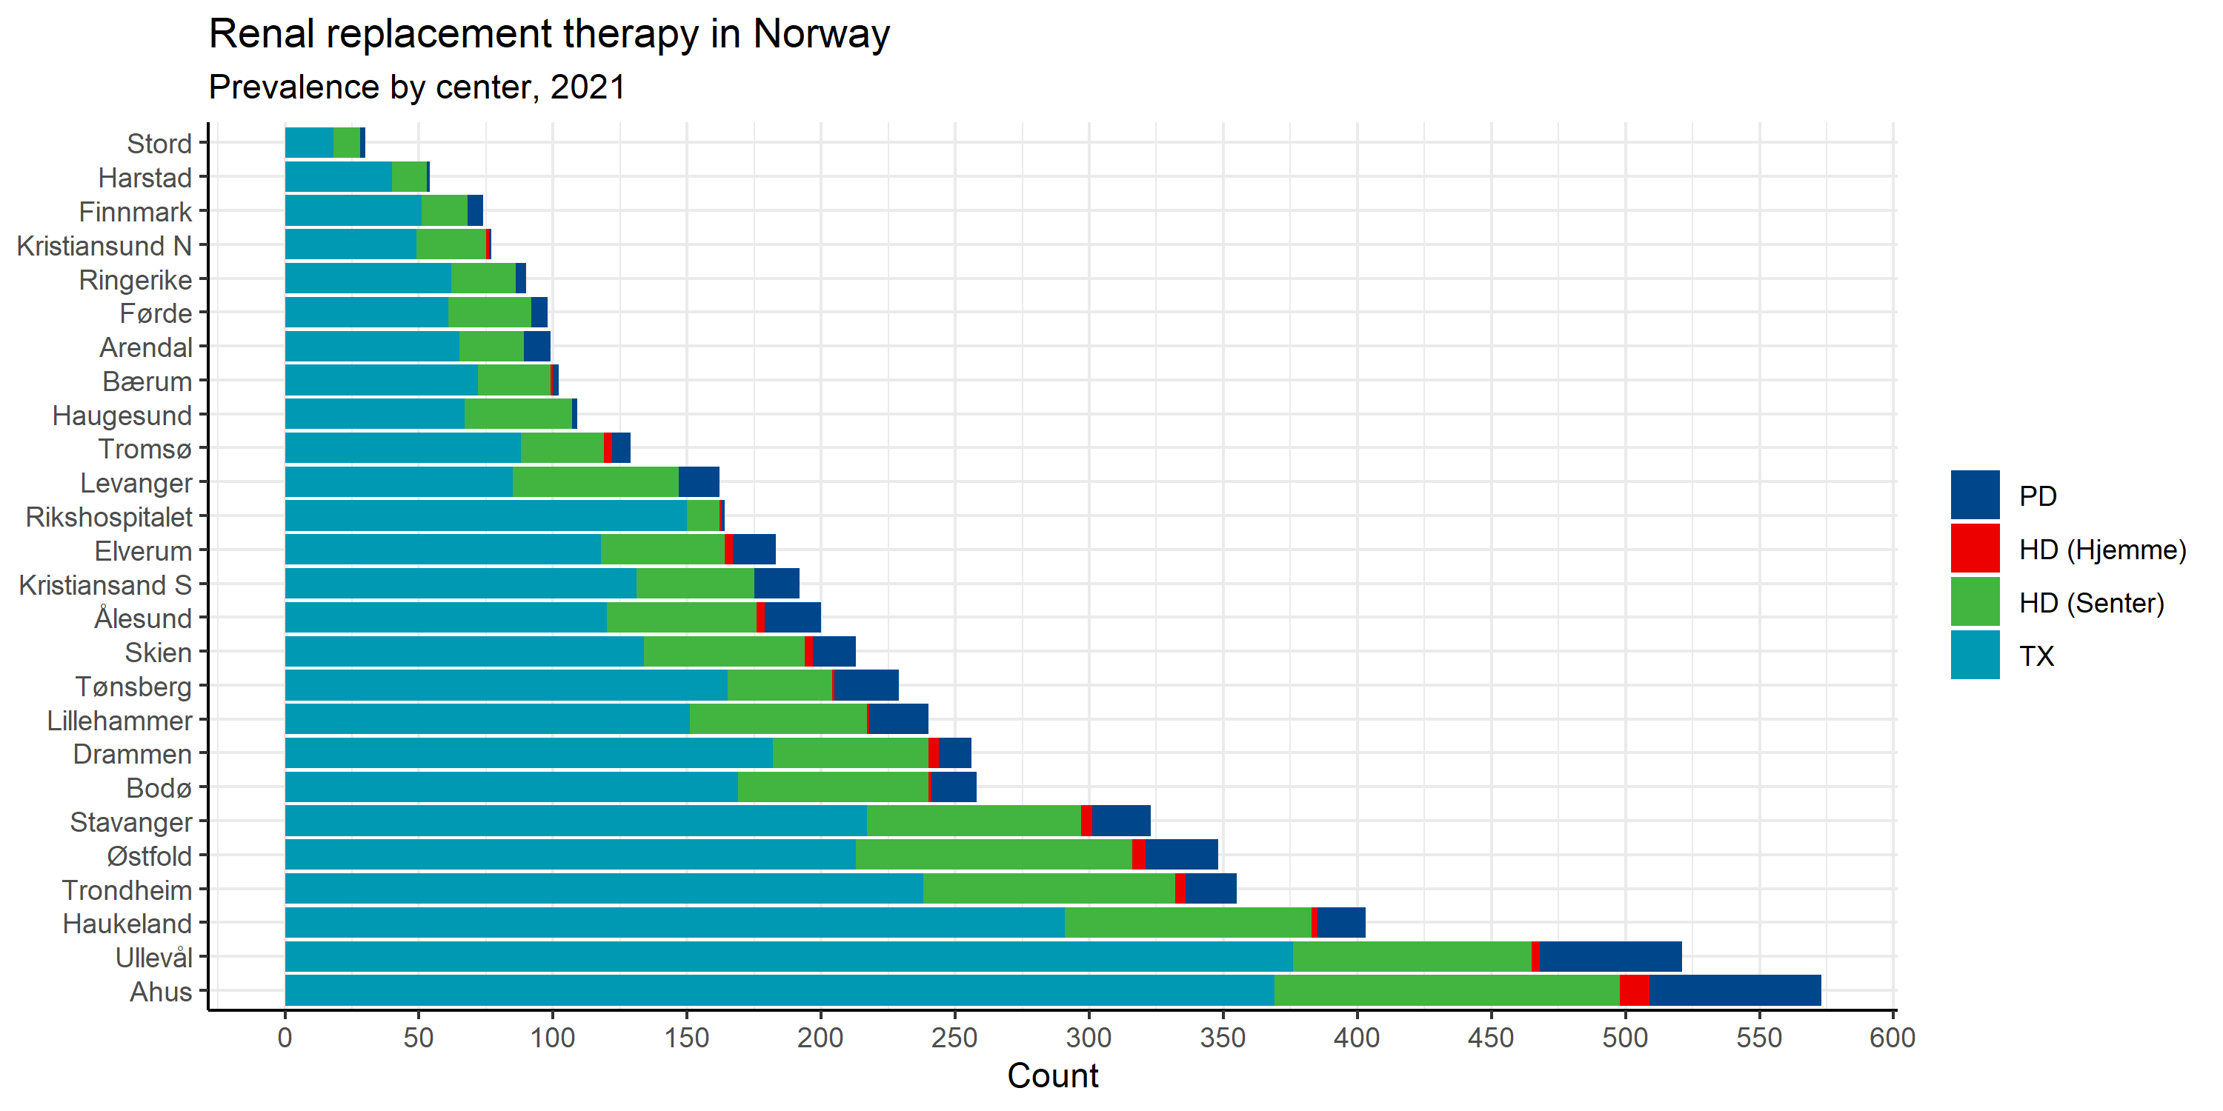

### New annual variables in the registry:

Information about SARS-CoV-2 IgG status was included in the capture of annual data 2021. The data is unfortunately incomplete since only 10-20% of patients in the different groups are reported to be IgG positive, while data from the national screening study, with samples from more than 80% of all RRT patients, that the registry has initiated, indicate that about two of three patients are IgG positive.

### Transplantations and patients listed for transplantation:

A total of 231 renal transplants were performed in Norway in 2021, i.e. 42.3 per million inhabitants, 16% were retransplantations. Preemptive transplantation was performed in 26% of all first transplantations in 2021, an increase by 4%-points from the year before (22%). The144 non-preemptive, first transplant recipients had been in dialysis for a median of 2.05 years (mean 2.5 years), ranging from 7 days to 11.4 years. Distribution of transplantations with deceased and living donors, relation between recipient and donor etc. is presented in the figures below. Simultaneous pancreas and kidney (SPK) transplantation was performed in 4 patients and simultaneous liver and kidney transplantation in 3.

In principle, transplantation is offered to all patients considered to profit from it, with no strict upper or lower age limit. The age of the 137 first-DD-graft recipients in 2021 ranged from 7 to 82 years, with a median age of 61 years. Out of these, 39% were above the age of 65 and 10 % were 75 or older. The 57 recipients of a first-LD-graft were from 2.1 to 78 years, with a median age of 46 years. Regraft recipients, LD and DD (n=37), were from 9 to 71 years, median 48 years.

### Fun-facts Transplantation (by 31.12.2021):

The oldest kidney transplant recipient ever was 84.1 year at time of transplantation (youngest 9.5 months). In total 1,006 recipients have been transplanted at an age older than 70 years, 44 older than 80 years. The oldest kidney transplant recipient became 93.8 years and the now living oldest recipient is 92.8 years. In total 15 patients have become older than 90 years (3 now living) and 634 reached an age over 80 years (131 now living).

The longest graft survival is 52.1 years, and still functioning. In total 51 (28 still working) grafts have functioned in a new body for over 40 years. The oldest transplanted kidney ever is 110.7 years and it is still working. In total 12 (5 still working) transplanted kidneys have reached a total age of over 100 years and 84 (35) over 90 years.

**Figure 25:**

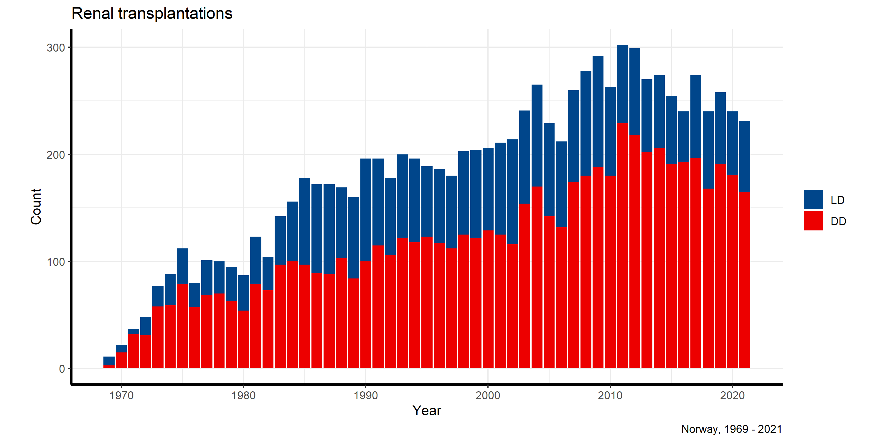

**Figure 26:**

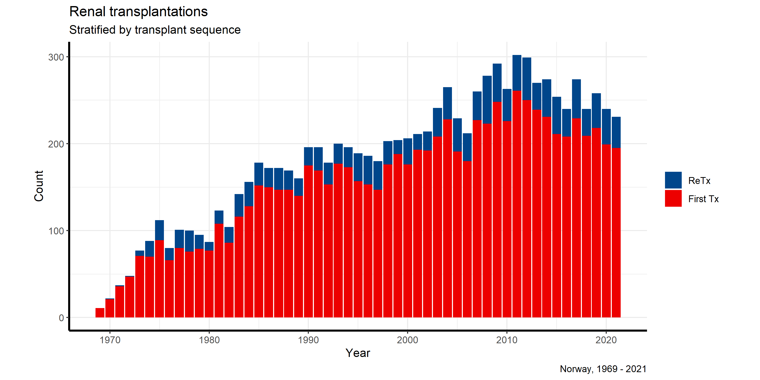

**Figure 27:**

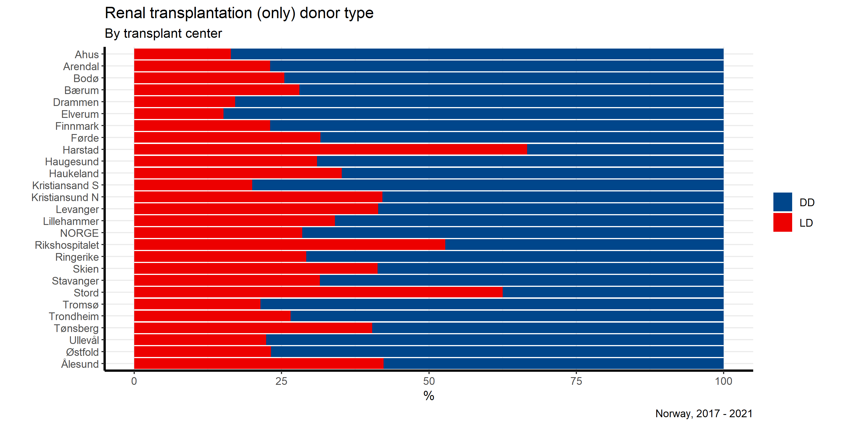

**Figure 28:**

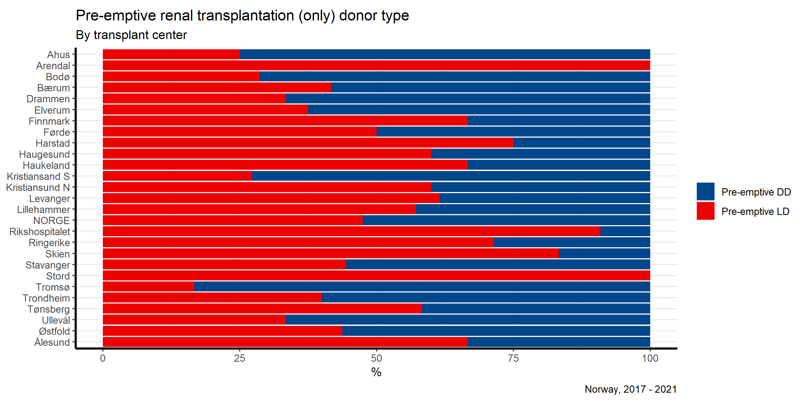

**Figure 29:**

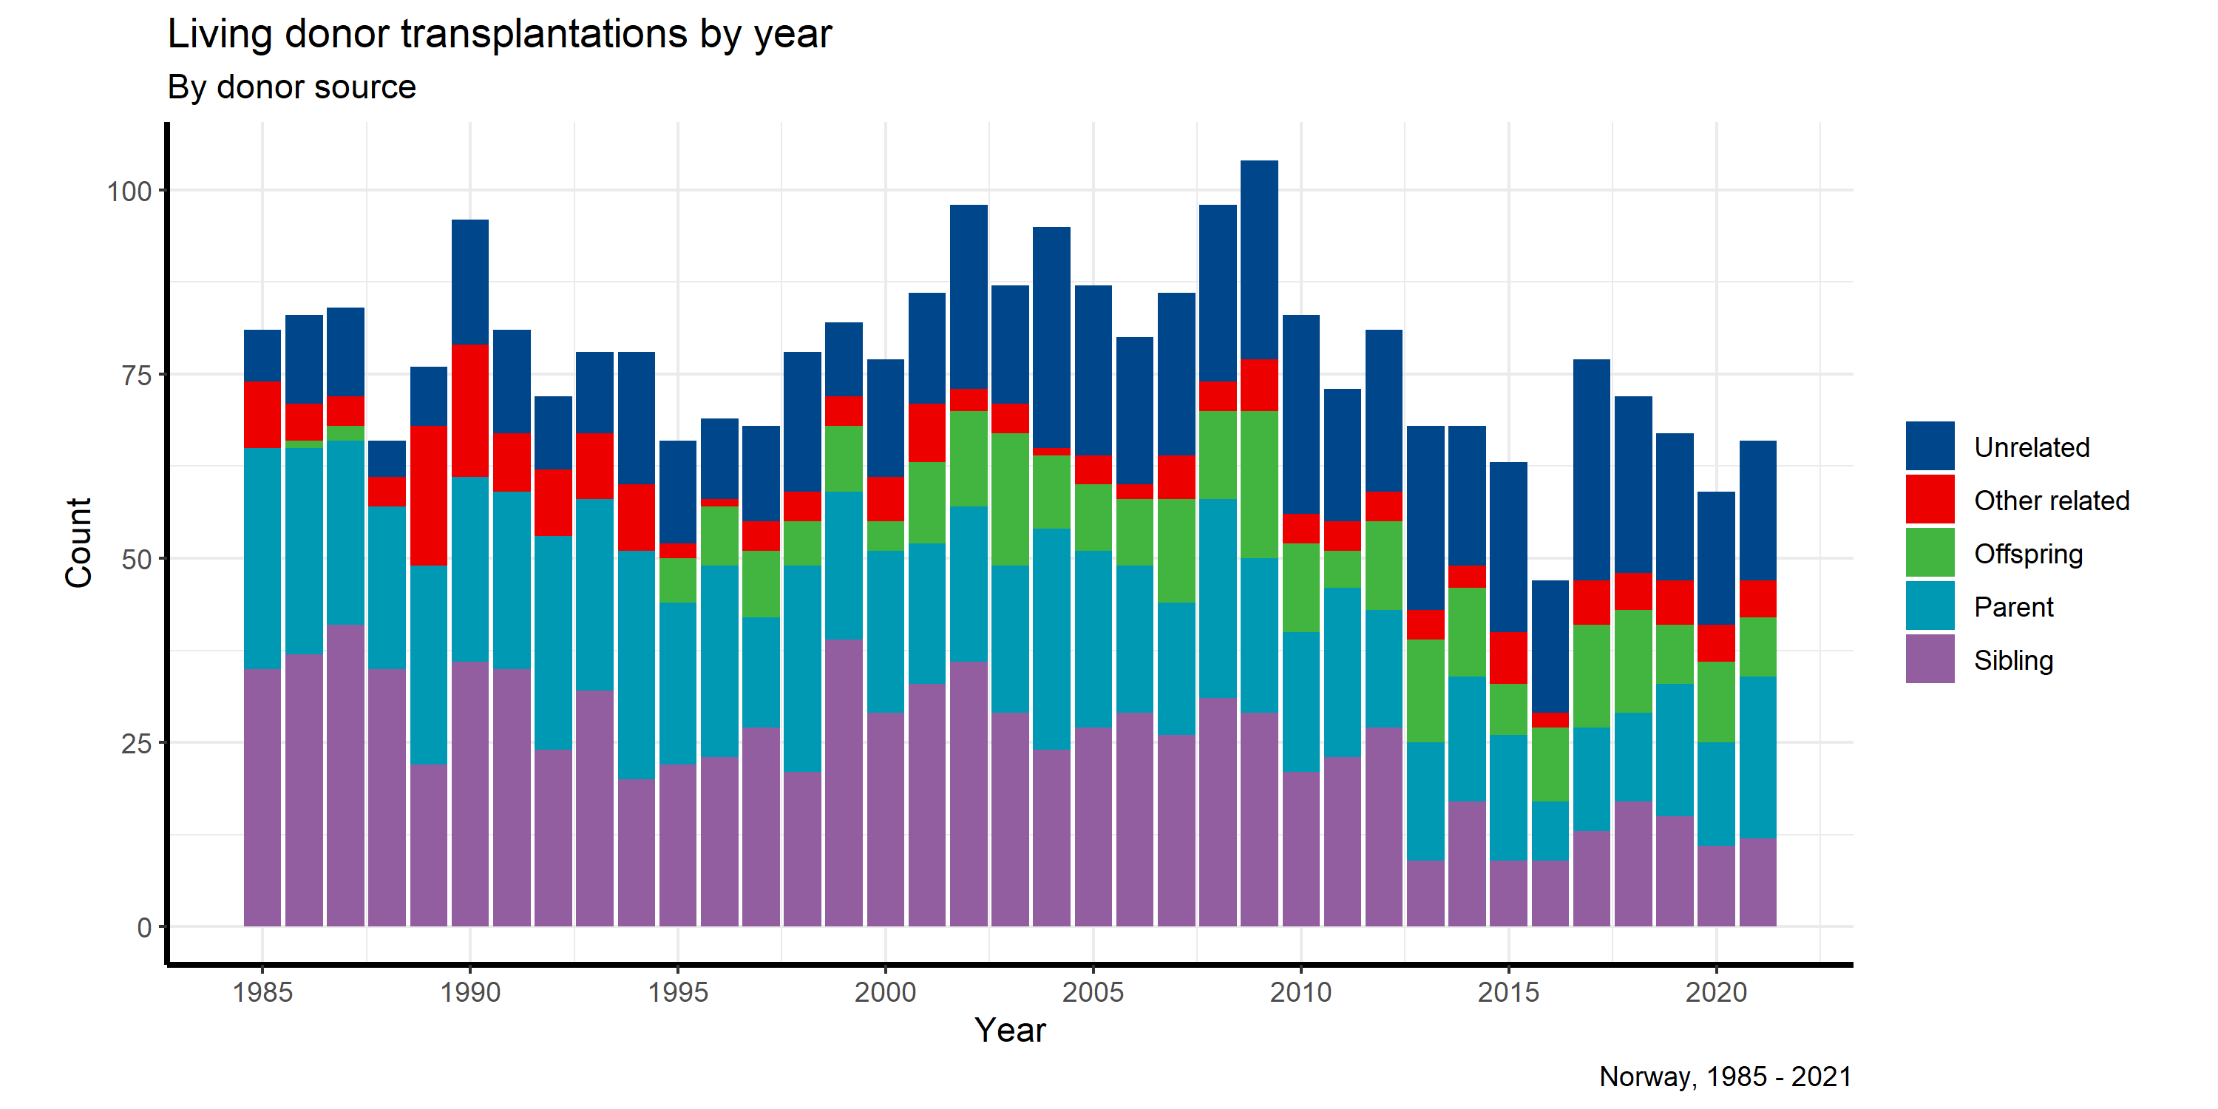

**Figure 30:**

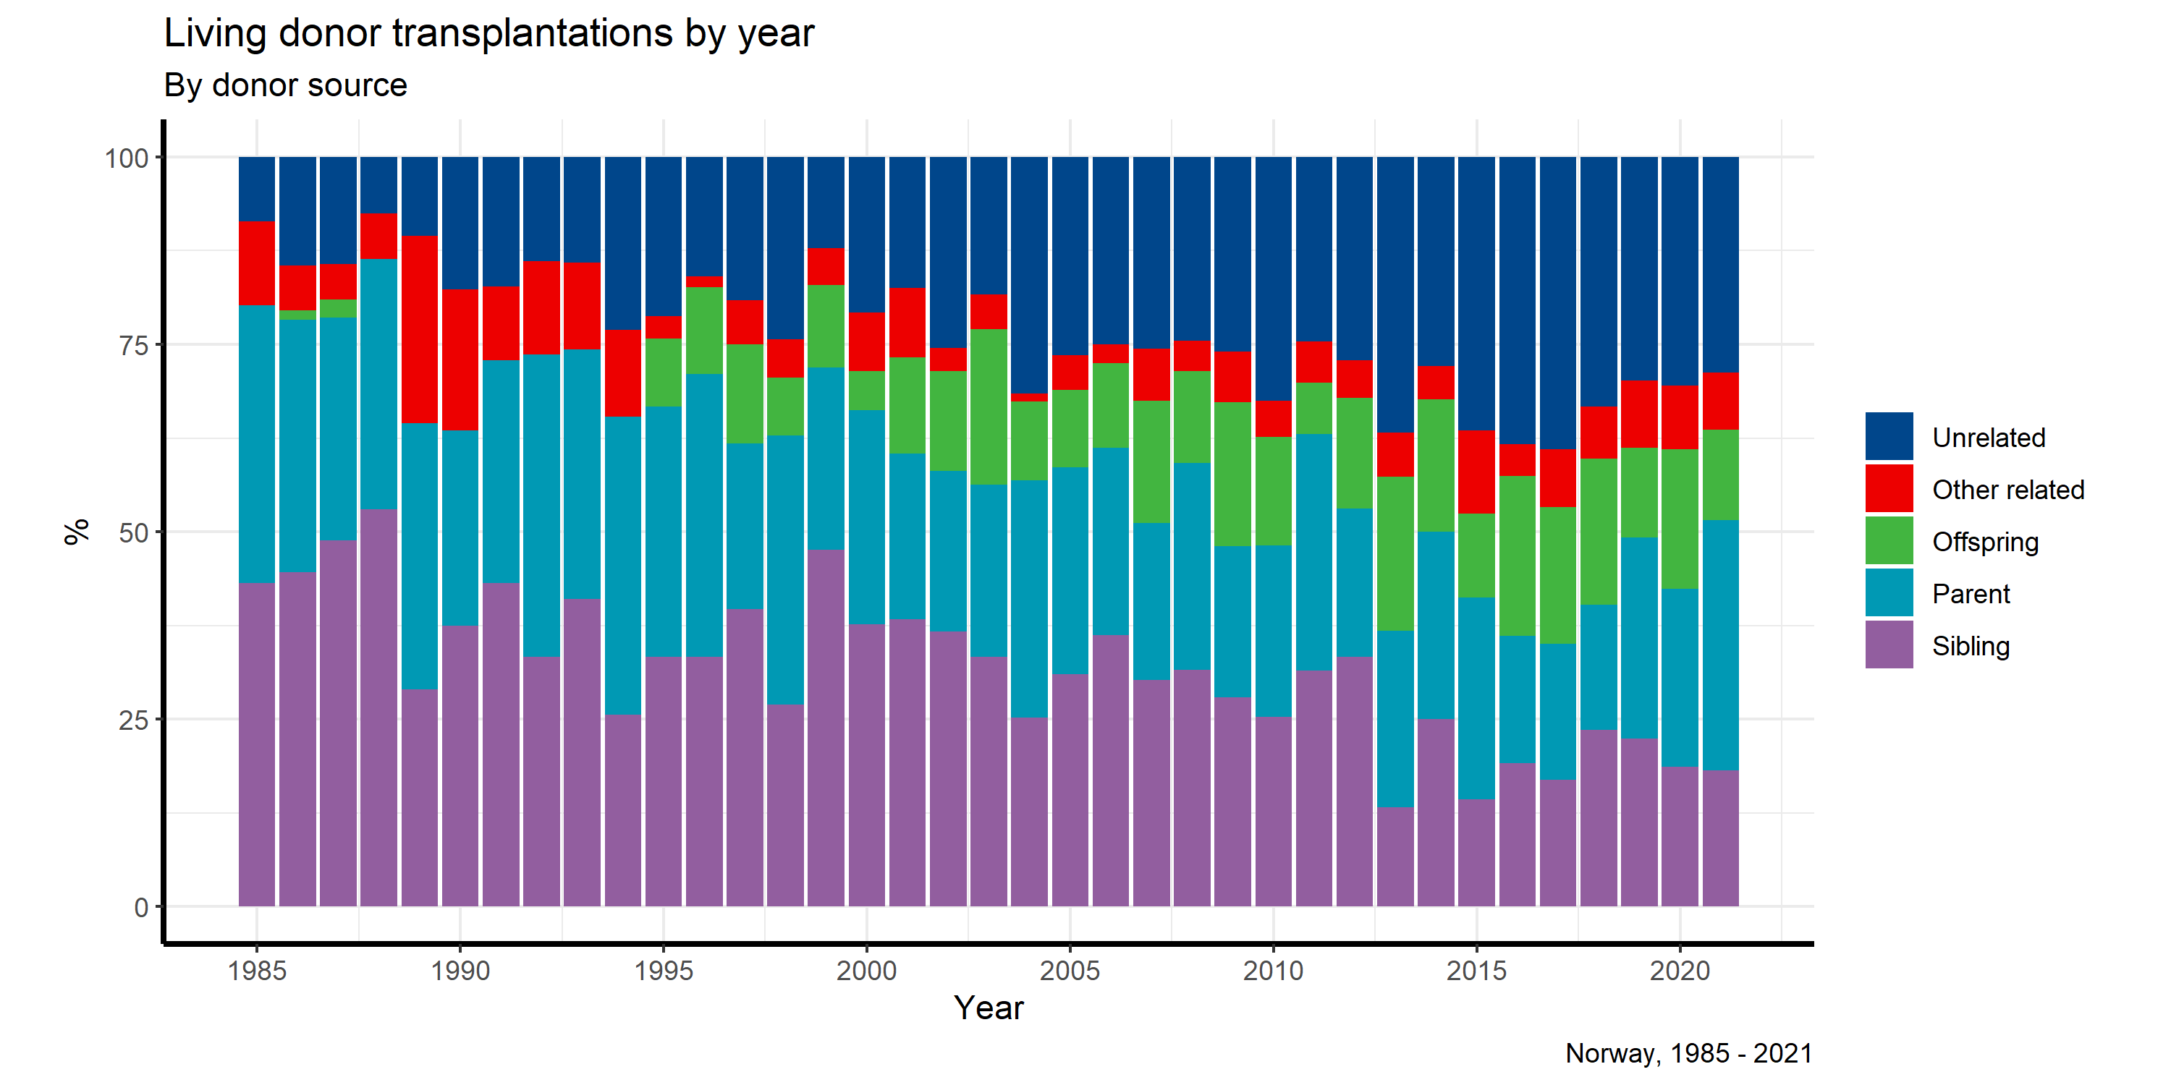

The list of patients actively waiting for a kidney transplant at entry into 2021 consisted of 410 patients and at the end of 2021 it has decreased to 391 patients (71.7 per mill.) due to more patients temporarily off the list. Including those temporarily not on the list, the total number waiting for a kidney at the end of 2021 was 565 patients (103.6 per mill.), an increase from 535 by end of 2020 (459 end of 2017).

Among those actively waiting by December 31st, median time on the list was 14 months for a first transplant, 45 % had waited less than one year and 25 % more than two years. The 165 recipients transplanted with a DD-graft in 2021 had a median waiting time of 18 months for a first transplant and 14 months for a retransplant and a maximum of 84 months at the time of grafting.

**Figure 31:**

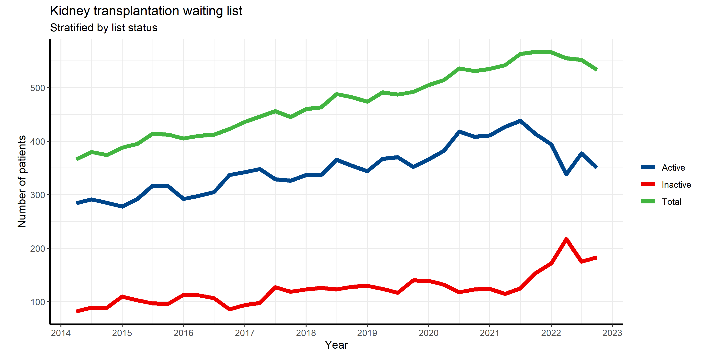

# Patient and graft survival:

Below different Kaplan-Meier analyses on graft (not death censored) and patient survival are presented, crude plots only. Changes in baseline characteristics should be taken into consideration, for example that median age when starting RRT is increasing by the year.

**Figure 32:**

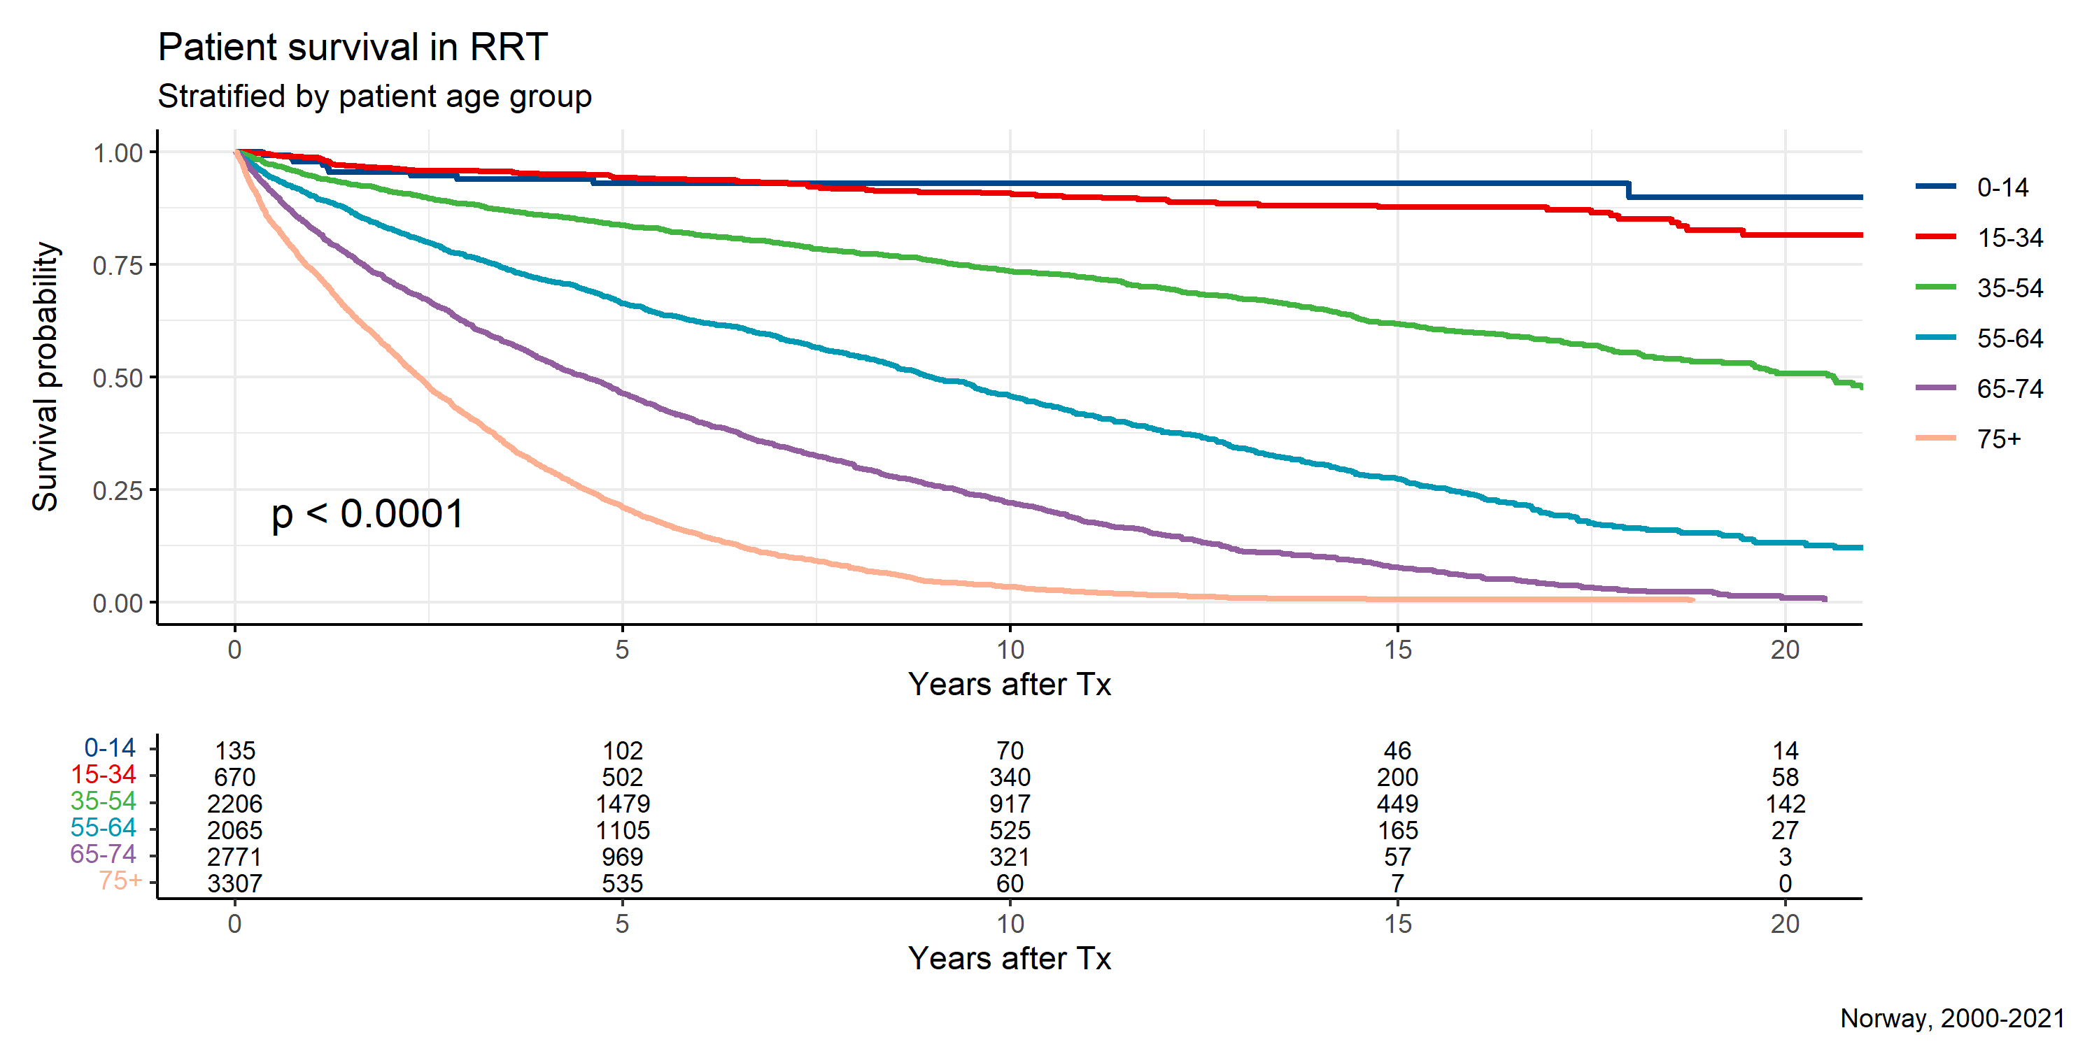

**Figure 33:**

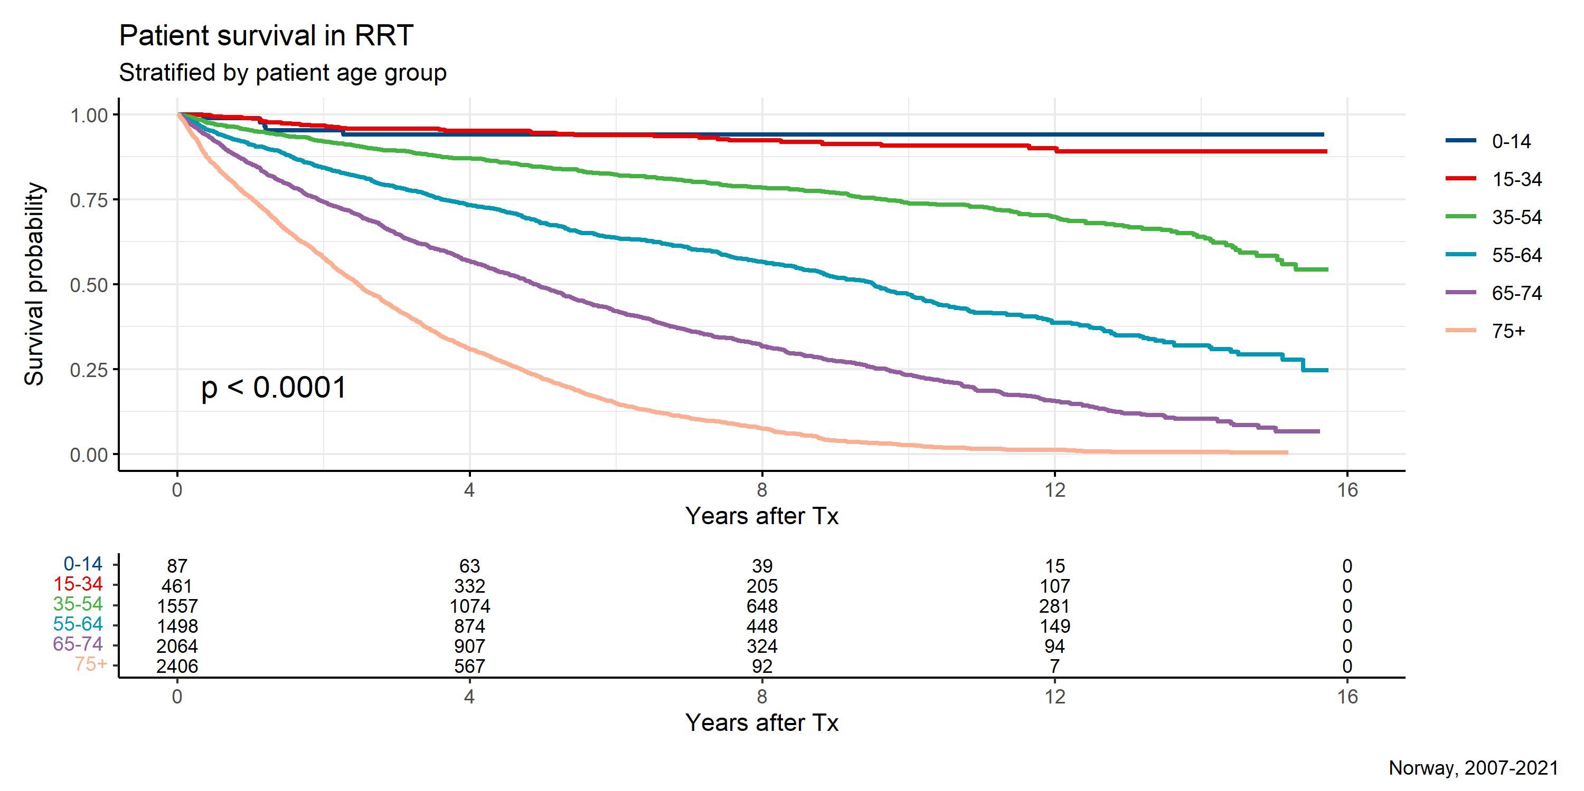

**Figure 34:**

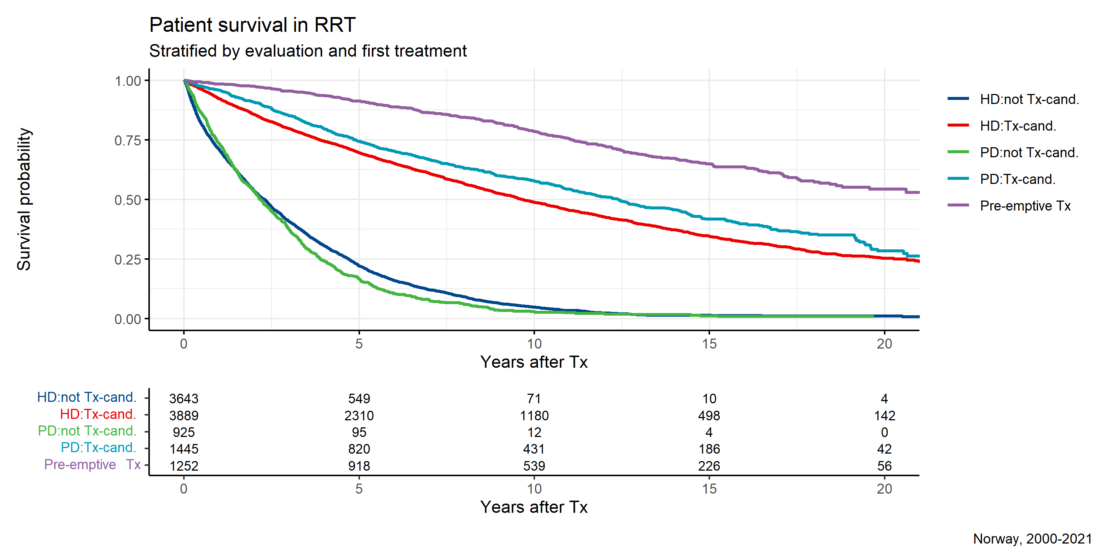

**Figure 35:**

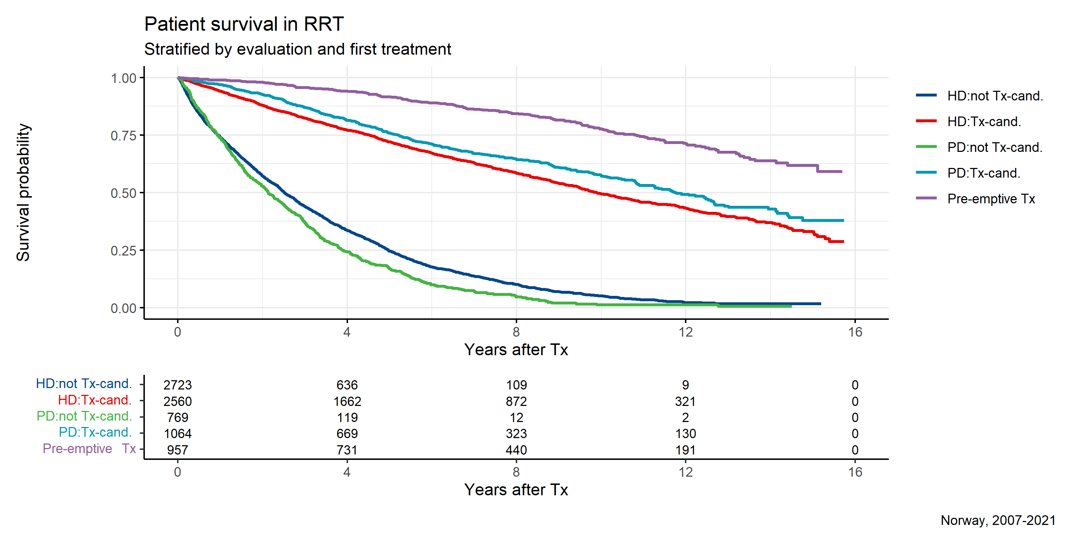

A new analysis last year’s annual report is repeated here; the 2-year patient survival of patients in renal replacement therapy has been included. The data, both un- and age adjusted, are shown in **Figure 36** for each health region separately. The trends are presented using 1-year overlapping, 4-year bins since the year 2000.

**Figure 36:**



**Figure 37:**

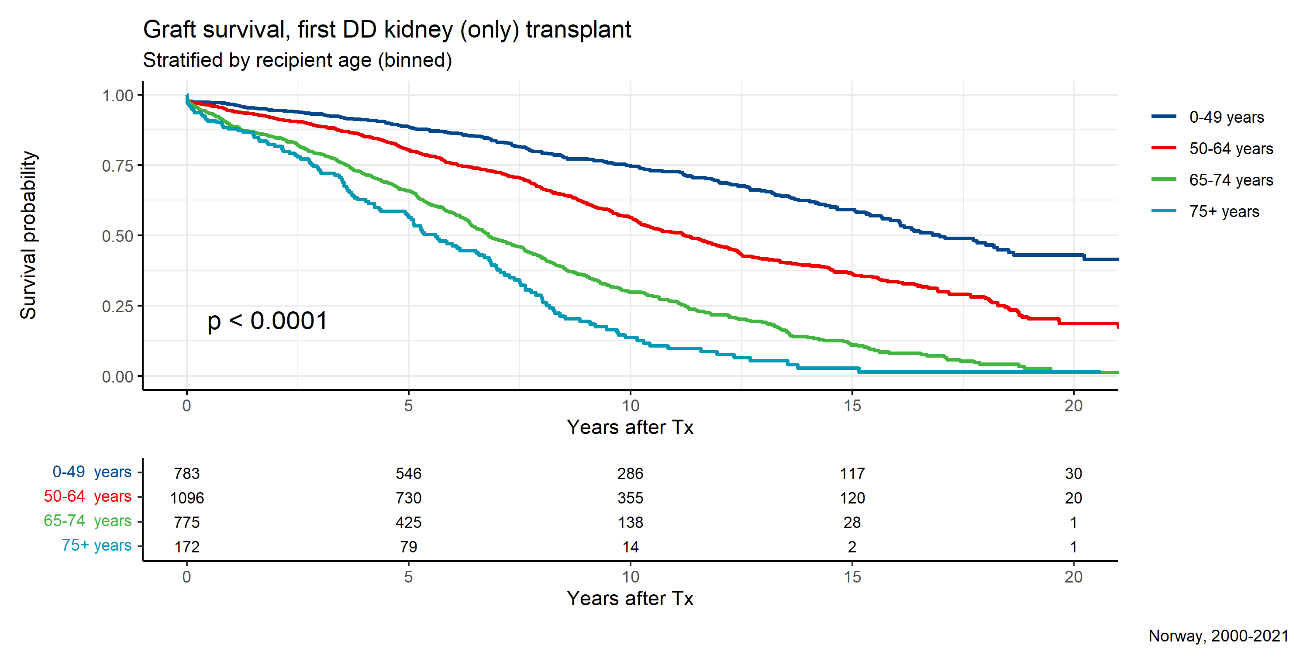

**Figure 38:**

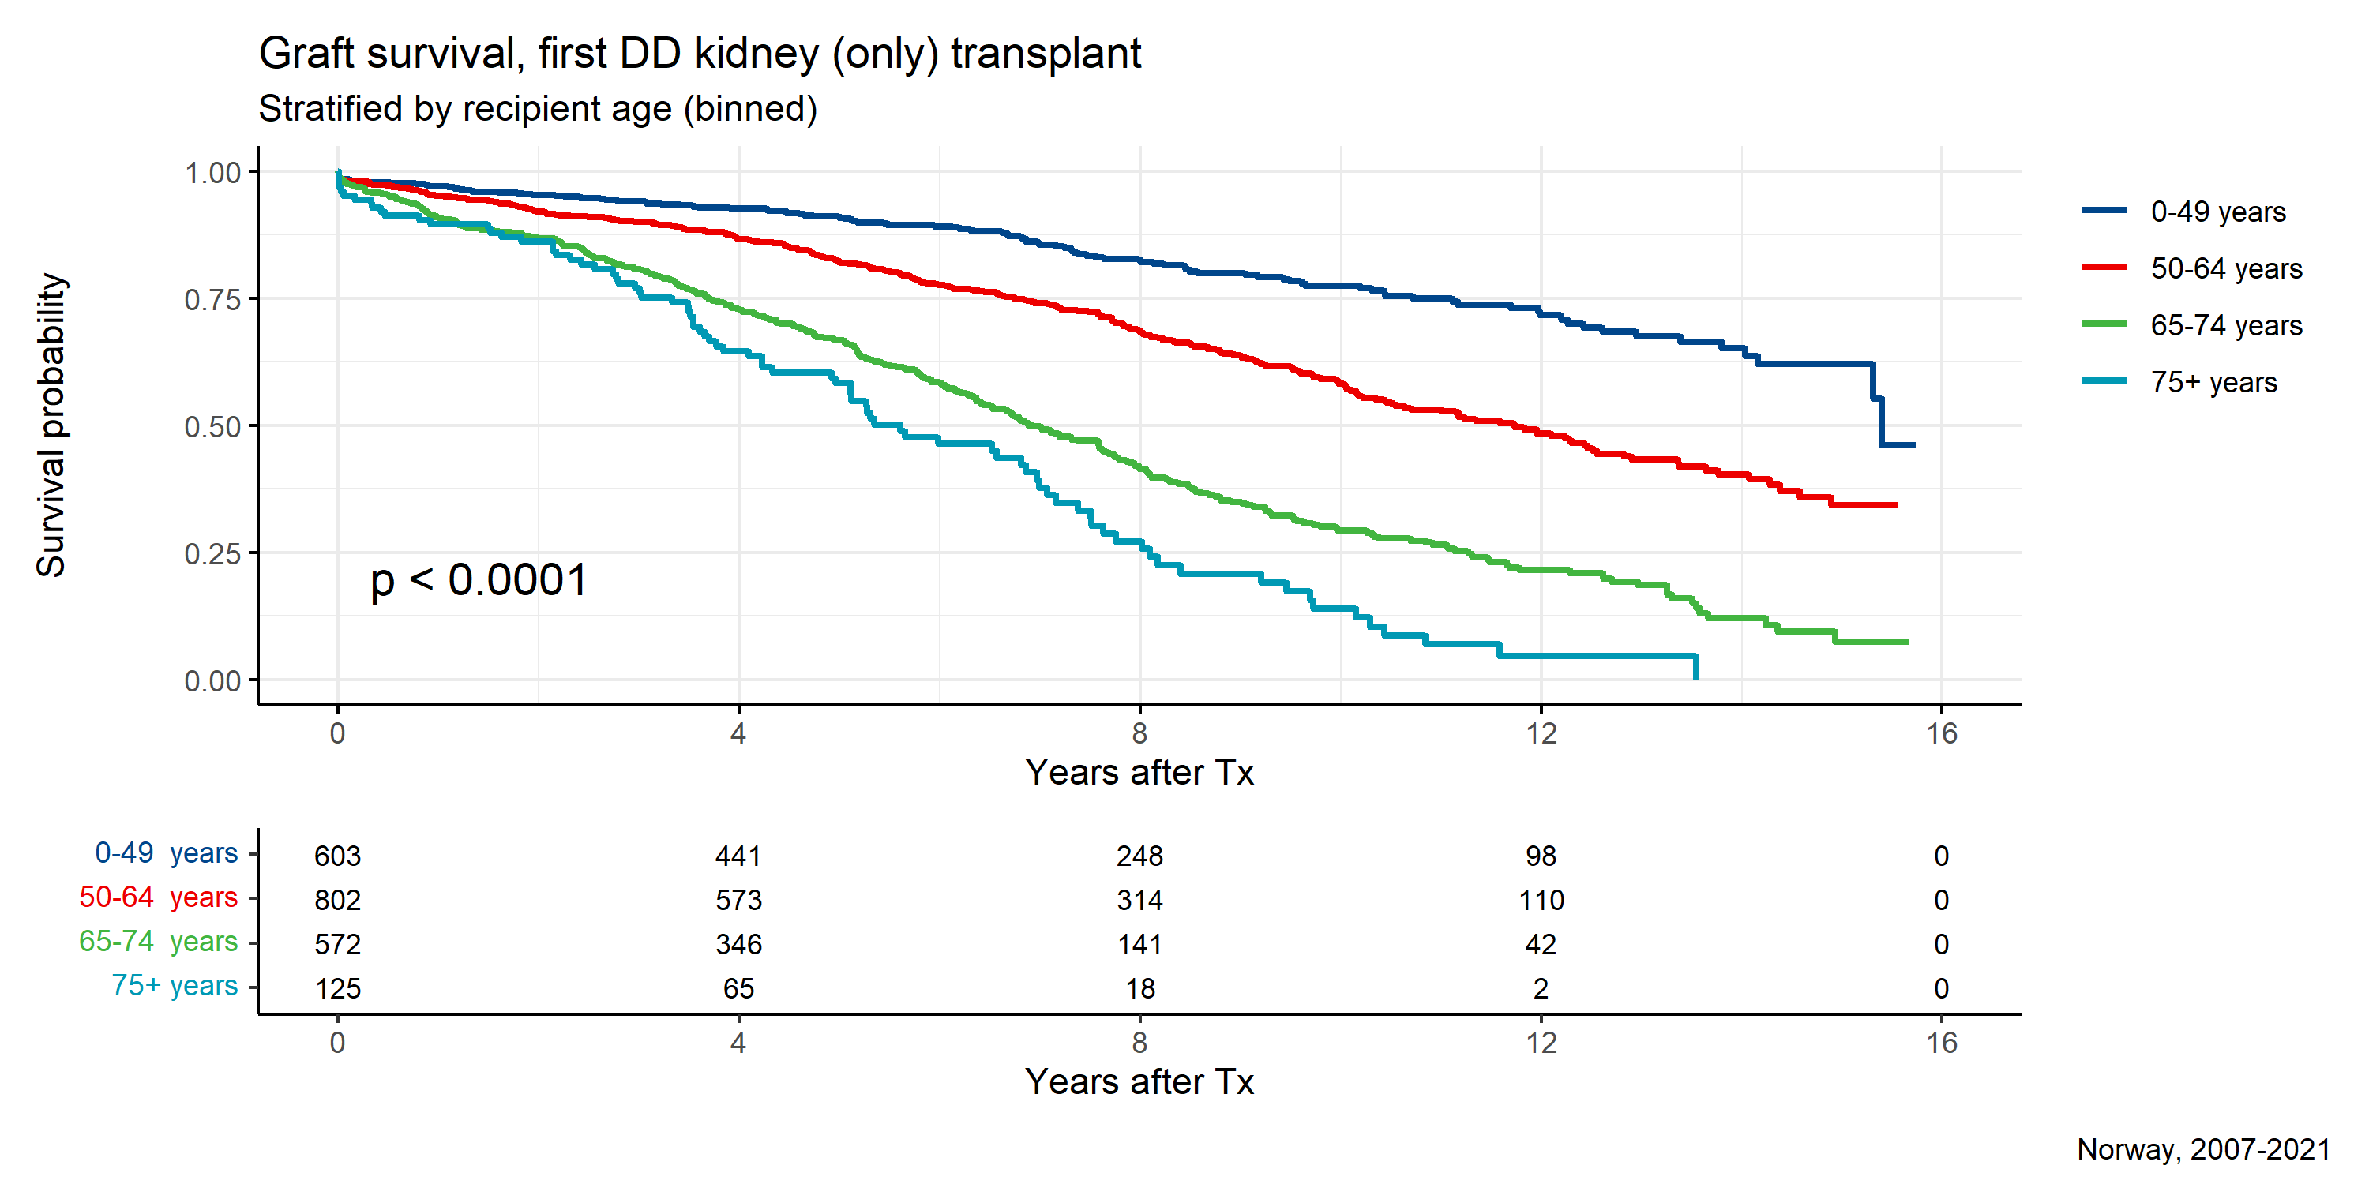

**Figure 39:**

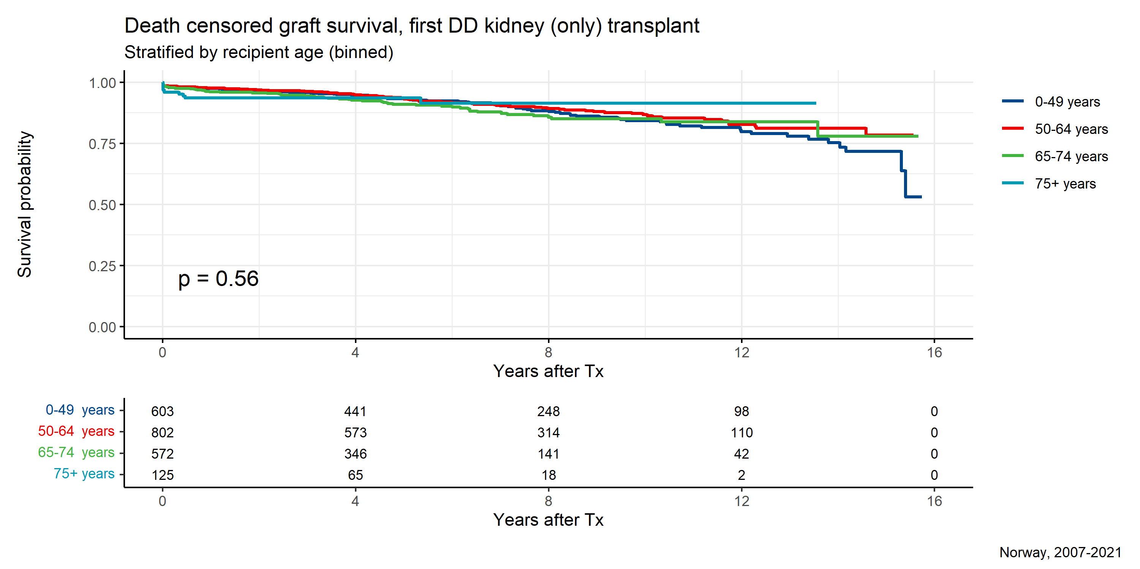

**Figure 40:**

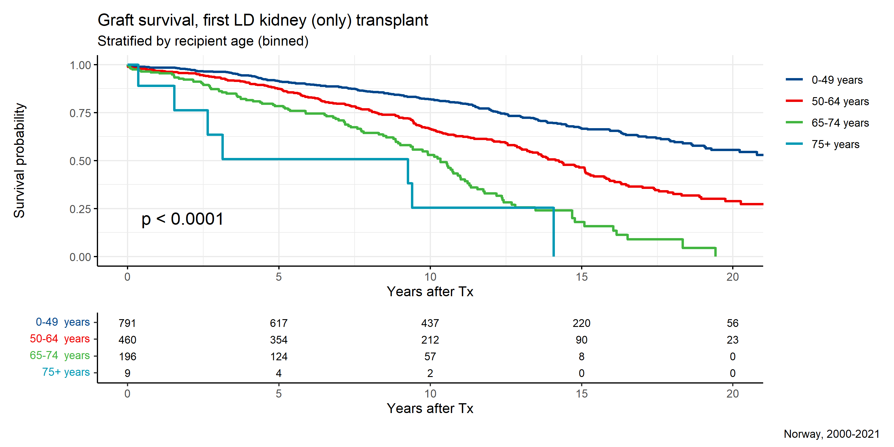

**Figure 41:**

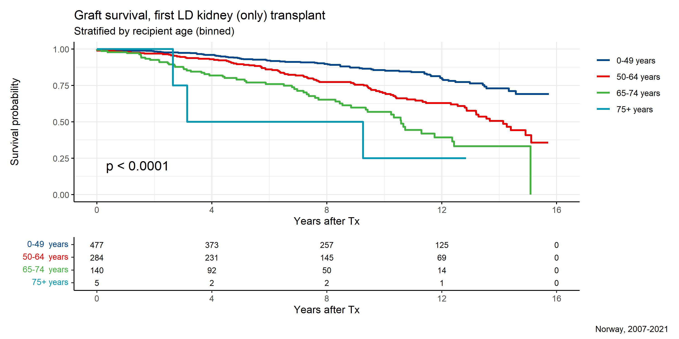

**Figure 42:**

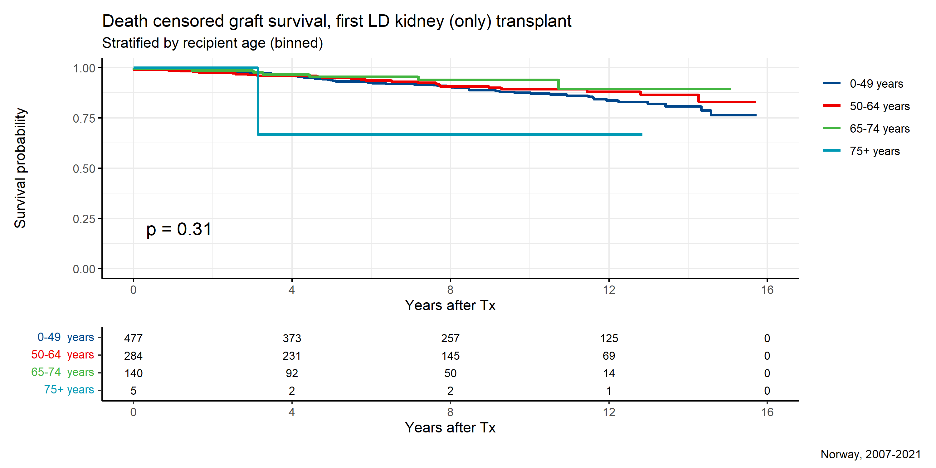

**Figure 43:**

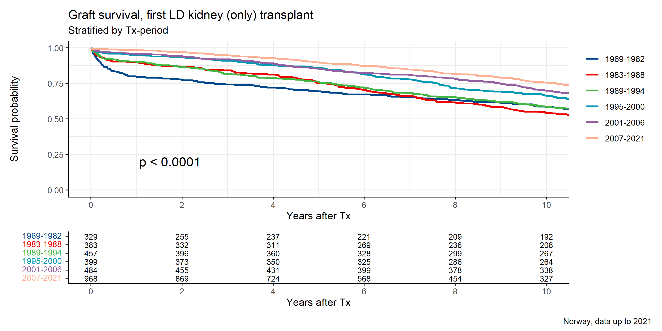

**Figure 44:**

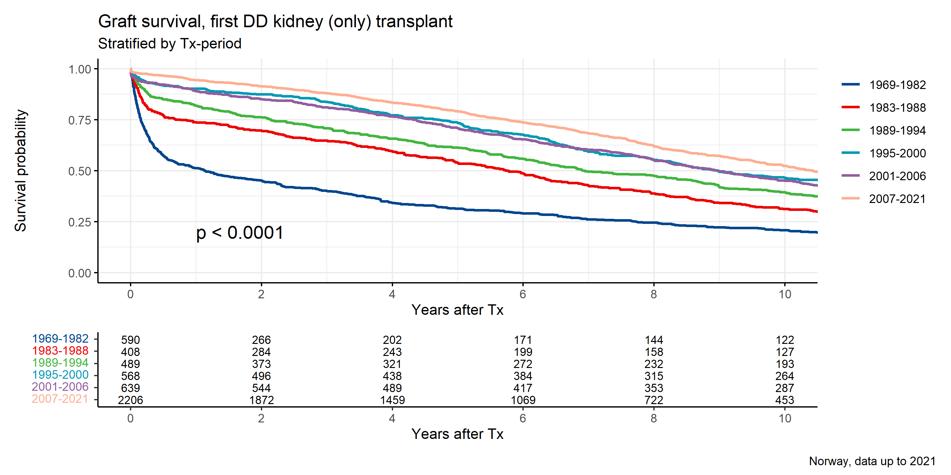

**Figure 45:**

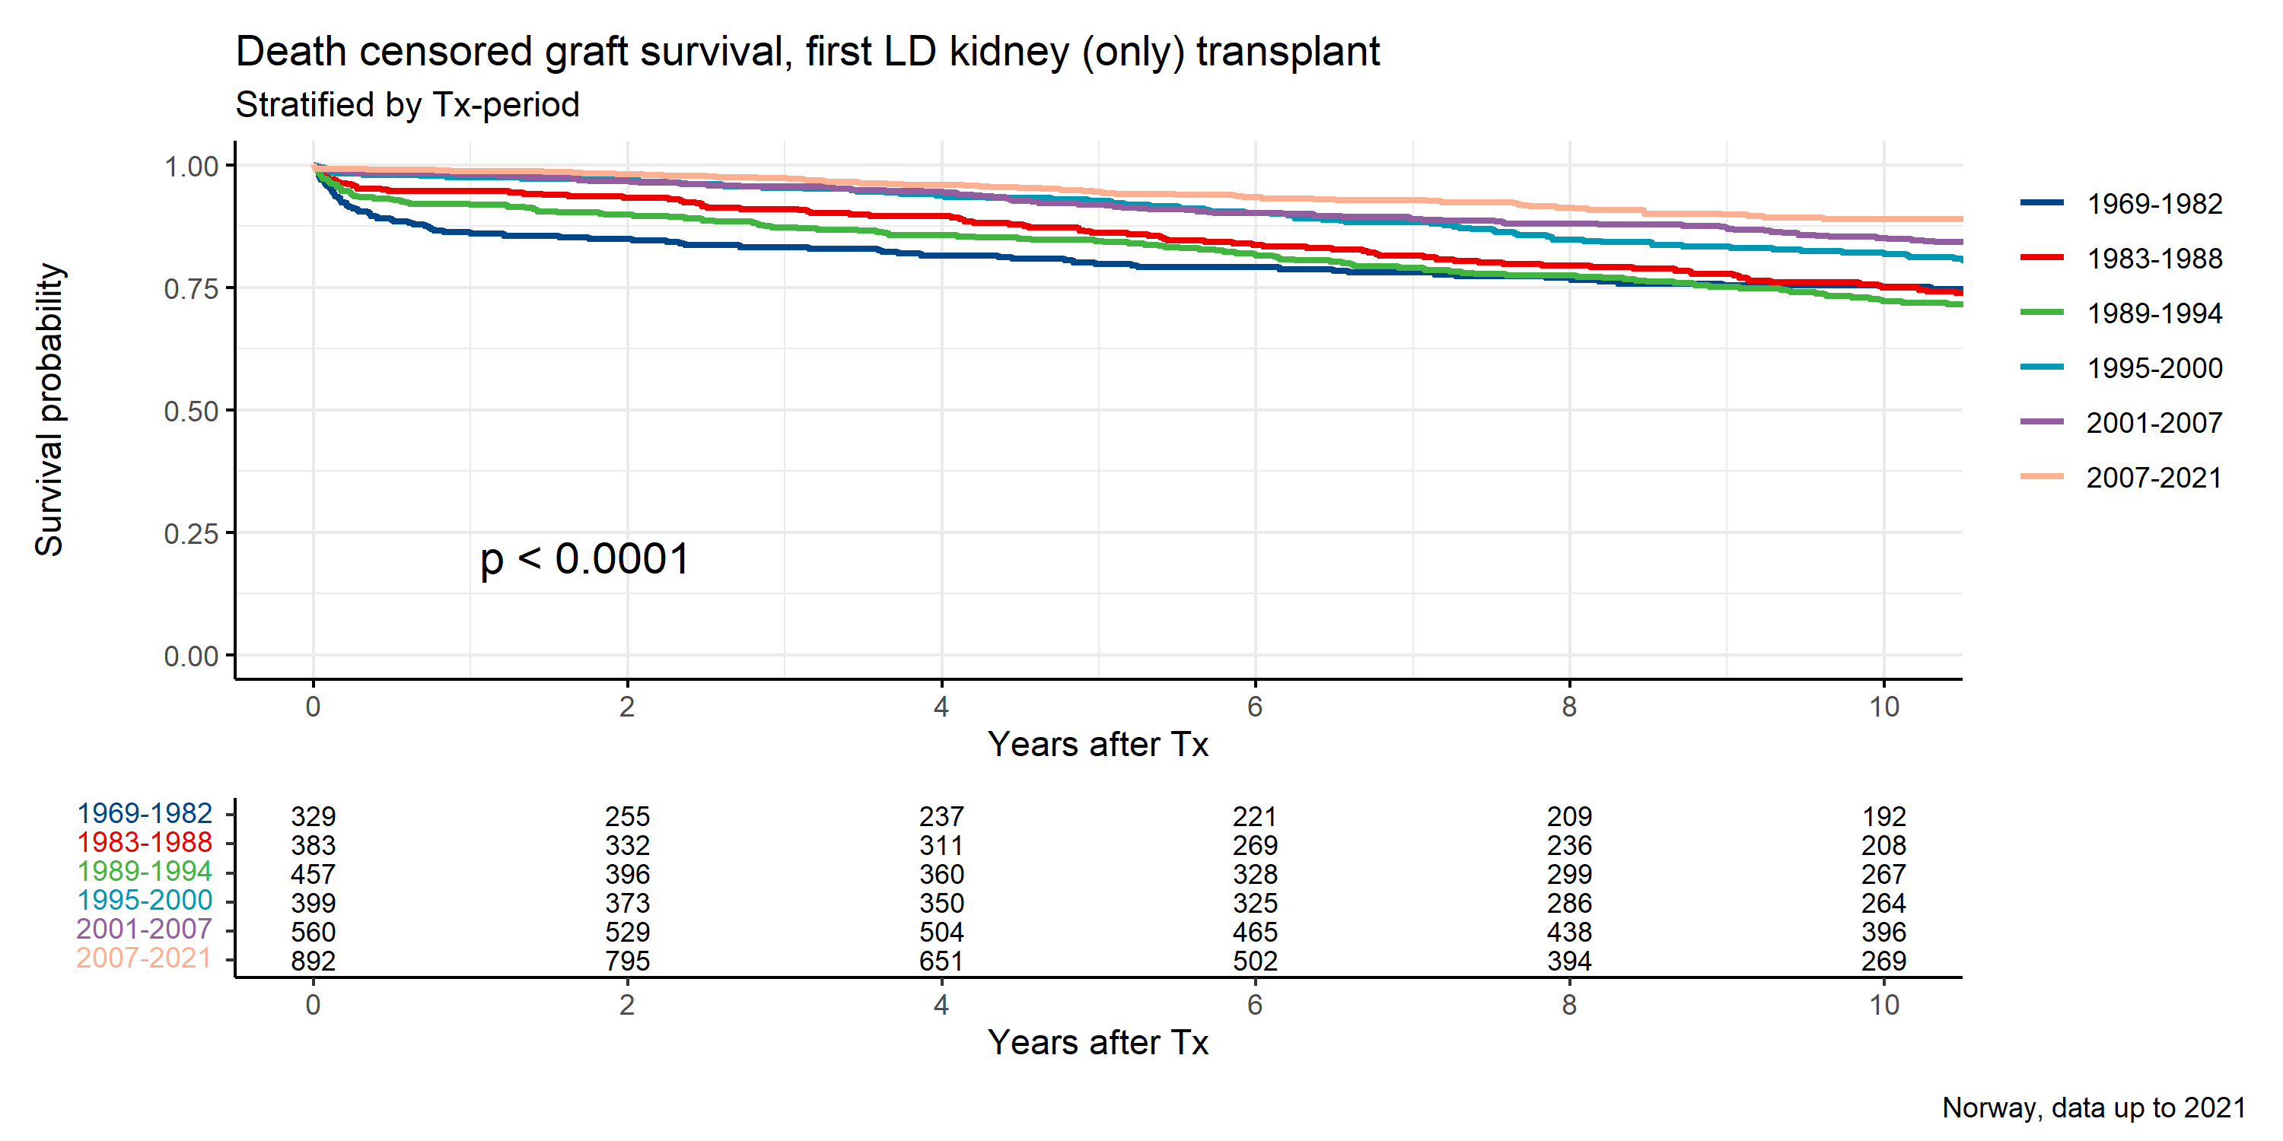

**Figure 46:** 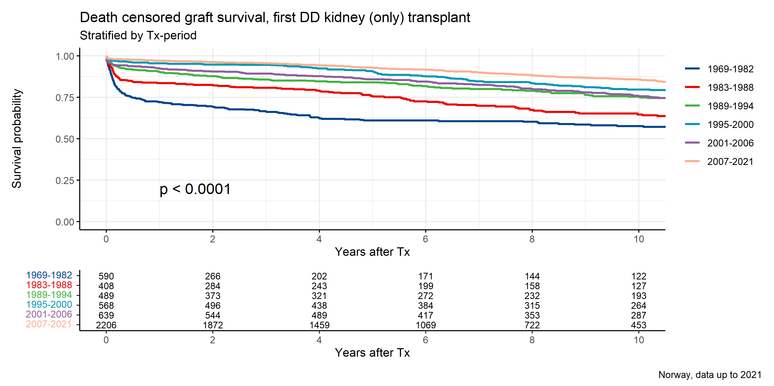

**Figure 47:**

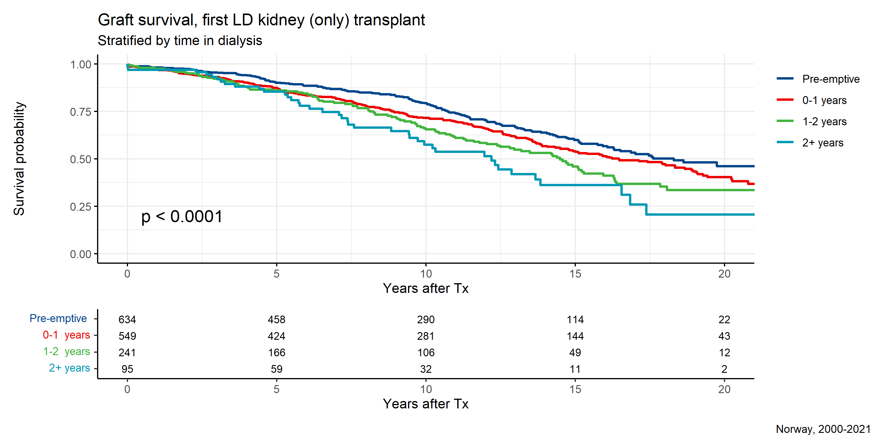

**Figure 48:**

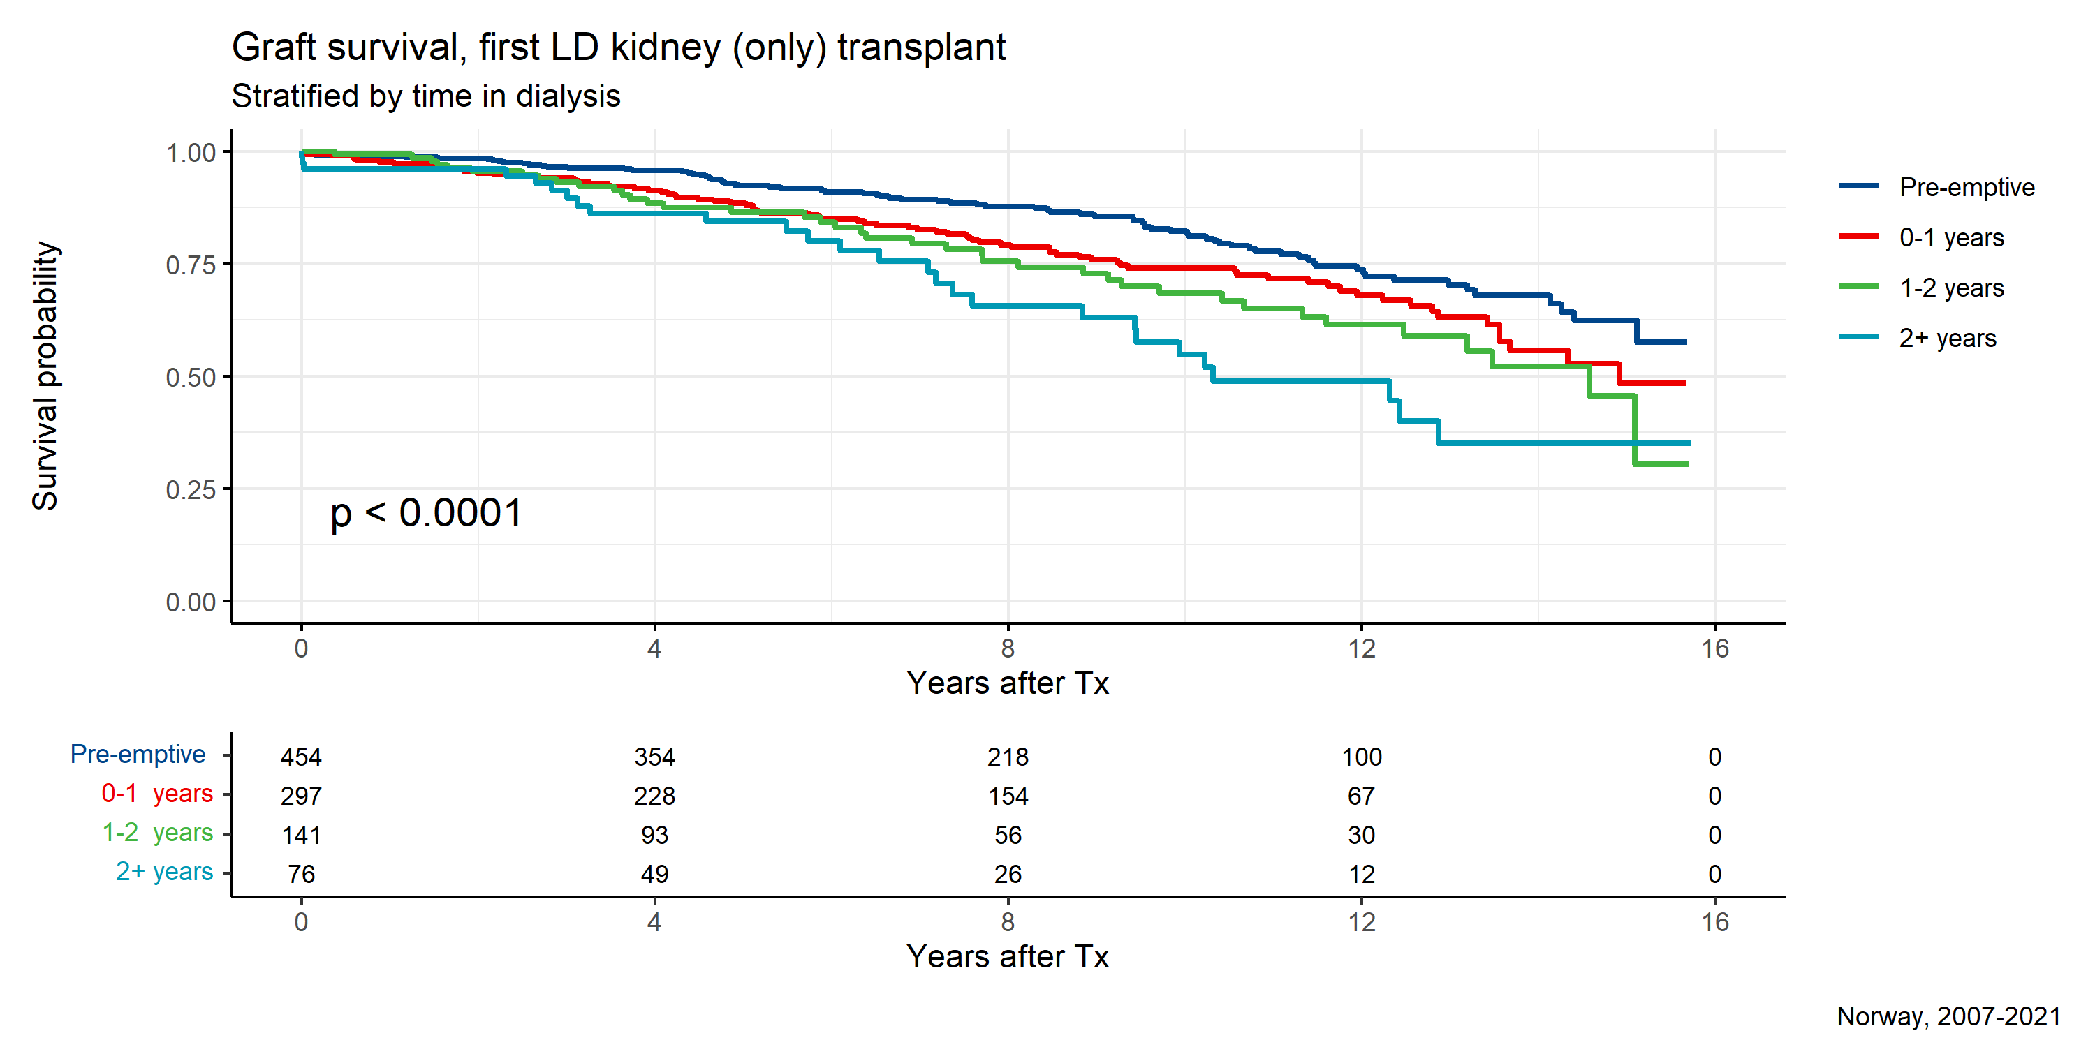

**Figure 49:**

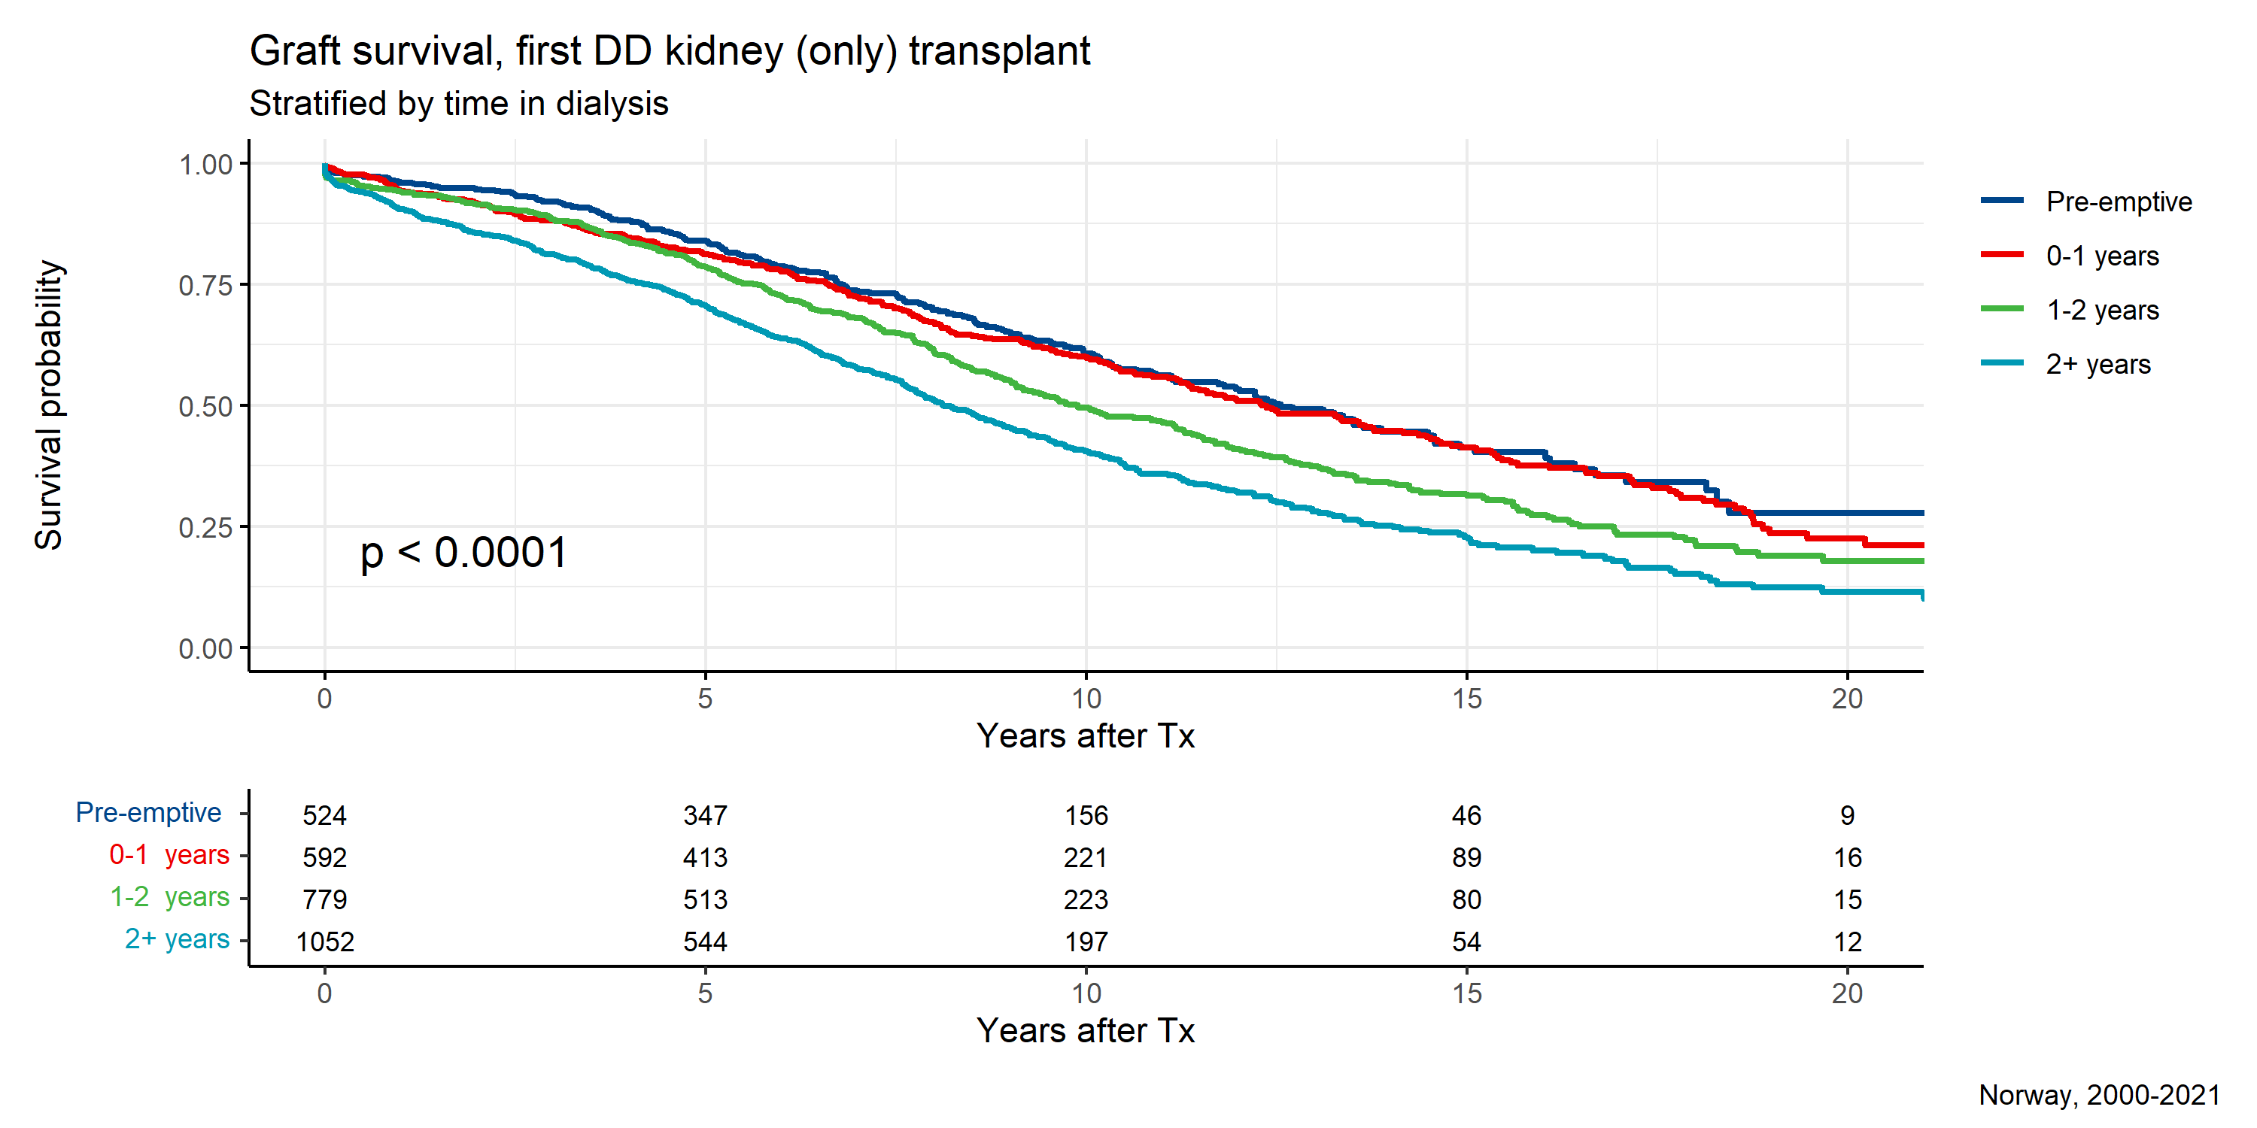

**Figure 50:**

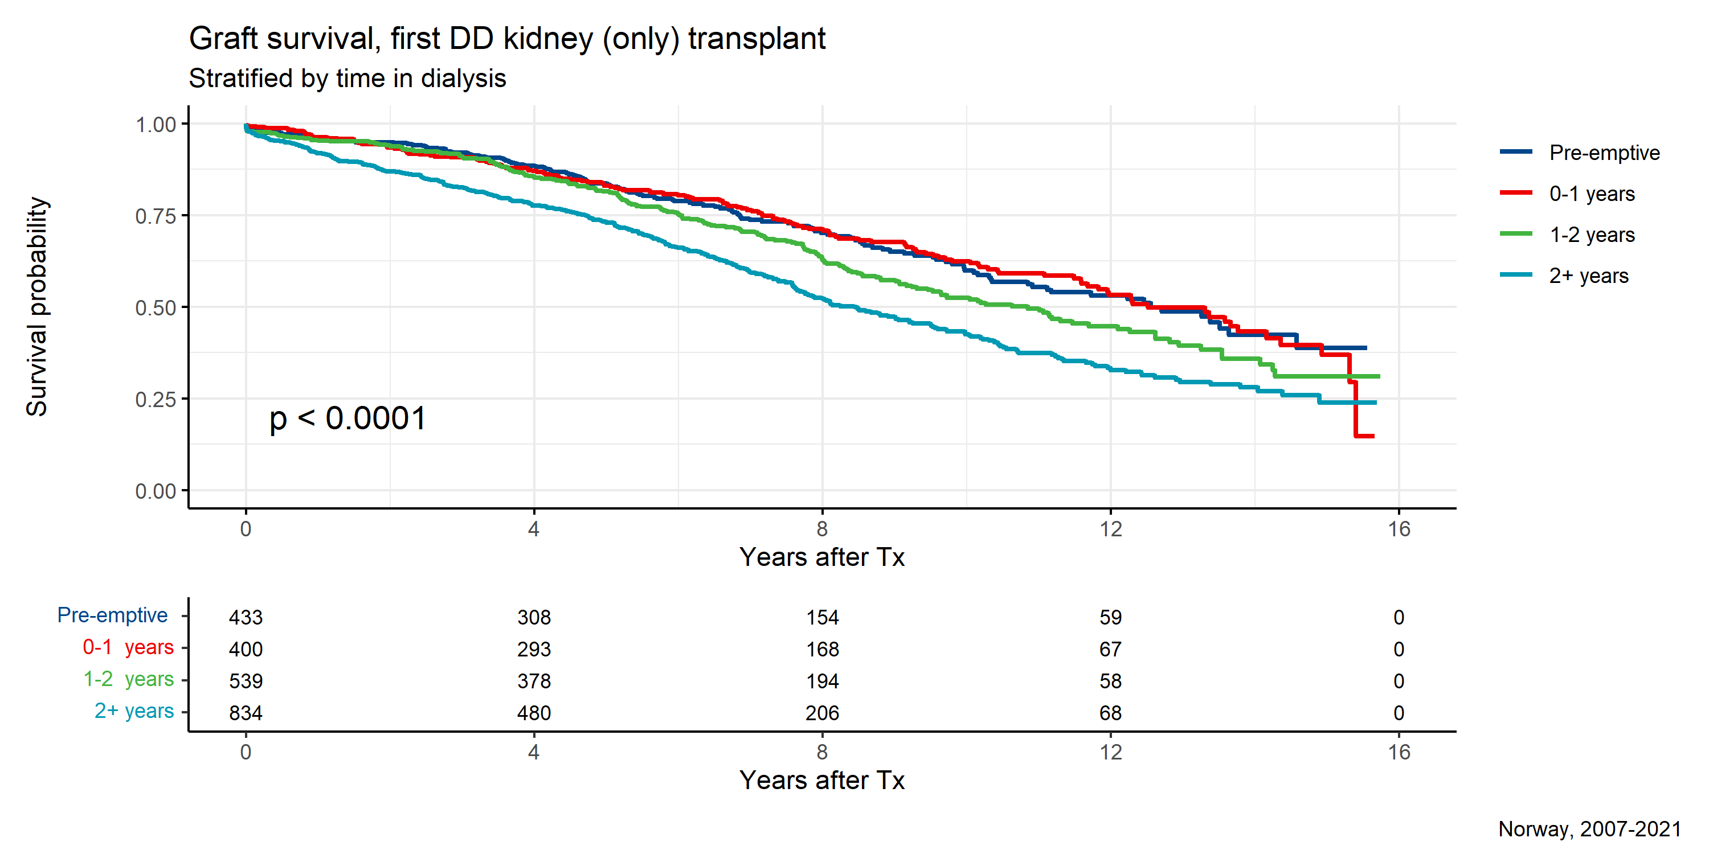

**Figure 51:**

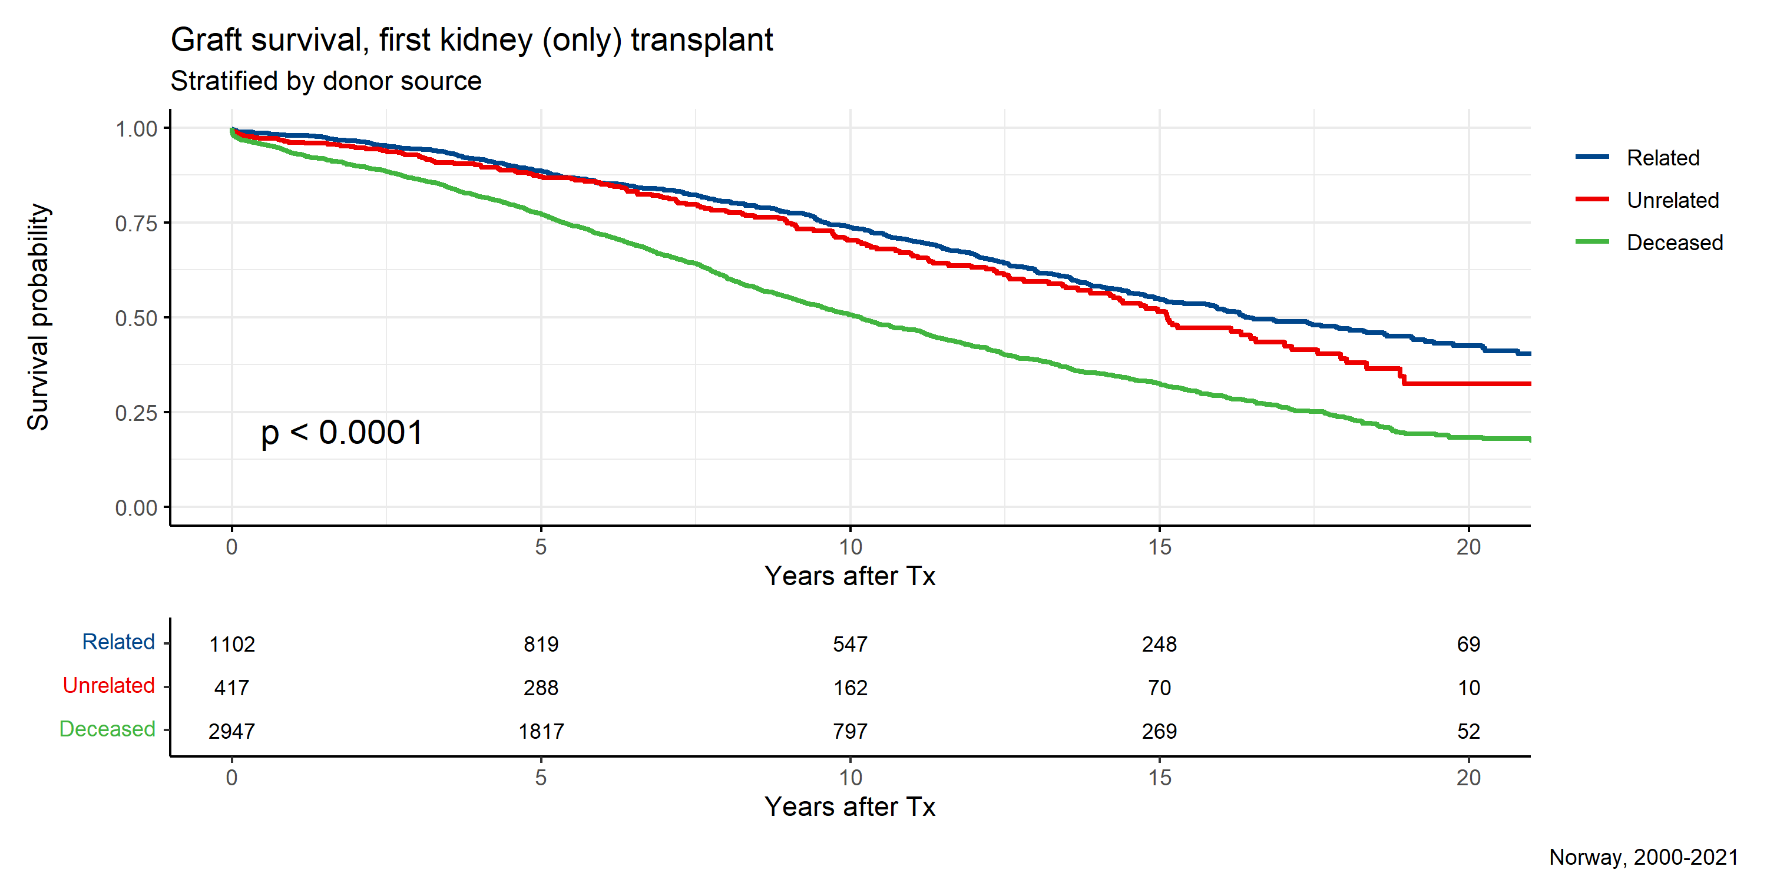

**Figure 52:**

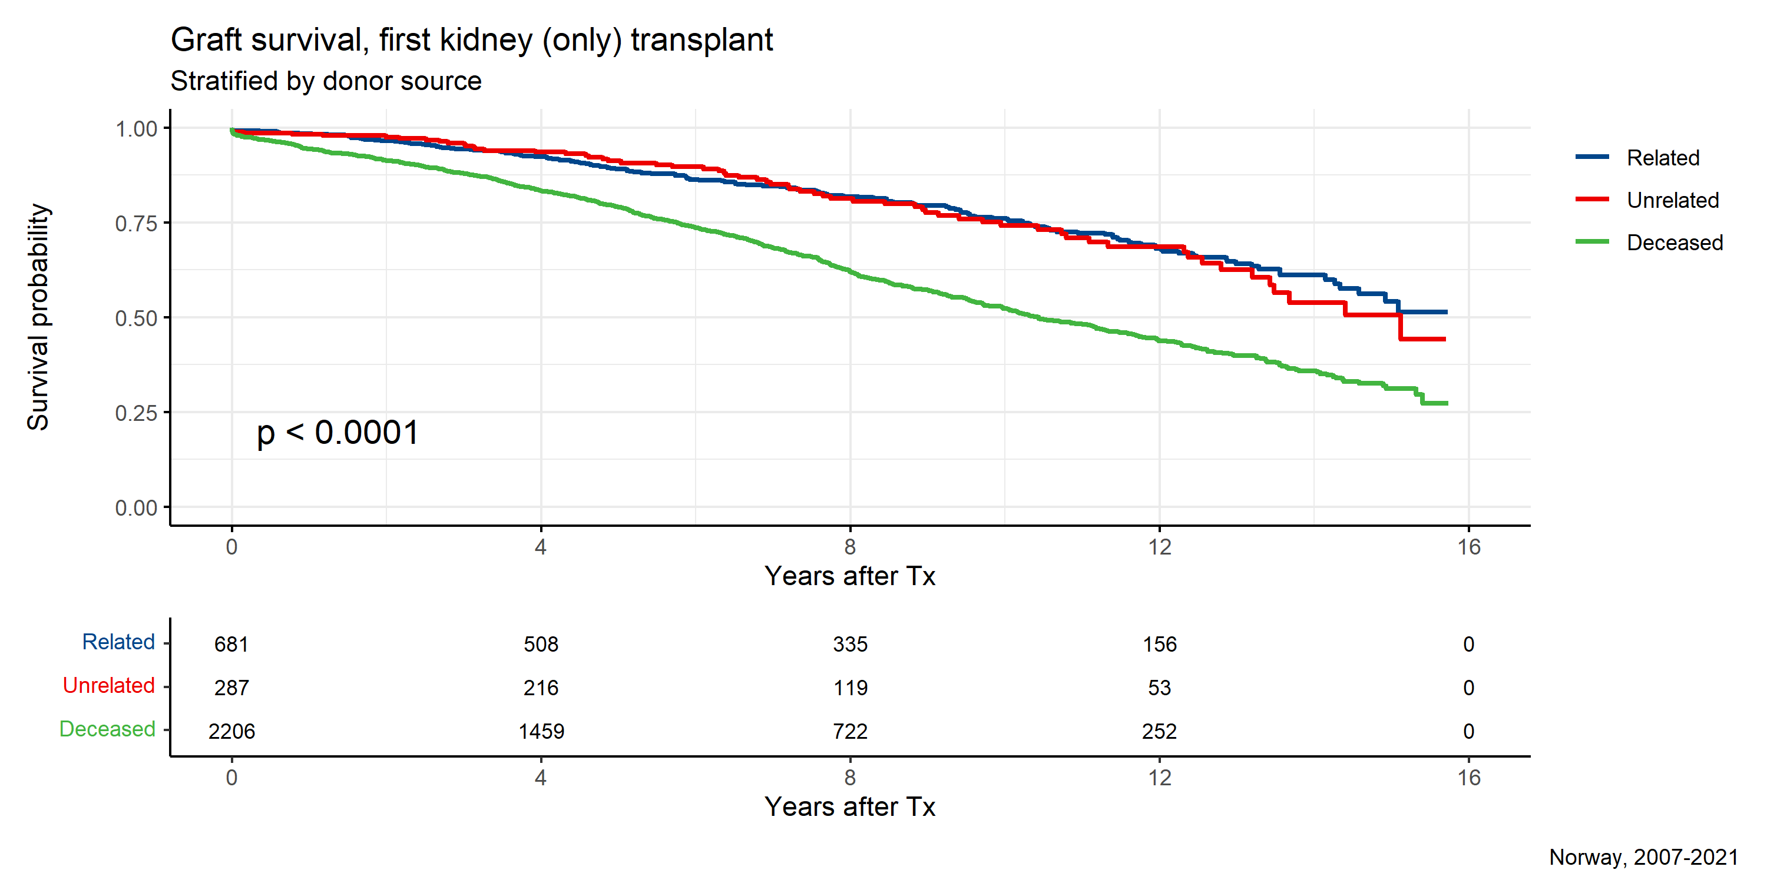

# Death in CKD5:

A total of 577 patients in CKD5 died during 2021, 79 of these patients had never started RRT (48% being RRT candidates), 312 of patients were in active dialysis (of which 27 were previously transplanted) and 140 transplanted. Dialysis treatment was terminated and followed by death in 46 patients.

Median age at death was 75 years (mean 74 years), ranging from 23 to 96 years. Median time from start of RRT until death was 4.9 years (mean 8.3 years), ranging from 6 days to 52 years.

Infections and cardiac complications were the most frequent causes of death, followed malignant tumors.

# Quality indicators:

The registry has implemented 22 quality indicators (see appendix) that will be followed year by year to assure the quality of the treatment the patients included in the registry is subjected to. These data are presented interactively at this site (<https://www.kvalitetsregistre.no/registers/464/resultater>) and the national quality indicator of part in home dialysis is presented three times per year here (https://www.helsedirektoratet.no/statistikk/kvalitetsindikatorer/behandling-av-sykdom-og-overlevelse/andel-dialysepasienter-som-har-hjemmedialyse). Only a short summary of the results is presented as figures in this report for completeness.

Data on acute rejections are still not possible to extract from the database where these are registered at OUS-Rikshospitalet. Therefore complete data is not available and the indicator is not presented in the report. The approximate acute rejection rate the first year after transplantation is in the range of 10% to 13%.

Data on part of the patients on the waiting list for a kidney transplant that has been in dialysis for more than 2 years (first kidney transplant only, excluding immunized patients, counting also time during temporary withdrawals) is not relevant to present on a center level. In the period 2017-2020 the rate ranged between 28%-30% and in 2021 it was increased to 37% for patients actively on the transplantation list. During COVID-19 a higher proportion of the patients on the transplantation list has however been temporarily off, which may have biased the quality indicator *part actively on the list with a longer time in dialysis*.

In the figures below the red line indicate the target percentage, the black line the national average and shading in color the relative number of patients at respective center.

**Figure 53:**



**Figure 54:**

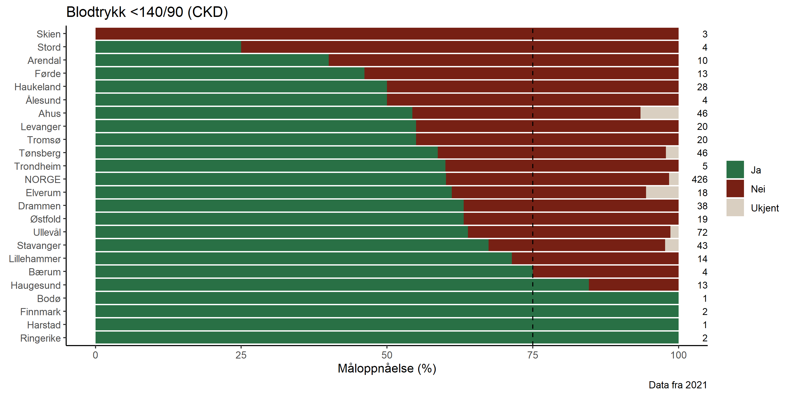

**Figure 55:**

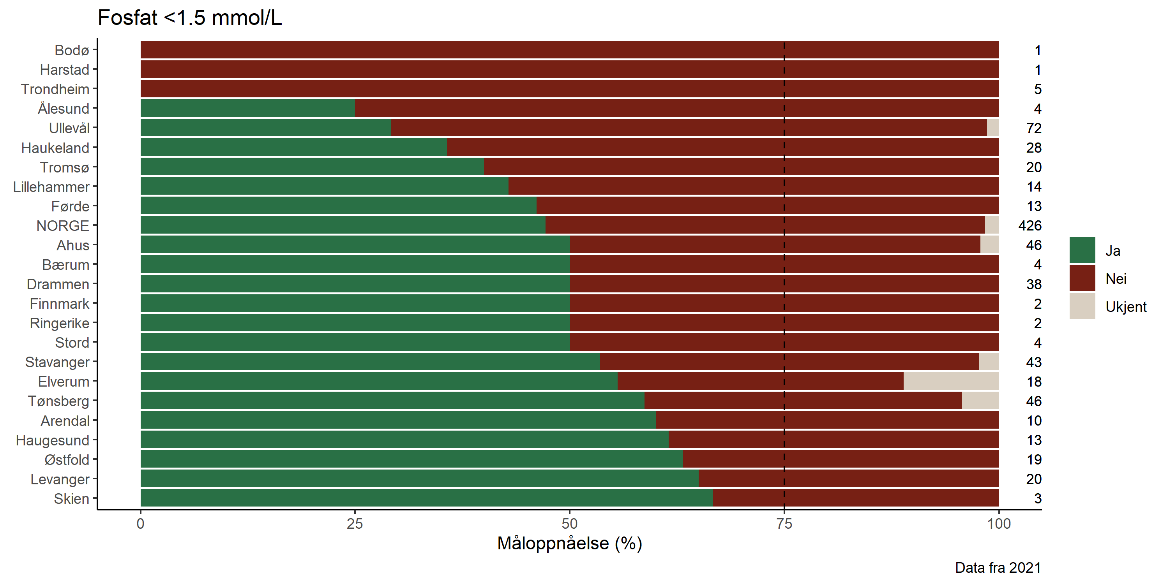

**Figure 56:**

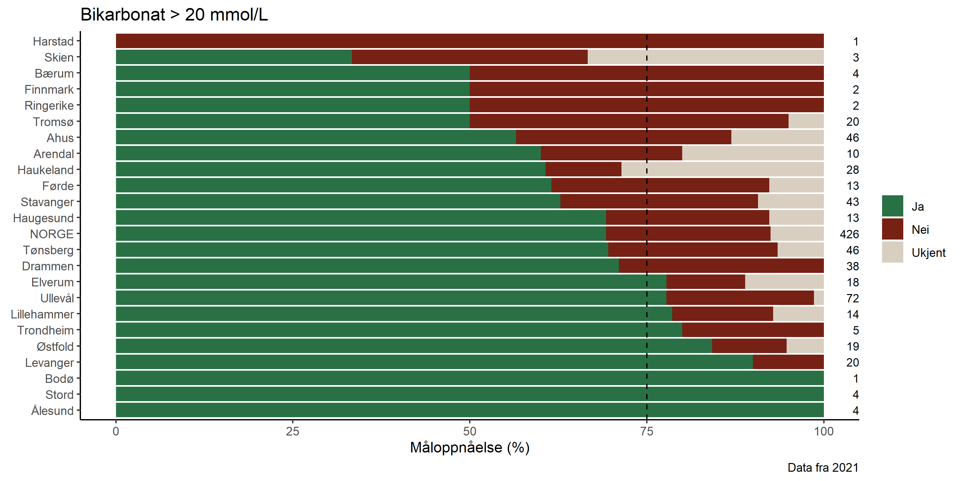

**Figure 57:**

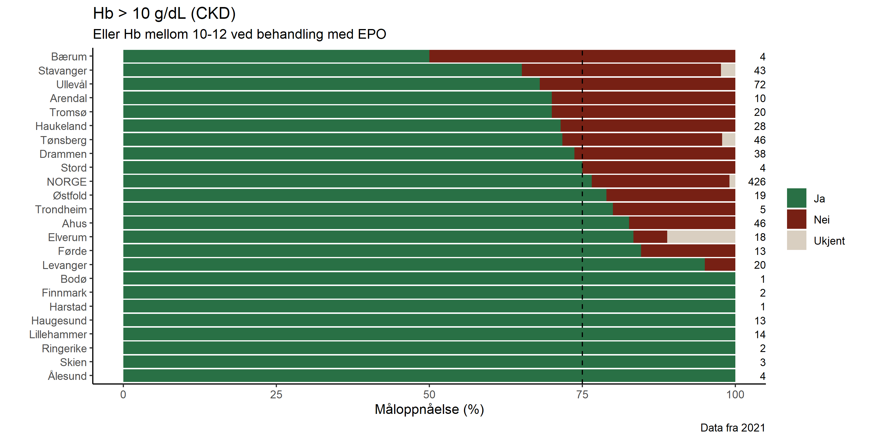

**Figure 58:**

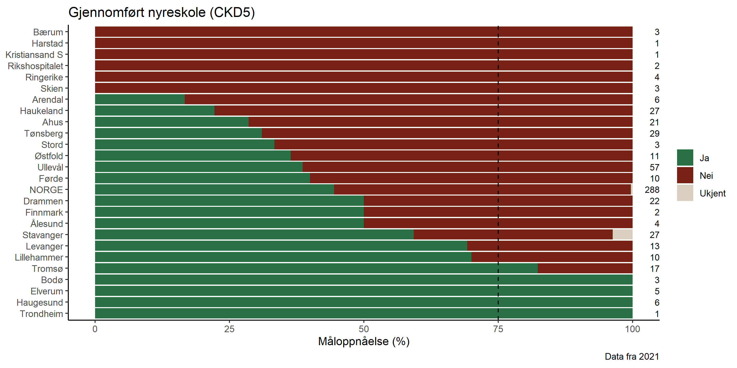

**Figure 59:**

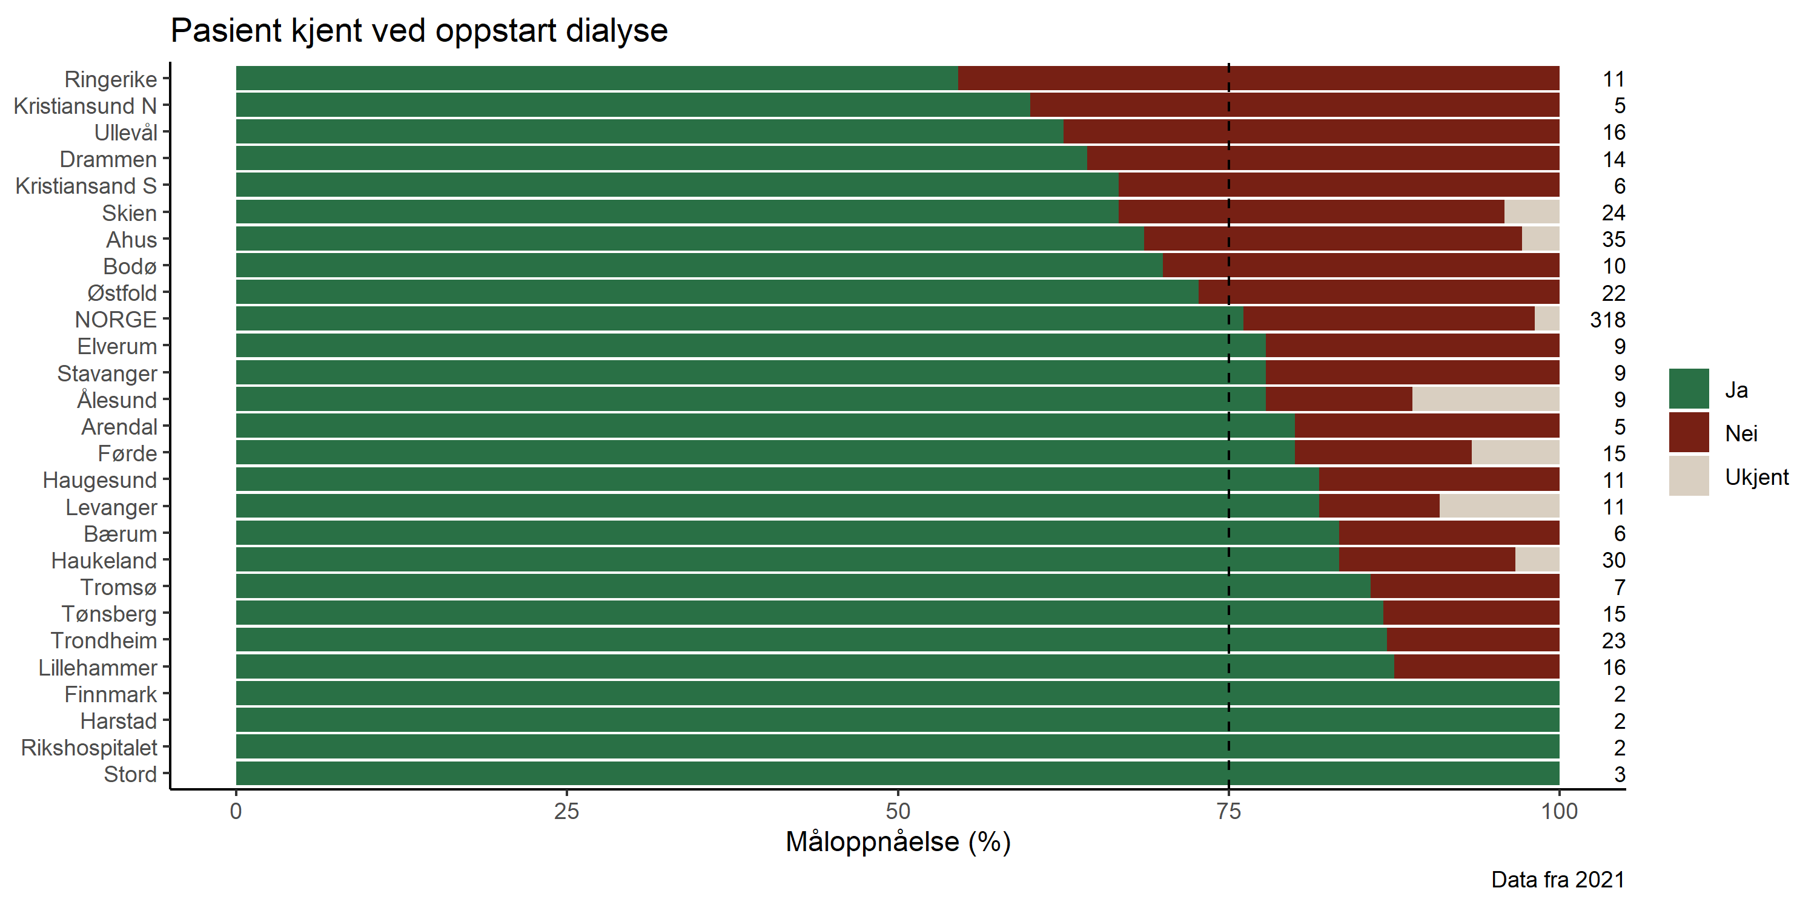

**Figure 60:**

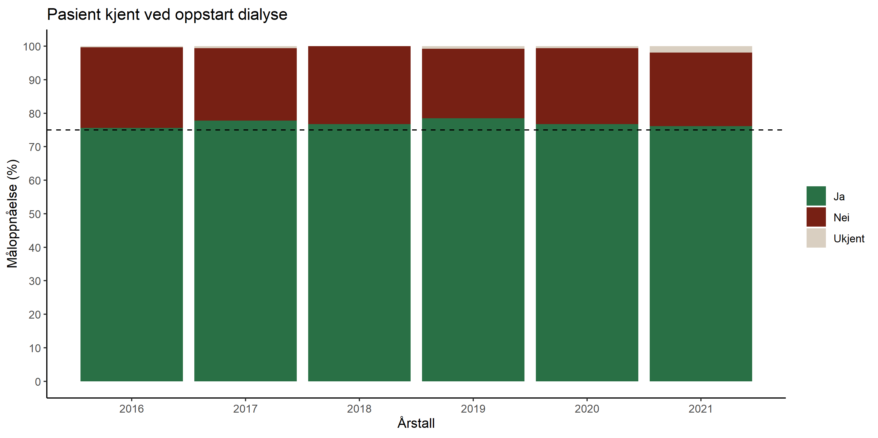

**Figure 61:**



**Figure 62:**



**Figure 63:**

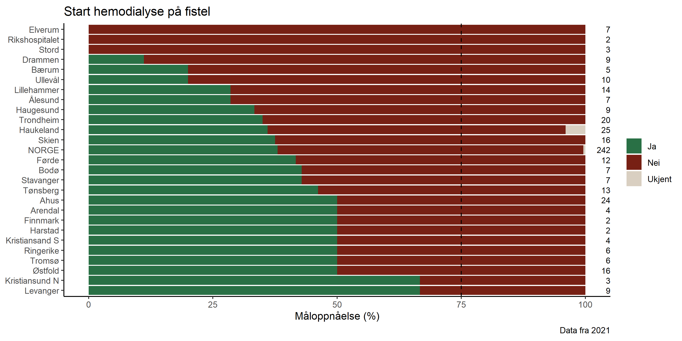

**Figure 64:**

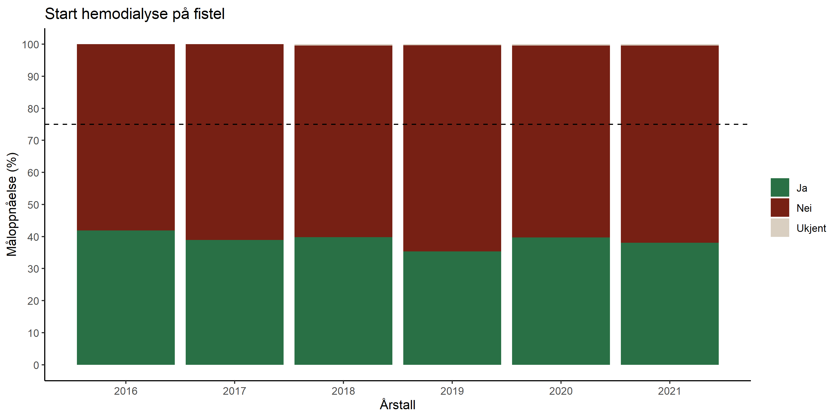

**Figure 65:**

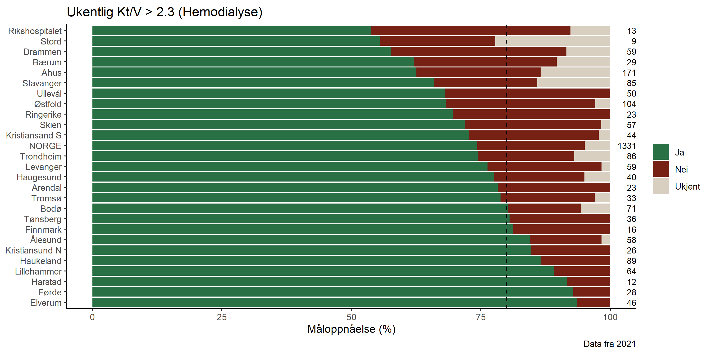

**Figure 66:**

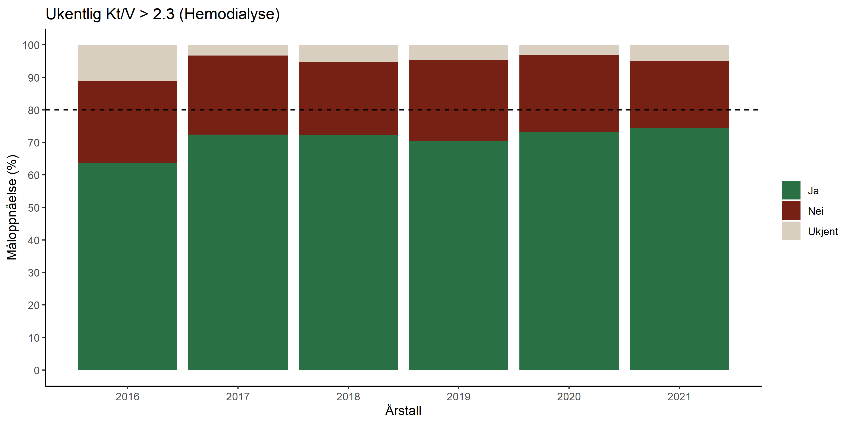

**Figure 67:**

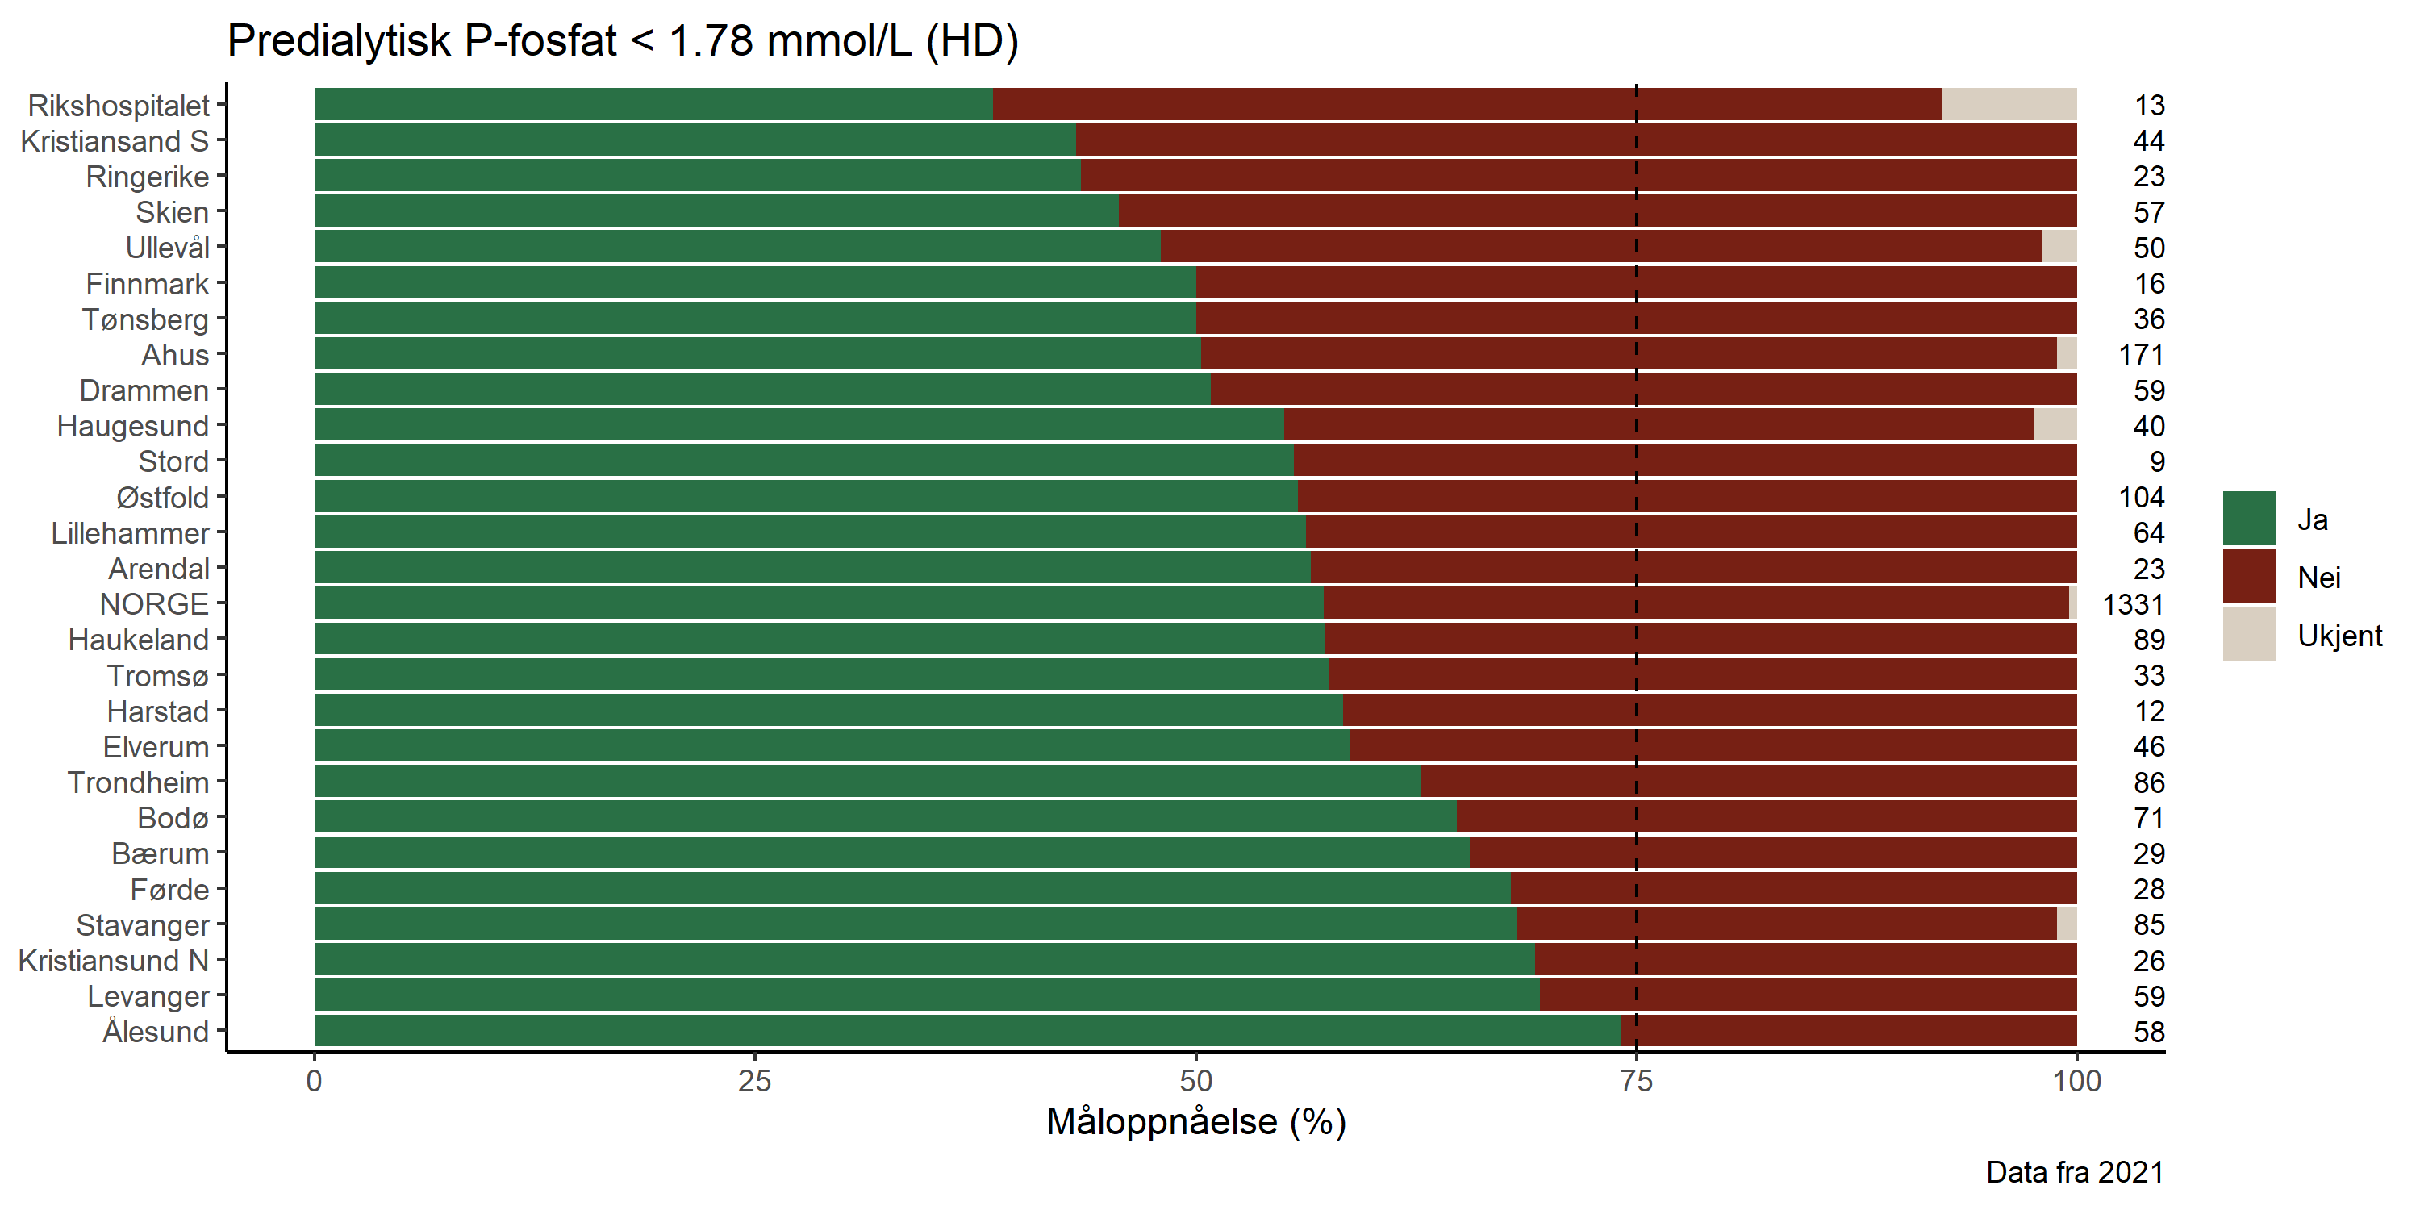

**Figure 68:**

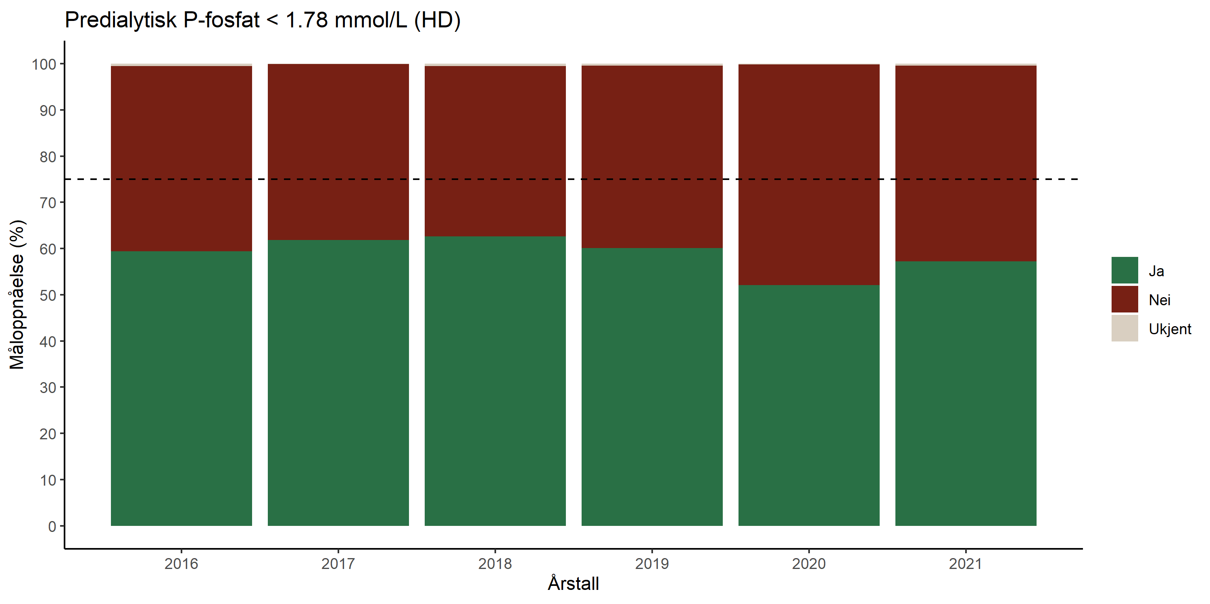

**Figure 69:**

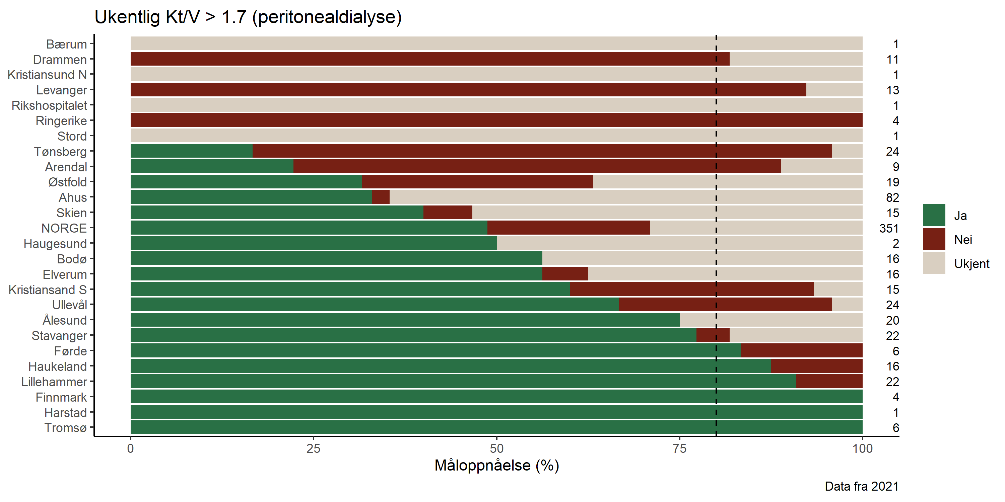

**Figure 70:**

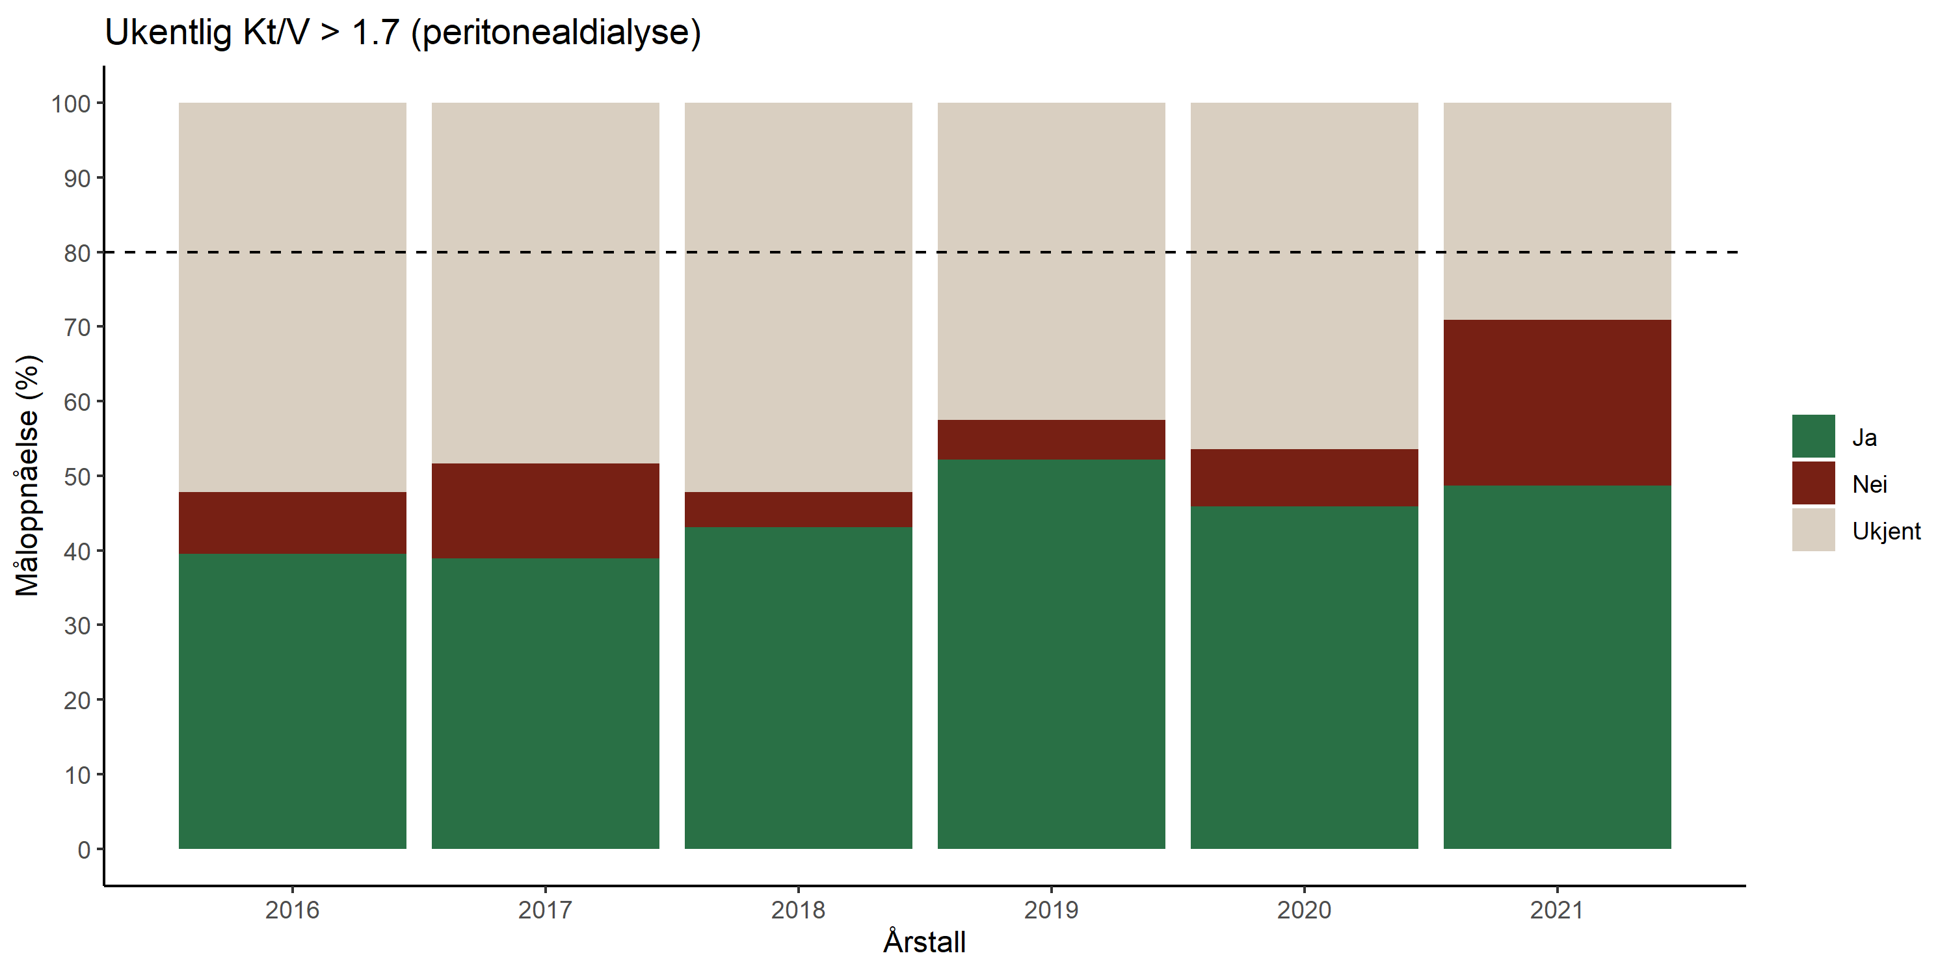

**Figure 71:**



**Figure 72:**



**Figure 73:**

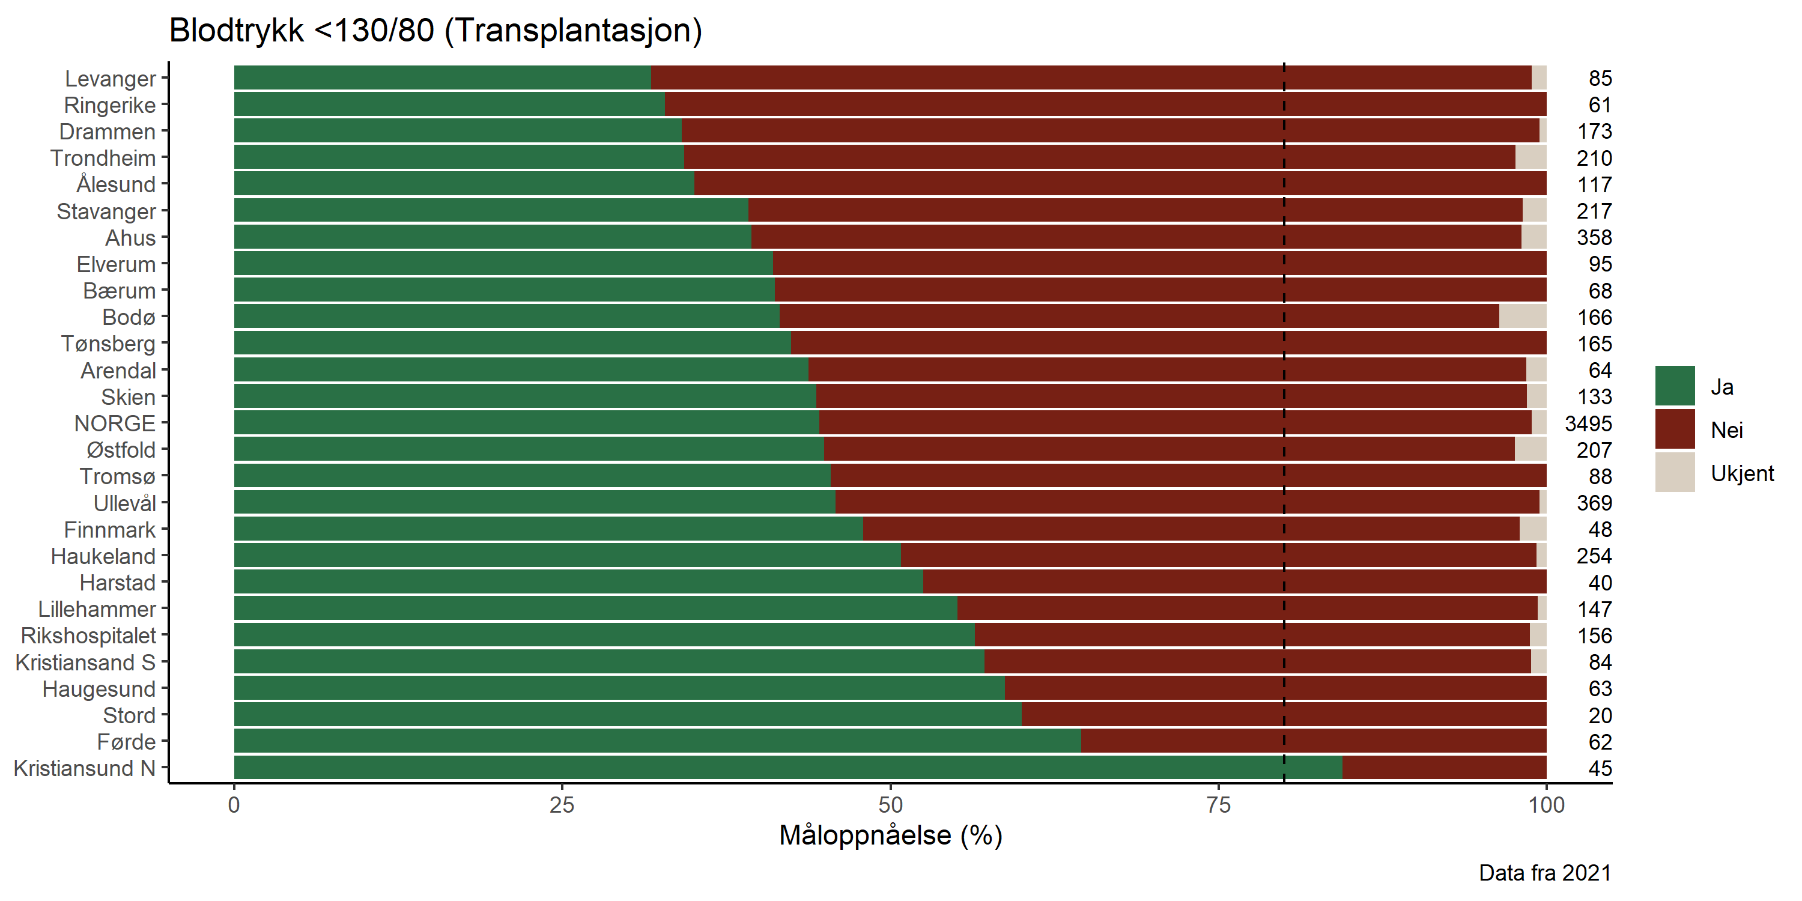

**Figure 74:**

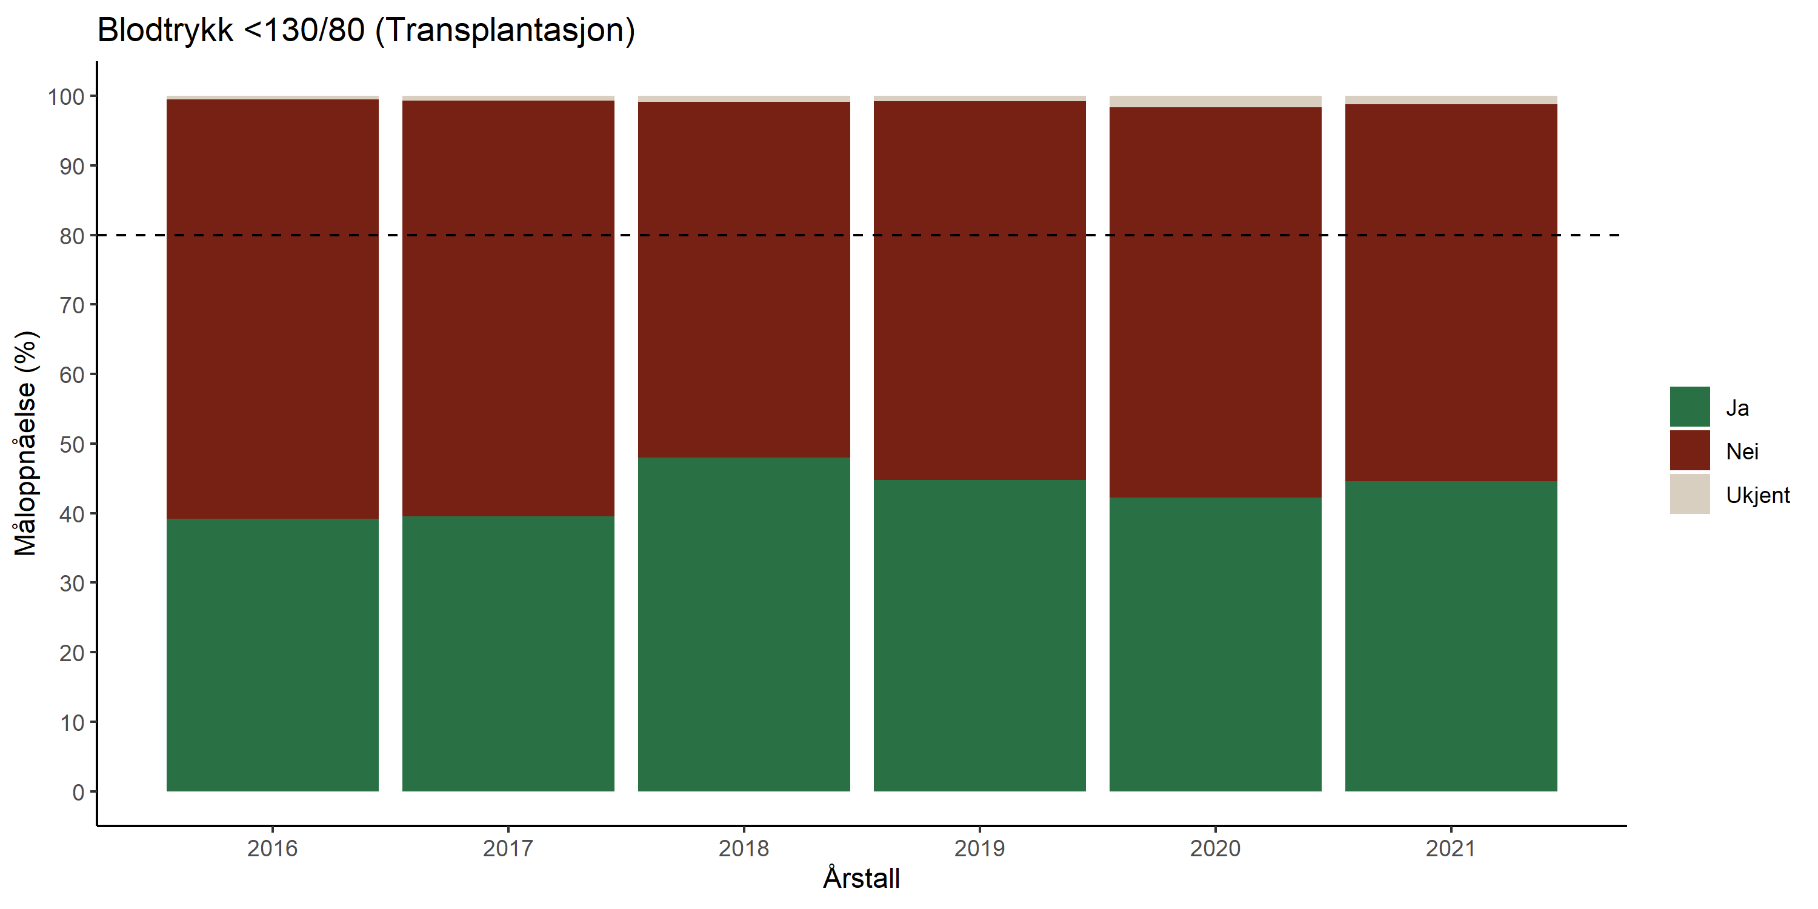

**Figure 75:**

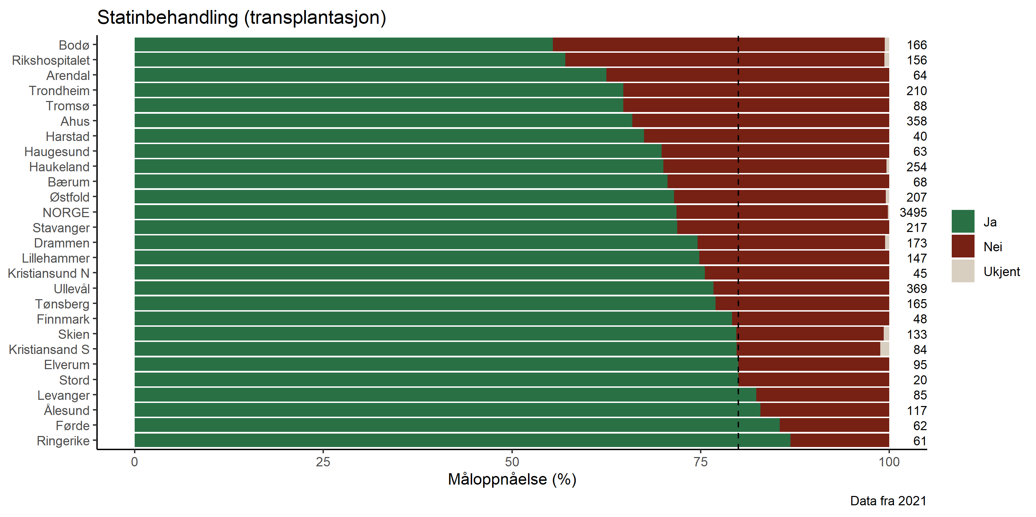

**Figure 76:**

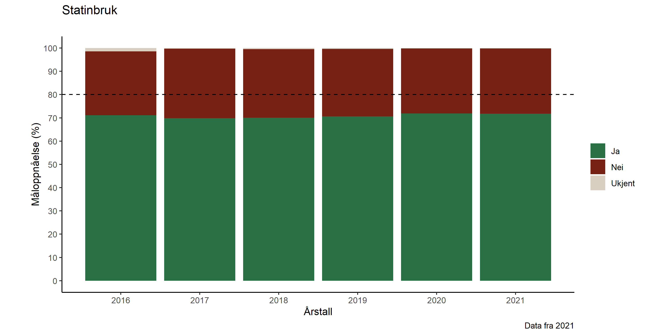

**Figure 77:**

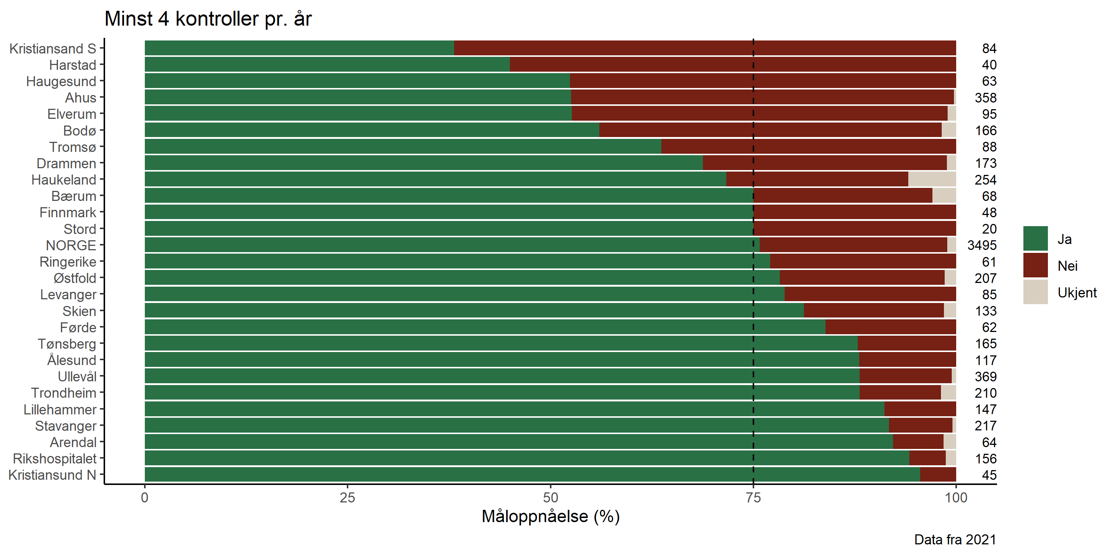

**Figure 78:**

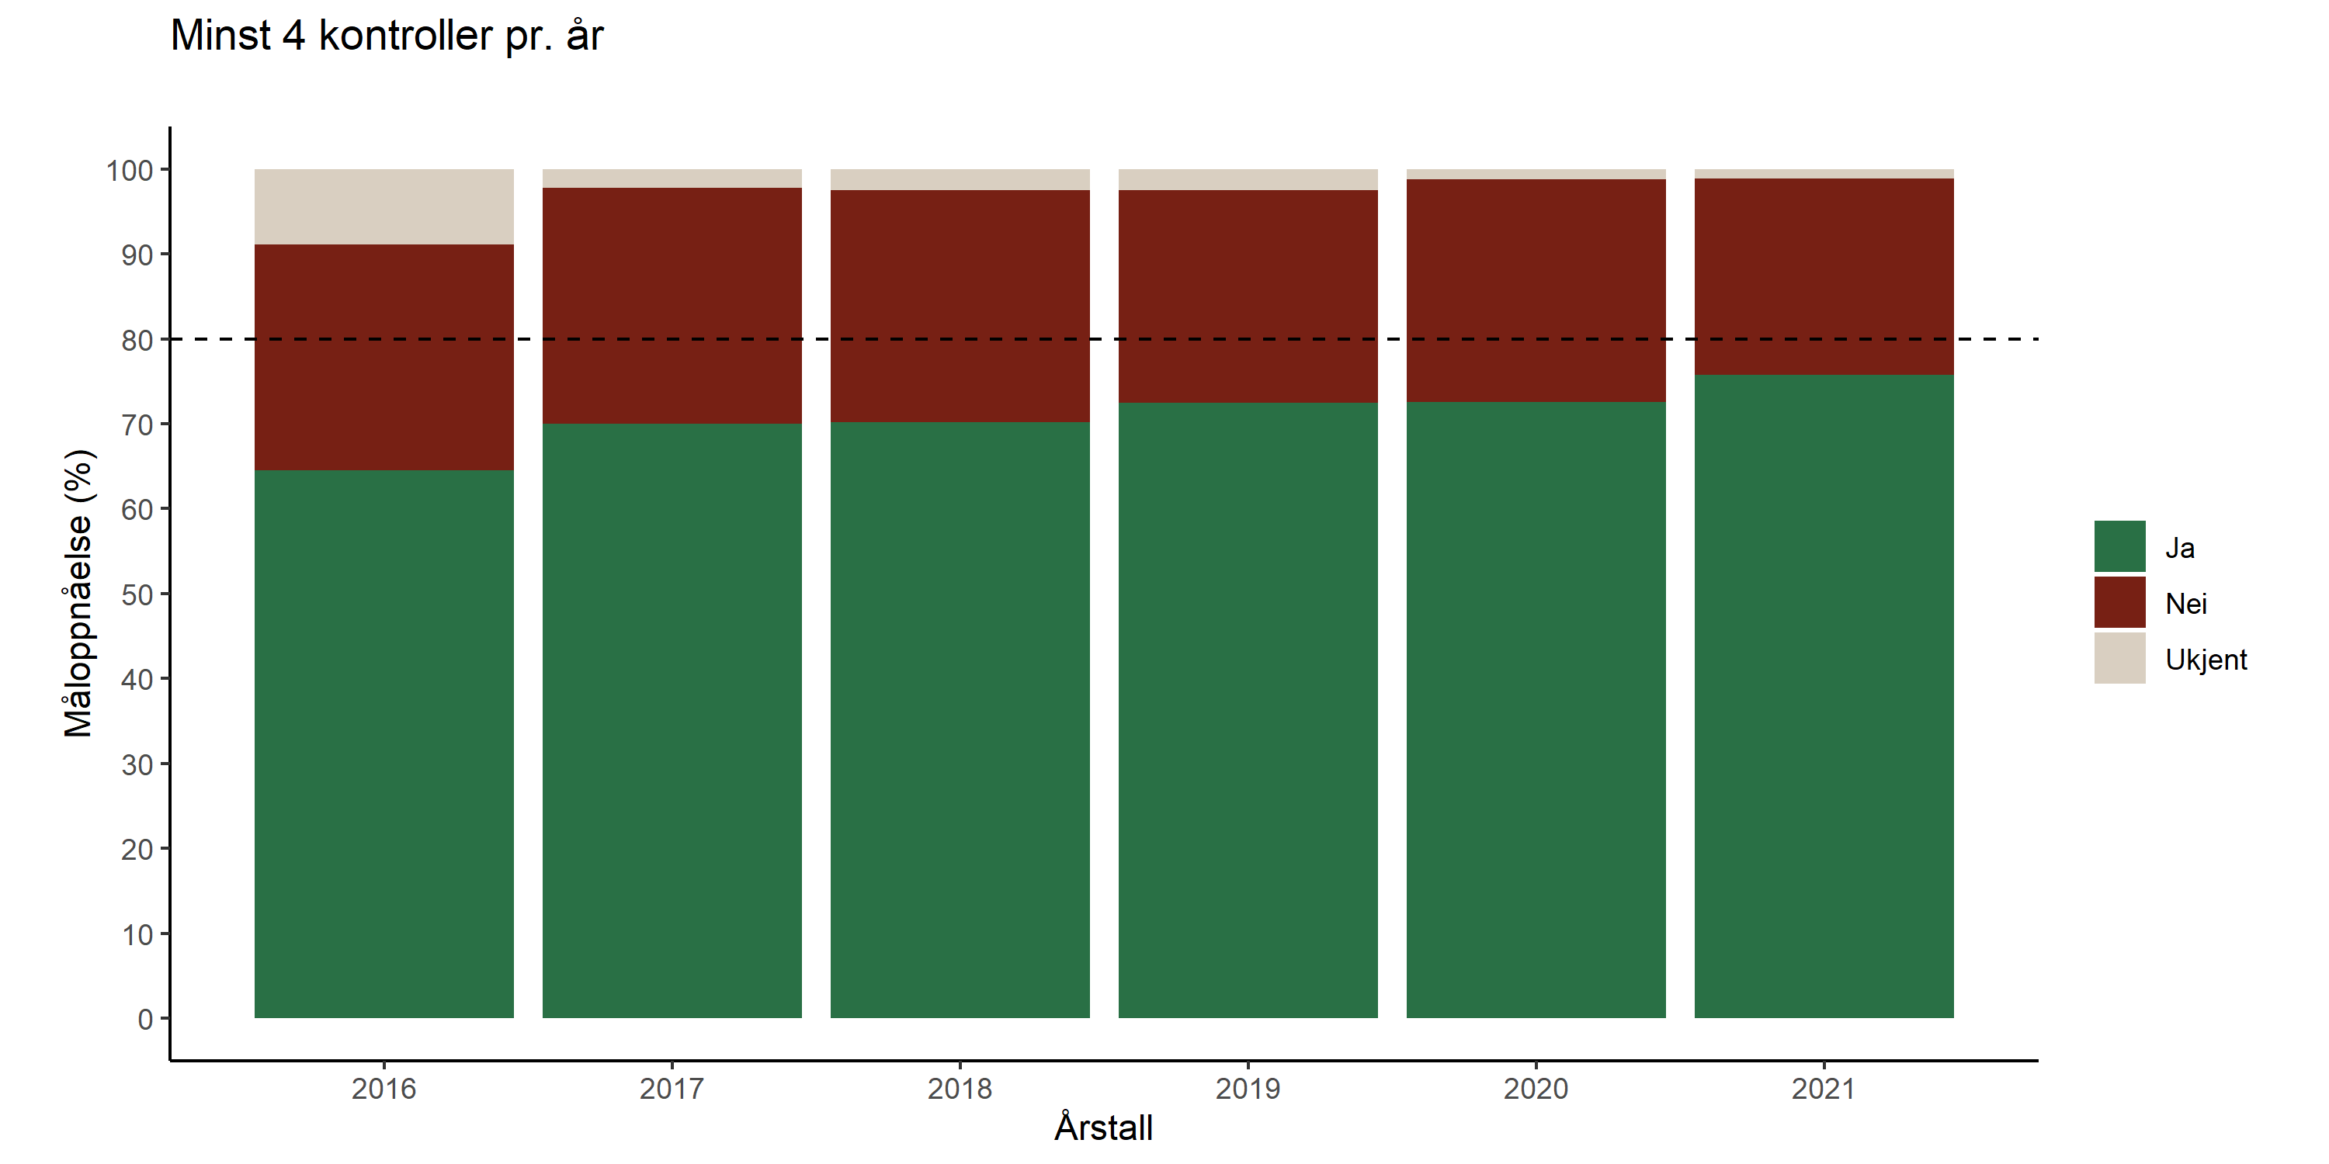

# Quality projects

### Reasons for not starting HD with AV-fistula as blood access:

One of the quality indicators for the registry is part of new patients (known at the nephrology unit for more than 4 months) starting HD with AV-fistula as blood access. The target achievement has been low over many years and in 2020 it was just over 40% reaching this target. The goal for the registry is to have 75% of the patients using an AV-fistula when starting HD. Maybe this is not realistic? So, in 2020 a quality project was initiated to collect reasons for not starting with AV-fistula. Data collection has been continued in 2021 and here we present data on 429 patients fulfilling the above-mentioned criteria for being included in the calculation of this quality indicator (also presented in the 2020 annual report). In total 168 (39.2%) of the patients did start on AV-fistula. There is missing information of reason for 114 patients (26.6%). In **Figure 79** below the patients without information is disregarded, assuming that the percentage of different reasons for not starting using an AV-fistula is represented by those with reasons provided.

**Figure 79.** Percentage of different reasons for not starting HD using AV-fistula as blood access in the period 2020 to fall 2021. Total number of patients in the period is 429, for114 (26.6%) of patients not starting on an AV-fistula there is missing information about reason.

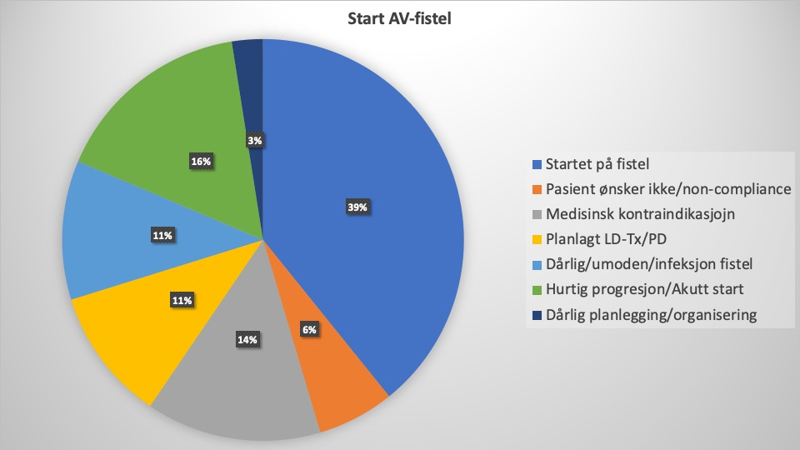

From these results it seems unrealistic to get 75% of patients starting on AV-fistula. The second to fourth reason listed in the figure, in total 31% of the total was not appropriate to be started on AV-fistula. For some of the patients covered by reason five and six it may have been feasible to start dialysis on AV-fistula with some relevant interventions, but it is difficult to state an exact number. If 25% of these that seems to be feasible to start on AV-fistula, the target level for this quality indicator should probably be more in the range of 50%. Instead of changing the target level to 50% the definition of the indicator will be changed to count number of *HD start by planned blood access* with a target level of 75%.

### Phosphate level as quality indicator?

Based on recent indications in the literature about the low predictability of plasma phosphate levels for long-term outcomes the registry performed Kaplan Meier analyses on patient survival for this quality indication in CKD5 patients without RRT and in dialysis. The results are shown in **Figures 80 and 81**.

**Figure 80.**

**Figure 81.**

### Blood pressure in kidney transplant recipients:

Blood pressure treatment has been a focus for the registry for several years without having succeeded to increase the rate of patients reaching the target of 130/80 mmHg. During the fall 2021 a new study with the primary objective to investigate the effect of home blood pressure monitoring on target achievement.

# COVID-19 in patients on renal replacement therapy

In 2020 the registry started to collect data on renal replacement patients with COVID-19. The registry also reported data to the European collaboration initiative ERACODA, coordinated by ERA-EDTA. In cooperation with researchers at OUS-Rikshospitalet and all the local contact persons at the 26 nephrology units in Norway a national screening of SARS-CoV-2 IgG antibodies was also initiated, inviting all kidney transplant recipients in the registry, to see how many of the patients that had been infected with the virus, also covering subclinical infections. In 2021 this national screening was extended to also investigate immunological response to the SARS-CoV-2 vaccines, in both dialysis and kidney transplant patients, which was rolled out during the first quarter of 2021,

By the end of 2021, 288 patients (5.3%) had been registered with COVID-19; 79 patients in dialysis (4.4%) of which 7 later died due to COVID-19 and 209 kidney transplant recipients (3.8%) of which 30 later died due to COVID-19. In the national screening of SARS CoV-2 antibodies we received samples from over 85% of all kidney transplants in relation to the first COVID-19 wave and approximately 80% and 66% of the dialysis and transplant population, respectively, have been identified with positive SARS CoV-2 IgG antibodies but far from all have high enough levels for proper protection against severe disease. In **Table 18** and **19** monthly data in 2022 is presented (during the omicron era).

**Table 18. Monthly and overall incidence of SARS-CoV-2 infection and severity in Dialysis patients in Norway.**



**Table 19. Monthly and overall incidence of SARS-CoV-2 infection and severity in Kidney transplant patients in Norway**



# Concluding remarks:

The reporting of patients in CKD5 without RRT is very variable between centers and needs to come up to the coverage level of the rest of the registry. A coverage analysis on the 2019 data underway in cooperation with the Norwegian Patient Registry (NPR). The prevalence is still increasing, majorly driven by an increased survival in RRT. Despite the increased age in patients starting RRT the survival is increasing.

A worrying trend is the continued increasing waiting list for kidney transplantation. Action has been taken to increase the number of living donors with a good result, but there is still need for more available organs for transplantation to meet the demand. During the COVID-19 pandemic more patient on the transplant list has been temporarily withdrawn. Numbers for both active and temporarily withdrawn patients must be considered when analyzing changes in the transplant list.

This year the focus has been on why only a low number of patients starting on hemodialysis utilize AV-fistula as blood access. The results of a survey indicate that the target level should be lowered. This was addressed by the “Fagråd” during 2022 and the target has been reduced to 50% from the 2022 reporting.

Registry data are also regularly used by Norwegian nephrologists as basis for scientific papers, congress presentations and PhD-thesis. A list of publications is published on [www.nephro.no](http://www.nephro.no) along with the annual reports. During 2021 a total of 28 international peer reviewed papers and one PhD-thesis have been based upon data from the registry.

Data delivered to the ERA-EDTA Registry in Amsterdam are included in its reports and publications; some data are also forwarded to the USRDS-reports (the chapter of “International Comparisons”). The registry has also in 2021 been active in keeping track of vaccination against SARS-CoV-2 in RRT patients and the development of COVID-19. These data show a general low vaccination response and high death rate from COVID-19 in RRT patients.

Regardless of status, the cooperation with all Norwegian nephrologists and nephropathologists, demanding their steady efforts to keep the registry updated, has always been, and will always be, a prerequisite for keeping a complete and reliable registry. All hard work over the entire country is GREATLY acknowledged!

*Report completed 13.12.2021*

# Appendix:







1. Chang A, Gibson IW, Cohen AH, Weening JW, Jennette JC, Fogo AB. A position paper on standardizing the nonneoplastic kidney biopsy report. Hum Pathol. 2012;43(8):1192-6.
2. Sethi S, D'Agati VD, Nast CC, Fogo AB, De Vriese AS, Markowitz GS, et al. A proposal for standardized grading of chronic changes in native kidney biopsy specimens. Kidney International. 2017;91(4):787-9.
3. <https://www.legeforeningen.no/foreningsledd/fagmed/den-norske-patologforening/faggrupper/nyrepatologi-ikke-neoplastisk/fagstoff/>